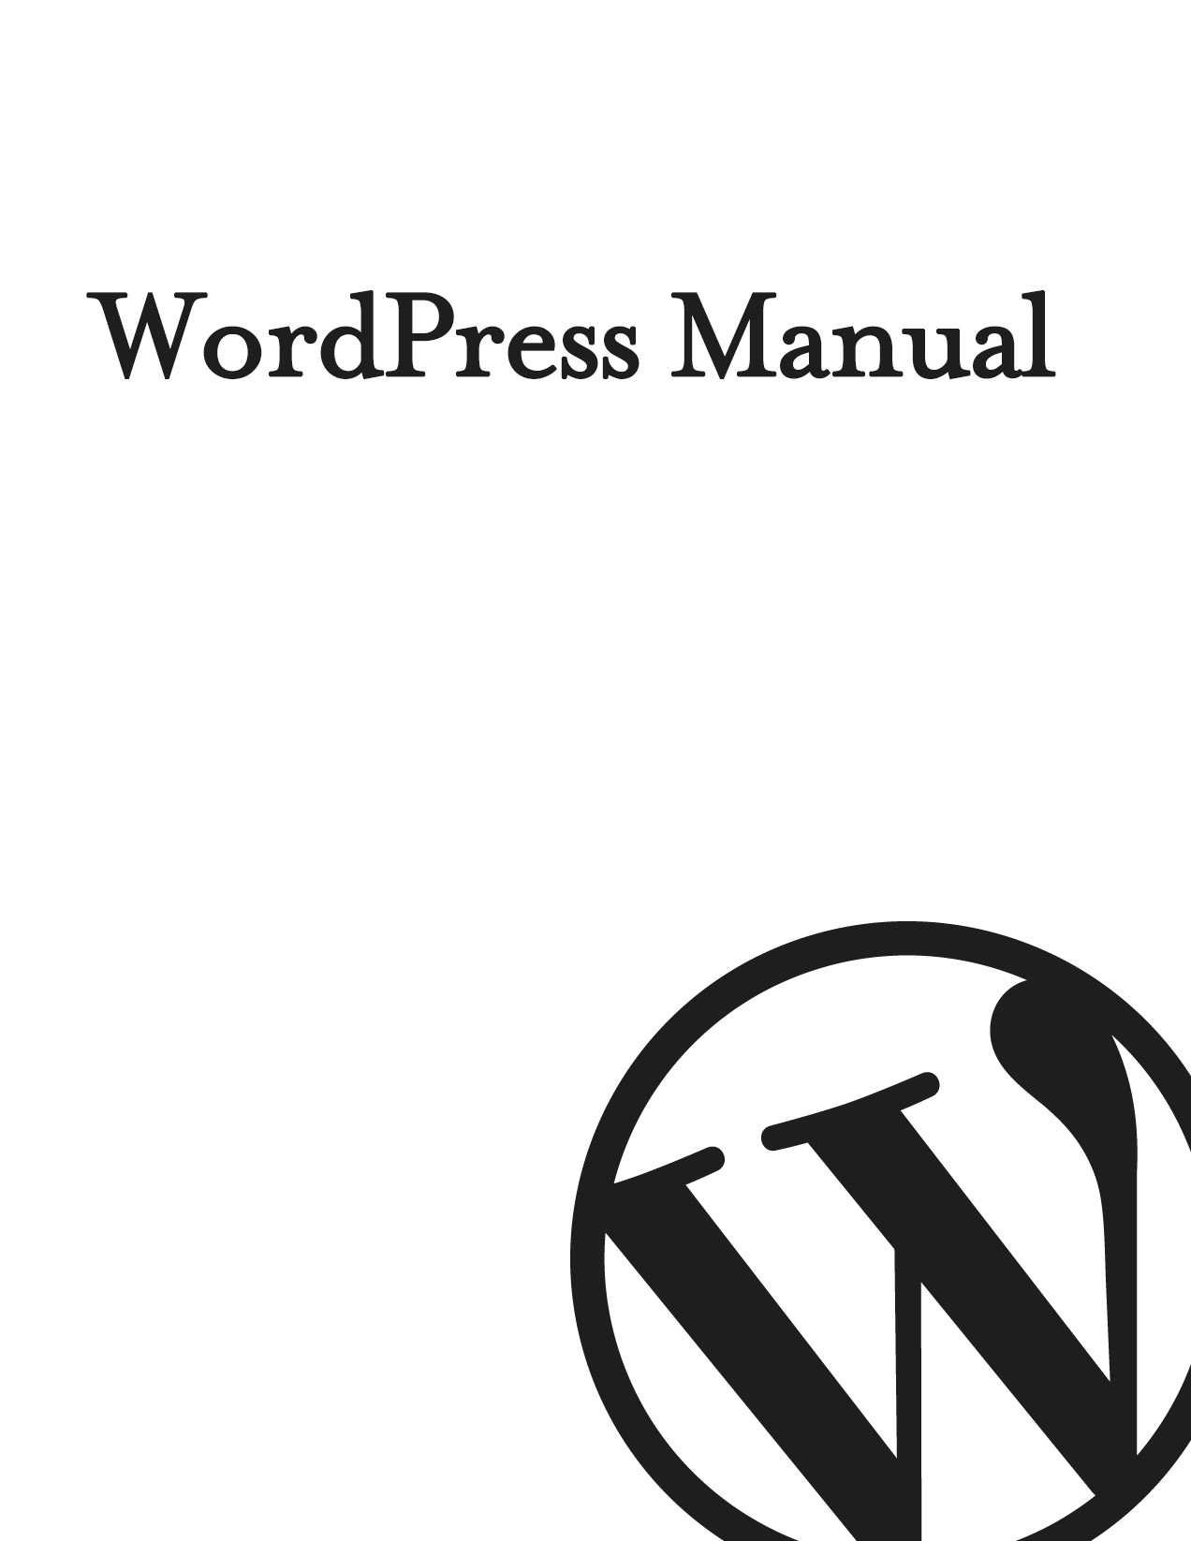
WordPress Manual
by June McKim
Belmar Design
belmardesign.com

Copyright © 2016 June McKim
All rights reserved

Contents
Welcome 7
Introduction 8
Login 10
Dashboard 11
Dashboard Menu Options 12
Toolbar 13
Hiding the Toolbar 14
Posts versus Pages 16
Posts 16
Pages 17
Adding your Site Content 19
Adding a New Page 19
Adding a New Post 20
Adding Content with the Visual Editor 21
Switching to the Text Editor 26
Changing your Post Format 28
Reviewing Past Revisions 29
Adding Images and Other Media 31
Inserting an Image 31
Edit or Delete an Image 36
Setting a Featured Image 39
Insert an Image Gallery 41
Edit or Delete an Image Gallery 43
Insert an Audio or Video Playlist 44
Inserting Video, Audio or Other File Type 46
Embedding a Video, Image or Other Content 47
Adding HTML Links 51
Inserting an HTML Link 51
Inserting Links to Media Files 53
Editing an HTML Link 55
Removing an HTML Link 56
Editing Existing Content 58
Deleting Content 59
Fullscreen Editing 61
Saving and Publishing Content 62
Categories 64
Adding Categories within your Post 65
Tags 67
Adding Tags within your Post 69
Media Library 71
Viewing a File in the Media Library 72
Adding a File to the Media Library 75
Editing the File Properties 77
Editing an Image 79
Deleting a File from the Media Library 82
Comments 83
Replying to a Comment 84
Editing a Comment 87
Quick edit 87
Edit 87
Unapproving and Approving Comments 88
Marking Comments as Spam and Trash 89
Appearance 91
Selecting your Theme 91
Previewing and Customizing your Theme 92
Adding a new Theme 93
Customizing your Site 94
Widgets 96
Updating the Menu 98
Adding a New Menu 99
Editing an Existing Menu Item 100
Adding a New Menu Item 102
Adding a Custom Link Menu Item 103
Deleting a Menu Item 104
Managing Menu Locations 105
Header 106
Background 107
Editor 107
Plugins 108
Adding a New Plugin 109
Users 113
Adding a New User 114
Deleting a User 116
Editing your Profile 116
Tools 120
Available Tools 120
Press This 120
Categories and Tags Converter 120
Import 120
Export 120
Settings 121
General 121
Writing 123
Reading 123
Discussion 124
Media 126
Permalinks 126
Keeping your Site Updated 128
Where To From Here? 131

Welcome
It might be easier to say what this guide isn’t, rather than what it is. It isn’t an in depth look at every single function available within the WordPress dashboard. Nor is it a guide to help you develop or modify WordPress themes. My aim is to create a simple WordPress guide that will help you to get an overall understanding of how you use the various features within the WordPress Dashboard to keep your site or blog updated.
If you’re looking for more in-depth knowledge, there are heaps of articles in the WordPress Codex that go into more detail. This is great if you want to get really involved in developing your own WordPress theme or modifying your site with plugins, but it can be a bit daunting for those users who just want a simple guide to using the Content Management side of WordPress or just need to update their site pages every so often.

Introduction
WordPress is an Open Source software system used by millions of people around the world to create beautiful websites and blogs. It is completely customisable by the use of themes and plugins.
“WordPress is web software you can use to create a beautiful website or blog. We like to say that WordPress is both free and priceless at the same time.”
Themes can be easily downloaded from the official WordPress site or from hundreds of other places around the web. The same goes with plugins, which are used to extend the functionality of your WordPress site.
As well as being a fantastic blogging and content management system, one of the huge benefits is the wealth of information out there. There’s a great community of people behind the design & development of the WordPress system itself. People from all over the world contribute their time, knowledge and skill to keeping WordPress updated and secure.
There’s also a huge number of designers, developers & bloggers who share their knowledge through blog posts, tutorials, reviews, videos and the creation of thousands of themes & plugins.
WordPress powers a staggering amount of websites. In fact, it powers over 26% of the whole web! Everything from personal blogs to large corporate websites. The following are just a very few examples of the millions of diverse sites powered by WordPress...

Women’s National Basketball Association (WNBA) – http://www.wnba.com
The Women’s National Basketball Association (WNBA) was founded in 1996, as the women’s counterpart to the National Basketball Association (NBA).
The Streamy Awards – http://www.streamys.org
The Streamy Awards are the first and most prestigious awards devoted to honouring excellence in web television. The Streamys celebrate the pioneers laying the groundwork for a new and dynamic entertainment medium.
The Herald Sun – http://www.heraldsun.com.au
The Herald Sun was established in 1990 as an amalgam of the afternoon daily, The Herald, and the morning daily, The Sun News-Pictorial. It is Victoria’s (Australia) paper of choice – on any given day, 49 per cent of the adult population of Victoria reads the newspaper and, in the course of a week, 48 per cent of Victorians will read at least one issue.
Felicia Day – http://feliciaday.com
Felicia Day is a professional actress who has appeared in numerous television shows including, Buffy the Vampire Slayer, Supernatural and Eureka. Felicia is best known for her work in the web video world. She costarred in Joss Whedon’s Emmy Award–winning Internet musical, Dr. Horrible’s Sing-Along Blog. She also created and starred in the hit web series The Guild.
The Official Star Wars Blog – http://www.starwars.com/news
Star Wars is an American epic space opera franchise conceived by George Lucas. The first film in the franchise was originally released on May 25, 1977, by 20th Century Fox, and became a worldwide pop culture phenomenon. Star Wars is one of the most popular movie series of all time and the series’ official blog is powered by WordPress.
thisisFINLAND – http://finland.fi
thisisFINLAND forms an attractive window on Finland for everyone interested in our country, its culture and its people. Produced by the Ministry for Foreign Affairs of Finland and published by the Finland Promotion Board, thisisFINLAND was originally established in 1995 as Virtual Finland.
Ladies Learning Code – http://ladieslearningcode.com
A new Toronto-based collective of women working to empower everyone to feel comfortable learning basic, beginner-friendly technical skills in a social, collaborative way.

Login
Before you can make any changes to your site, you will need to log in. The login for your site is typically found at the following URL - http://fourseasonswallnj.com/wp-admin.
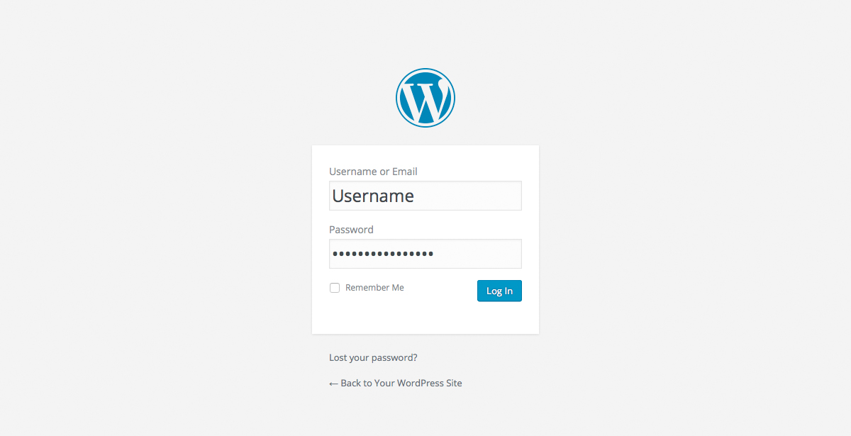
There are exceptions to this of course. For instance, your WordPress setup maybe installed in a subdirectory. For most standard setups though, you’ll find the above URL should work.
Starting from WordPress 4.5, you can login to your Dashboard using either your Username or your email address associated with your account.

Dashboard
Once you’ve logged in, the WordPress Dashboard appears. This is your main administration homepage. At the very top of your Dashboard (and across every page) you will see the name of your site in the header area. In the example screenshot below (and throughout this documentation) the site name is Your WordPress Site. This is also hyperlinked to your site's homepage. You will also see the name of the person who is currently logged in (e.g. Joe Blogg). Move your cursor over your name to reveal the Log Out link as well as a link to edit your Profile.
When new or updated features are introduced into WordPress, you’ll be shown a New Feature Pointer. This is simply to bring to your attention some feature within the Dashboard that’s been added or updated. In the following Dashboard image, the New Feature Pointer is highlighting the updated Toolbar. Click Dismiss to hide the pointer.
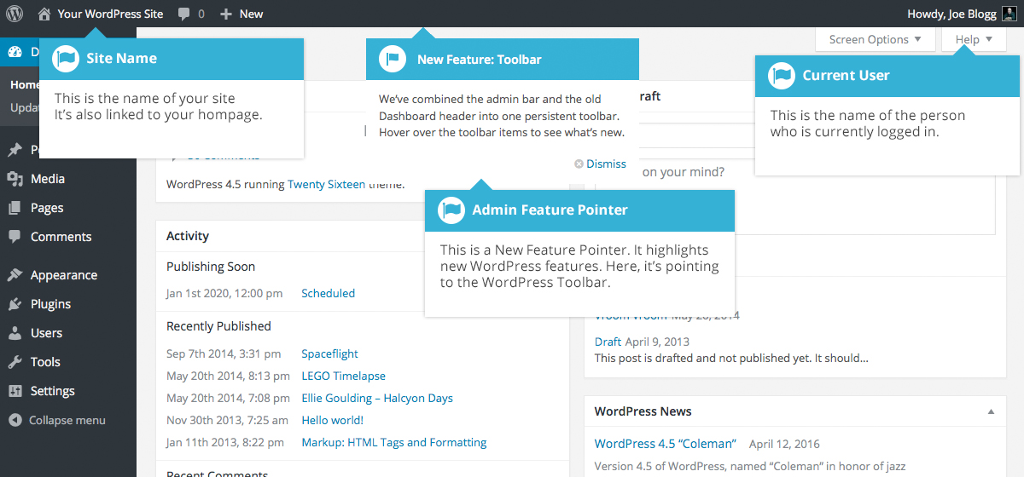
On most pages, just below your Username there are a couple of small inverted tabs. One called Screen Options and another called Help. Clicking either of these links will cause a panel to slide down from the top of the page. The Help link, not surprisingly, displays some help information. The Screen Options link will display various options that allow you to configure what is displayed on the current page. The details in this panel change depending on what page you’re currently viewing. As an example, on your main Dashboard page the Screen Options allow you to set which panels you’d like displayed on the page.

Dashboard Menu Options
Down the left-hand side of the Dashboard and on every page you will see your main navigation menu. This is where you’ll find all the options to update and configure your site.
Hovering your cursor over each of the main menu options will display a ‘fly-out’ menu with the various choices for that particular menu option. Once you click each of the main menu options, that particular menu will expand to show all the available options within that section (if there are any).
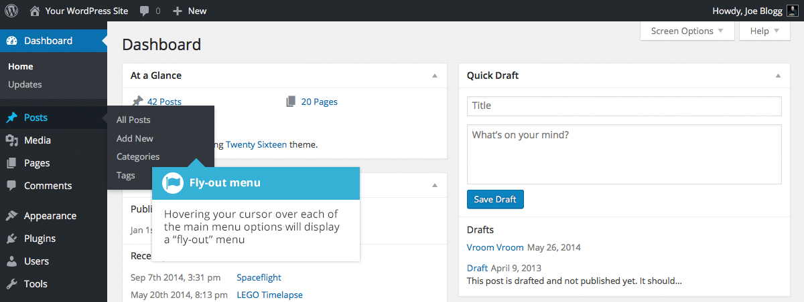
The main menu options and their usage are:

Dashboard
This will display your main Dashboard ‘homepage’. In the top left of your Dashboard you’ll see some brief stats on the number of Posts, Pages and Comments. If you have the Akismet anti-spam plugin activated, you’ll also see the number of Spam Comments or comments awaiting moderation.

Posts
This is where you can create a new Blog Post. You can also update your Categories and Post Tags.

Media
This is where all your uploaded images, documents or files are stored. You can browse through your Media library, as well as edit and update the files.

Pages
This is where you create and maintain all your Pages.

Comments
You can manage all your Comments within this section, including replying to comments or marking them as spam.

Appearance
This menu is where you control how your site looks. You can choose a new Theme, manage your site Widgets or Menus and even edit your site theme files.

Plugins
Plugins extend and expand the functionality of WordPress. You can add or delete plugins within here as well as activate or deactivate them.

Users
This screen lists all the existing users for your site. Depending on your Role, you can also add new users as well as manage their Roles.

Tools
This section gives you access to various convenient tools. You can also import data to your WordPress site or export all your WordPress data to a file.

Settings
This is where most of your site is configured. Among other things, it allows you to configure your site name and URL , where your Posts appear, whether people can leave Post Comments or not and numerous other settings. Most times, once your site is setup, there's no need to change any of the settings within this section.
At the bottom of the menu you'll see a link called Collapse menu. Clicking this will hide the menu and simply display their icons instead. Click the small arrow icon again to expand the menu.
Occasionally when you install a plugin, they will have their own configuration or setup pages. The location of these will be entirely dependent on the individual plugin but most times these pages will either appear within the Tools section, the Settings section or in a completely new menu section at the bottom of the menu.

Toolbar
The WordPress Toolbar is a way of easily accessing some of the most common WordPress features. When you are logged into your WordPress dashboard and you visit your website, you will see the Toolbar running across the top of your site. This bar only appears if you are currently logged into your WordPress site, which means that it won’t be visible to your everyday site visitors. If you are not logged in, the Toolbar won’t be displayed.
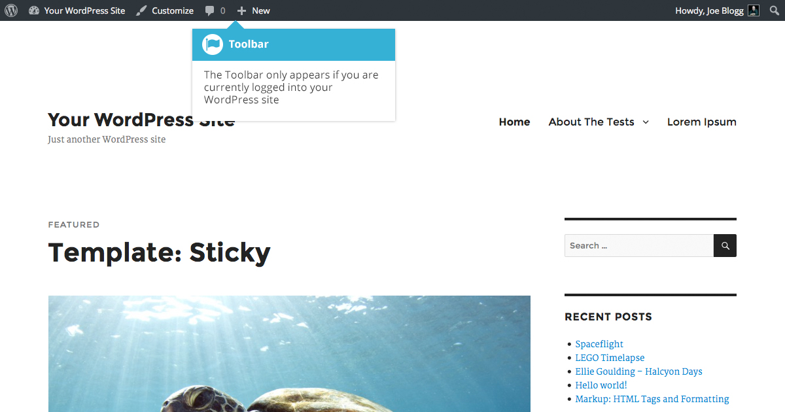
The Toolbar allows you to quickly access the following commonly used features.
- Visit the WordPress.org website, Codex or Support forums
- Display your site Dashboard and other commonly used menu options that allow you to update your site Themes, Widgets and Menus
- Visit the Customizer to update various site settings and depending on your theme, update your Background and Header images
- View or Edit your blog comments
- Add a new Post, Media, Page or User
- Perform a site Search
- View or Edit your Profile and logout from the WordPress Dashboard

Hiding the Toolbar
You can stop the Toolbar from displaying by modifying the preferences associated with your Profile. Simply click on the Users link in the left-hand navigation to display the list of Users. From this list of Users, click your user name or click on the Edit link that appears beneath the user name when hovering your cursor over each row. Alternatively, click on the Your Profile link underneath the Users menu option in the left-hand navigation or within the fly-out menu.
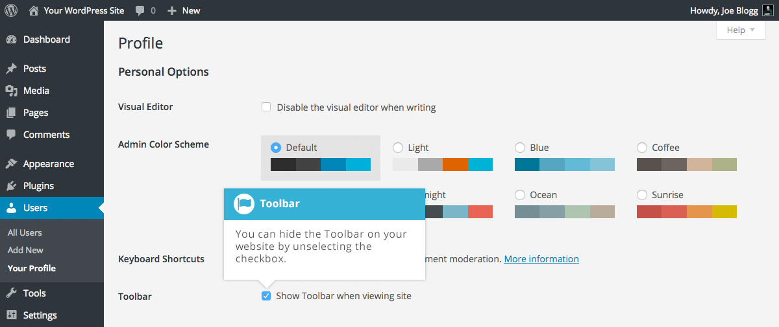
When editing your Profile there is a Toolbar option as shown in the screen above.
- Show Toolbar when viewing site – Checking this box will display the Toolbar at the very top of your website (only for the person who is currently logged in)

Posts versus Pages
WordPress is built around two basic concepts. Posts and Pages. Posts are typically blog entries. A series of articles, listed (usually) reverse-chronologically. Pages are used for more static content (i.e. content that doesn’t change or changes infrequently). An ‘About us’ page is an example of a Page on a typical website. In most cases you’ll find that the content in the ‘About us’ page doesn’t change all that frequently.
Now, you might be thinking, “but I don’t need a blog”. This might be true, but you can also use the blog concept if you have a site where you need to display your ‘latest news’ or even just company updates. Basically, any information that gets updated on a semi-regular basis can benefit from the ‘blog’ functionality. Whether that’s a traditional blog, your company’s ‘latest news’ or even just your own personal updates.

Posts
After clicking on the Posts menu option you'll be shown a list of Posts that your site contains. Among the information displayed is the Post title, the Author, Categories, Tags, No. of Comments and either the Date Published, Date Scheduled or the Date the Post was Last Modified. The Posts screen will look similar to the screen below.
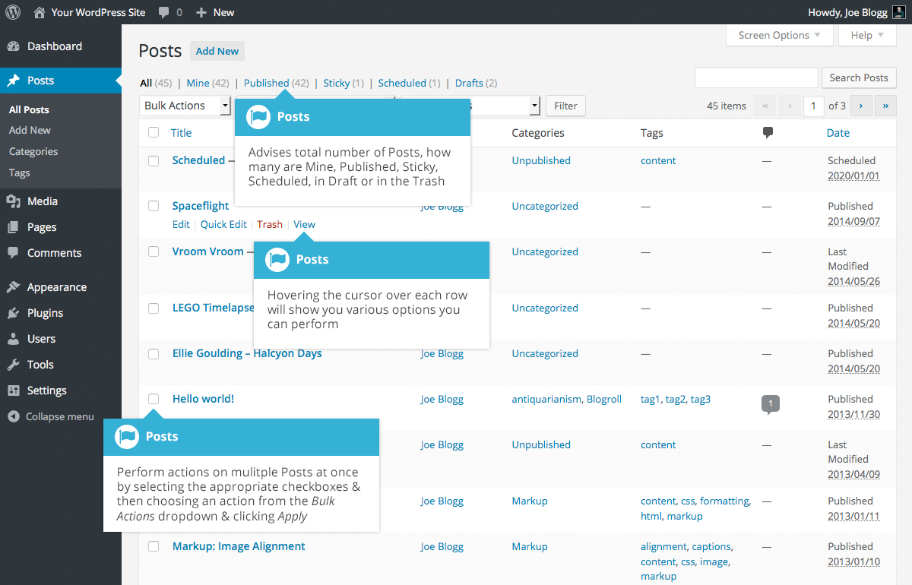
At the top of the page you can view how many Posts in total you have in your site, how many have been published by yourself orPublished, Scheduled, Sticky, Pending, in Draft or in the Trash.
When hovering your cursor over each row, a few links will appear beneath the Post title.
- Edit – Will allow you to edit your Post. This is the same as clicking on the Post title
- Quick Edit – Allows you to edit basic Post information such as Title, Slug, Date plus a few other options
- Trash – Will send the Post to the Trash. Once the Trash is emptied, the page is deleted
- View – Displays the Post. If the Post hasn’t been published yet, this will say Preview
Next to each Post title is a checkbox. This allows you to perform an action on multiple items at once. You simply check the Posts that you would like to affect and then from the Bulk Actions dropdown select either the Edit option or the Move to Trash option and then click the Apply button. The Edit option will allow you to edit the Categories, Tags, Author, whether to allow Comments and Pings or not, the Status and whether or not the Posts are ‘Sticky’. The Move to Trash option will move the selected items to the Trash.
You can also filter the pages that are displayed using the dropdown lists and the Filter button.
Clicking the Screen Options button at the top-right of the screen allows you to change how the Posts list is displayed. Click the List View option to display the posts in the traditional List View or click the Excerpt View option to display a short excerpt from the Post underneath the Post title. You can also hide various columns from view if you don’t want to see them. Clicking the Apply button will save your changes.

Pages
After clicking on the Pages menu option you'll be shown a list of Pages that your site contains. Among the information displayed is the Page title, the Author, No. of Comments and either the Date Published or the Date the Page was Last Modified. The Pages screen will look similar to screen below.
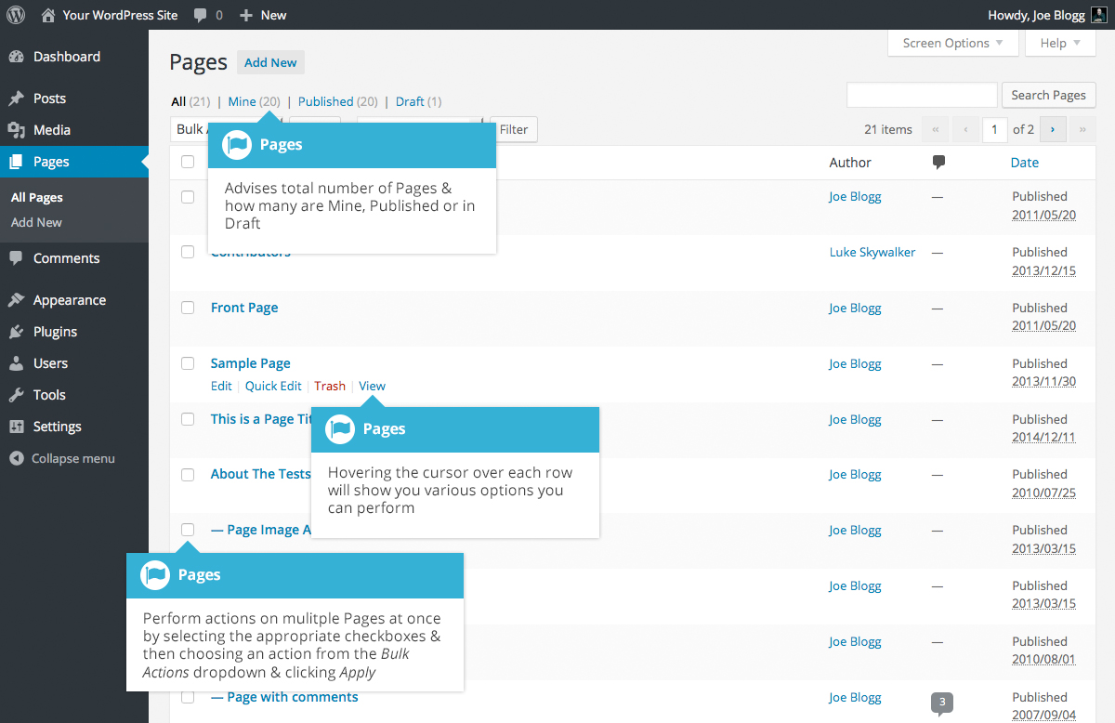
At the top of the page you can view how many Pages in total you have in your site, how many have been published by yourself or how many are Published or in Draft.
When hovering your cursor over each row, a few links will appear beneath the Page title.
- Edit – Will allow you to edit your Page. This is the same as clicking on the Page title
- Quick Edit – Allows you to edit basic Page information such as Title, Slug, Date plus a few other options
- Trash – Will send the Page to the Trash. Once the Trash is emptied, the page is deleted
- View – Displays the Page. If the Page hasn’t been published yet, this will say Preview
Next to each Page title is a checkbox. This allows you to perform an action on multiple items at once. You simply check the Pages that you would like to affect and then from the Bulk Actions dropdown select either the Edit option or the Move to Trash option and then click the Apply button. The Edit option will allow you to edit the Author, Parent, Template, whether to allow Comments or not and the Status of each of the checked items. The Move to Trash option will move the selected items to the Trash.
You can also filter the pages that are displayed using the dropdown list and the Filter button.

Adding your Site Content
Adding content to your site is an easy process no matter whether you’re creating a Post or a Page. The procedure for both is almost identical. Apart from how they display on your site, which was described earlier, the other main difference is that Posts allow you to associate Categories and Tags whereas Pages don’t. What’s the difference between categories and tags? Normally, Tags are ad-hoc keywords that identify important information in your Post (names, subjects, etc) that may or may not recur in other Posts, while Categories are pre-determined sections. If you think of your site like a book, the Categories are like the Table of Contents and the Tags are like the terms in the index.

Adding a New Page
To add a new Page, hover your cursor over the Pages menu option in the left-hand navigation menu and in the fly-out menu, click the Add New link. Alternatively, click the Pages menu option and then click the Add New link underneath, or the Add New button at the top of the page. You will be presented with a page similar to the image below.
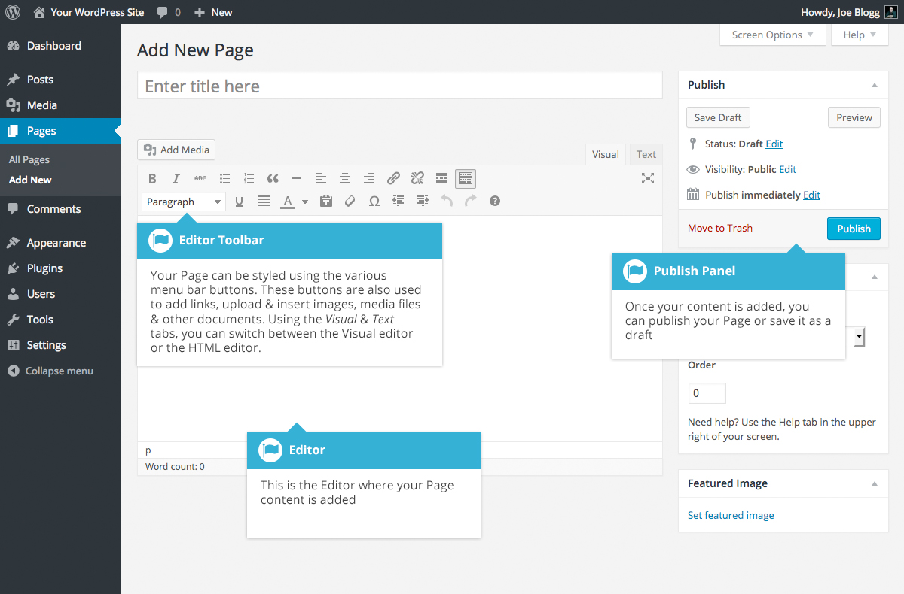

Adding a New Post
To add a new Post, hover over the Posts menu option in the left-hand navigation menu and in the fly-out menu, click the Add New link. Alternatively, click the Posts menu option and then click the Add New link underneath, or the Add New button at the top of the page. You will be presented with a page similar to the image below.
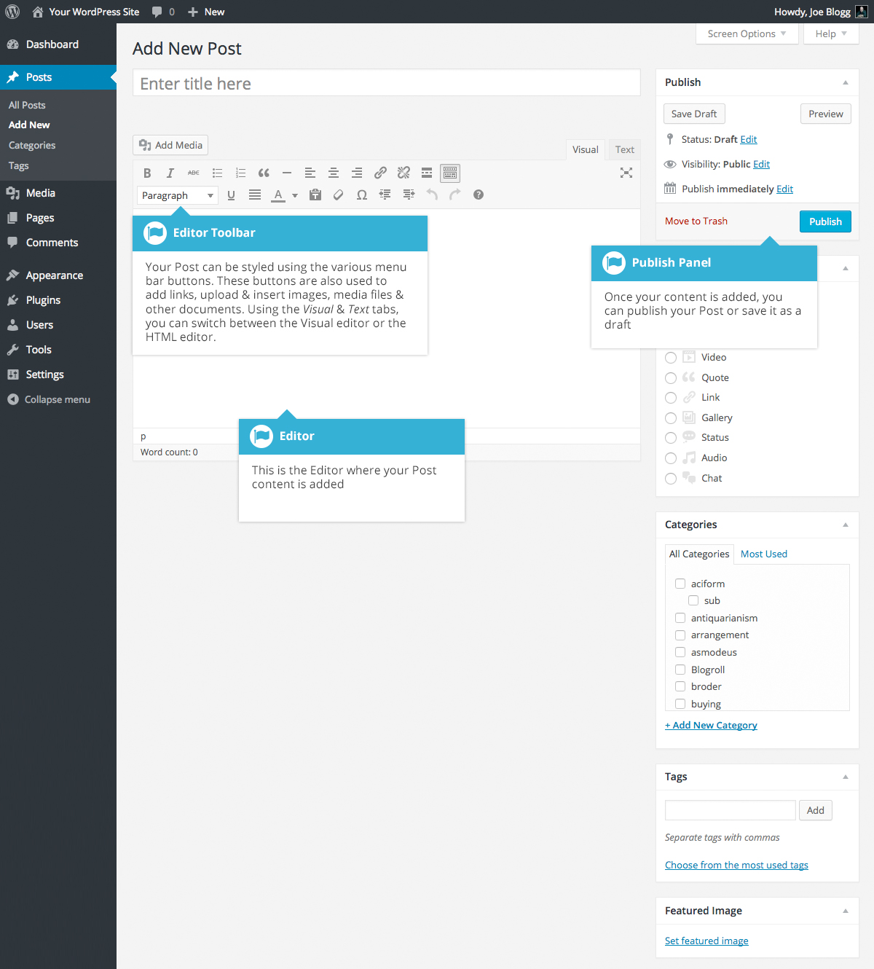

Adding Content with the Visual Editor
The editor used to enter content into your Page or Post is very easy to use. It’s much like using a regular word processor, with toolbar buttons that allow you to Bold () or Italicize () text or enter in Headings () or bullet points (). You can even use most of the basic keyboard shortcuts used in other text editors. For example: Shift+Enter inserts a line break, Ctrl+C/Cmd+C = copy, Ctrl+X/Cmd+X = cut, Ctrl+Z/Cmd+Z = undo, Ctrl+Y/Cmd+Y = redo, Ctrl+A/Cmd+A = select all, etc. (use the Ctrl key on a PC or the Command key on a Mac).
When adding content to your page, the Visual Editor expands to fit your content, rather than simply scrolling. On top of that, no matter how tall the Visual Editor becomes, the toolbar buttons will be available at all times by sticking to the top of the page.
By making use of special keyboard shortcuts, adding content is now even easier. When you want to add different size headings to your content, rather than having to select the heading size from the toolbar dropdown you can now start a line with two or more hashtags (#) and once you hit Enter to go to the next line, the Visual Editor will automatically convert your text to the appropriate heading. Like headings, you can also use * or - to create an unordered list, using 1. will start an ordered list, and > will create a blockquote.
The complete list of keyboard shortcuts available are as follows;
- * – Start an unordered list
- - – Start an unordered list
- 1. – Start an ordered list
- 1) – Start an unordered list
- ## – H2
- ### – H3
- #### – H4
- ##### – H5
- ###### – H6
- > – Add a blockquote
- --- – Add a horizontal line
- `..` – Convert text into code block (replace .. with your text)
At the top of the editor there are two tabs, Visual and Text (). These switch the editor view between the Visual Editor and the Text editor. The Text view will enable you to view the HTML code that makes up your content. For the more experienced users this can be helpful at times but for those not familiar with HTML tags, it’s not recommended.
When creating a new Page or Post, the first thing to do is enter in your title in the top entry field where it says Enter title here. After moving the cursor down to the editor a new Permalink is created for your page. Permalinks are the permanent URL’s to your individual Posts, Pages, Categories etc.. Though not usually necessary, you can manually edit your permalink by clicking on the actual permalink (the part after the domain name with the yellow background) or by clicking the Edit button next to it. Once you’ve modified it, click Ok to save or Cancel to cancel your changes.
At the top of the editor where your content is written, there are numerous formatting buttons. Clicking the Toolbar Toggle button () will show or hide a second line of formatting buttons which gives you extra functionality. The editor buttons perform the following functions:
Add Media – Used to upload and insert media such as images, audio, video or documents
Bold – Bold text
Italic – Italicise text
Strikethrough – Add a strikethrough to your text
Bulleted List – Create an unordered (bullet point) list
Numbered List – Create an Ordered (numbered) list
Blockquote – Used as a way of showing a quote. How this looks will be entirely dependent on the Theme that your site is currently using
Horizontal Line – Inserts a horizontal line into your page
Align Left – Align text to the left
Align Center – Align text in the center of the page
Align Right – Align text to the right
Insert/edit link – Used to create an html link to another page or website. If no text is selected first, the URL that you enter will also be used for the link text
Remove link – Remove the html link from the selected link. Your cursor must be sitting on an active link for the button to work
Insert Read More tag – Inserts the More tag into your Page. Most blogs only display a small excerpt of a Post and you’re required to click the Post title or a ‘Read more...’ link to continue reading the rest of the article. When you insert a ‘More’ tag into your Post, everything prior to the tag is considered as this excerpt. Most times you’d only use this button when you’re creating a blog Post, rather than a Page
Toolbar Toggle – Used to show or hide the second row of formatting buttons on the editor toolbar
Distraction Free Writing – Clicking this button will enlarge the editor so that it fills the browser window. Clicking the Exit fullscreen link at the top of the screen will reduce it back to its original size
Style – Used to format the Page text based on the styles used by the current Theme
Underline – Underline your text
Justify – Align text on both the left and right (i.e. justify)
Text color – Use to change the color of text
Paste as text – Copying and pasting text from other sites or word processors sometimes leaves the text formatted differently to what you were expecting. The reason for this is that quite often the html tags or codes that formatted the original text are pasted along with the text itself. To avoid this, Paste as Text will strip all these formatting and html tags. The Paste as Text option acts like a toggle, staying on until you turn it off by clicking the button again or until you save your page content
Clear formatting – Use this to remove all the formatting (e.g. Bold, Underline, text color etc..) from the highlighted text
Special character – Used to insert special characters not easily accessible via the keyboard (e.g. ¼, ½, ¾, ©, €, ö etc..)
Decrease indent – Removes one level of indenting
Increase indent – Indents text by one level
Undo – Undo your last action
Redo – Redo your last action
Keyboard shortcuts – Displays information about the WordPress Visual Editor along with keyboard shortcuts
Visual/Text – Switches the editor view between the Visual Editor and the Text editor. The Text view will enable you to view the HTML code that makes up your content. For the more experienced users this can be helpful at times but for those not familiar with HTML tags, it’s not recommended

Switching to the Text Editor
At the top of the editor there are two tabs, Visual and Text (). These switch the editor view between the Visual Editor and the Text editor. The Text view will enable you to view the HTML code that makes up your content. For the more experienced users this can be helpful at times but for those not familiar with HTML tags, it’s not recommended.
The Text editor is much like the Visual Editor, only not as intuitive. The numerous formatting buttons provide you with basic HTML formatting capabilities when editing your Page or Post content.
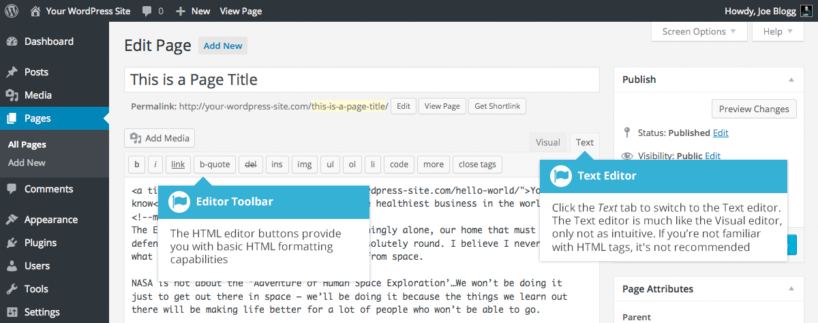
The buttons work in two ways. Clicking a button without highlighting any text first, will simply insert the opening HTML tag relevant for that button. As an example, clicking the Bold button will insert the <strong> HTML tag into your text. Clicking the Bold button again will close the tag by inserting the closing </strong> tag. If you highlight some text prior to clicking a button, both the opening and closing tags will be inserted around that highlighted text. For example, highlighting the text, ‘bold text’, prior to clicking the Bold button will insert ‘<strong>bold text</strong>’.
The following editor buttons are available whilst in the Text editor:
Bold – Bold text
Italic – Italicise text
Link – Used to insert a website link. When the button is clicked a pop-up window will appear where you type in the URL that you would like to link to
Blockquote – Used as a way of showing a quote. How this looks will be entirely dependent on the Theme that your site is currently using
Delete – Used as a way of showing deleted text. How this looks will be dependent on the Theme but is usually done by showing the text with a strikethrough
Insert – Used as a way of showing inserted text. How this looks will be dependent on the Theme but is usually done by showing the text with an underline
Image – Used to insert an image into the text. When the button is clicked a pop-up window will appear where you type in the URL of the image that you would like inserted
Unordered List – Used to insert an unordered (bullet point) list
Ordered List – Used to insert an ordered (numbered) list
List Item – Used to insert a list item into your ordered or un-ordered list
Code –Used for indicating a piece of code
More – Inserts the More tag into your Page. Most blogs only display a small excerpt of a Post and you’re required to click the Post title or a ‘Read more...’ link to continue reading the rest of the article. When you insert a ‘More’ tag into your Post, everything prior to the tag is considered as this excerpt. Most times you’d only use this button when you’re creating a blog Post, rather than a Page
Close Tags – Used to close open tags. If for example, you clicked both the Bold and Italic buttons to insert their opening tags, clicking the Close tags button will insert both of the matching closing tags, in the correct order
Distraction Free Writing – Clicking this button will enlarge the editor so that it fills the browser window. Clicking the Exit fullscreen link at the top of the screen will reduce it back to its original size

Changing your Post Format
A Post Format is meta information that can be used within a Theme to style or customise the presentation of a Post. The Post Formats feature provides a standardised list of formats that are available to all themes that support the feature. There is no requirement for Themes to support every format on the list and new formats cannot be introduced by themes or even plugins. If your Theme supports Post Formats you can choose how each Post looks by selecting a Post Format from a list of radio buttons, similar to the following screen. If your Theme doesn’t support Post Formats then the Format panel won’t be displayed.
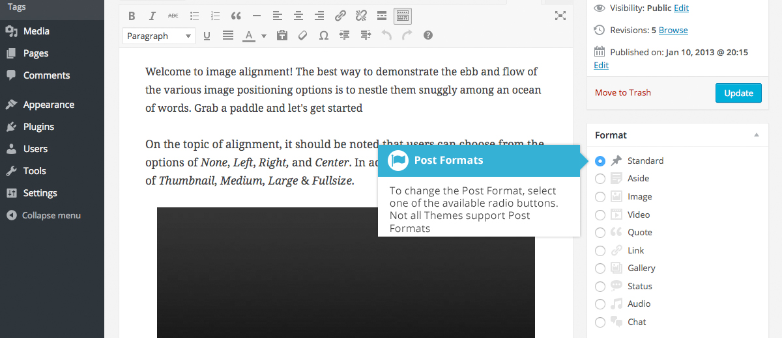
While the actual post content entry won't change, the theme can use the selected Format to display the post differently. How content is displayed is entirely up to the Theme, but the following list of available Post Formats provides some general WordPress guidelines as to how they might be styled.
- Aside – Typically styled without a title. Similar to a Facebook note update
- Audio – An audio file, such as a Podcast
- Chat – A chat transcript
- Gallery – A gallery of images. Post will likely contain a gallery shortcode and will have image attachments
- Image – A single image
- Link – A link to another site
- Quote – A quotation, most likely contained within a blockquote
- Status – A short status update, similar to a Twitter status update
- Video – A single video

Reviewing Past Revisions
When you’re editing your Post or Page, the number of revisions for that particular Post or Page is shown in the Publish Panel, if you have any.
Click the Browse link next to Revisions: in the Publish panel to browse through the various revisions for the current Post or Page.
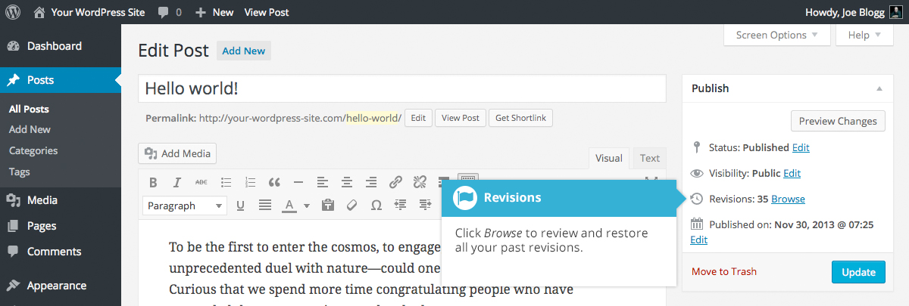
Use the slider at the top of the page or click the Previous and Next buttons to navigate through your various Post or Page revisions.
Content that has been deleted will be shaded red and content that has been added will be shaded green. If there is content that is shaded dark red and/or dark green, it’s highlighting specific content that was removed or added. If the paragraph or line is simply light red and/or light green, then the whole paragraph or line was affected by the change.
You can also compare two different revisions by clicking the Compare any two revisions checkbox at the top of the page.
If you’d like to restore a previous revision, click the Restore This Revision button.
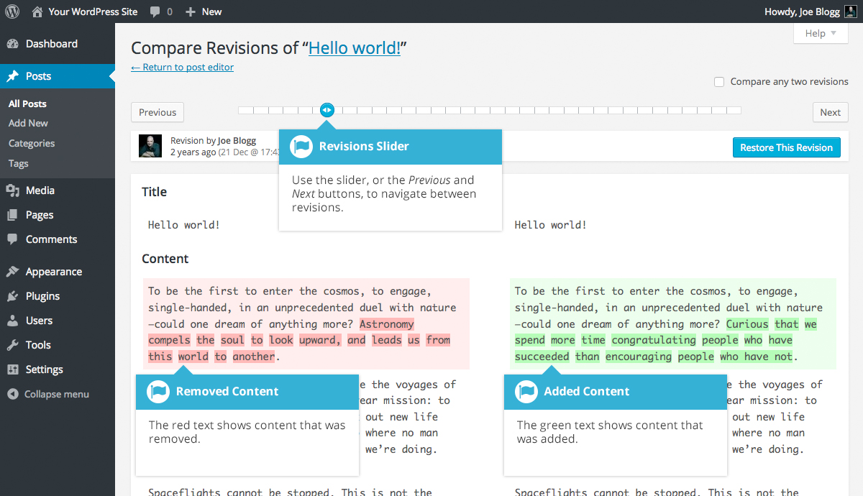

Adding Images and Other Media
Adding images and other media files such as videos, documents or PDFs is extremely easy within WordPress. All your images and files are stored in the Media Library. Once they’re uploaded into the Media Library, it’s a very simple matter to insert them into your Page or Post content. In the case of files such as Word Documents or PDFs, if necessary, it’s a simple process to create links to those files so that people can then download them.

Inserting an Image
Using the WordPress media manager, it’s extremely simple to insert, align and link your individual images and image galleries.
To insert an image into your Page/Post, click the Add Media button () and then simply drag your image(s) from wherever they are on your computer, into the browser window. Your file(s) will be automatically uploaded.
Alternatively, click the Select Files button and then select the file(s) that you’d like to upload, using the dialog window that is displayed.
It’s also possible to simply drag your image straight into the Visual Editor, rather than clicking the Add Media button.
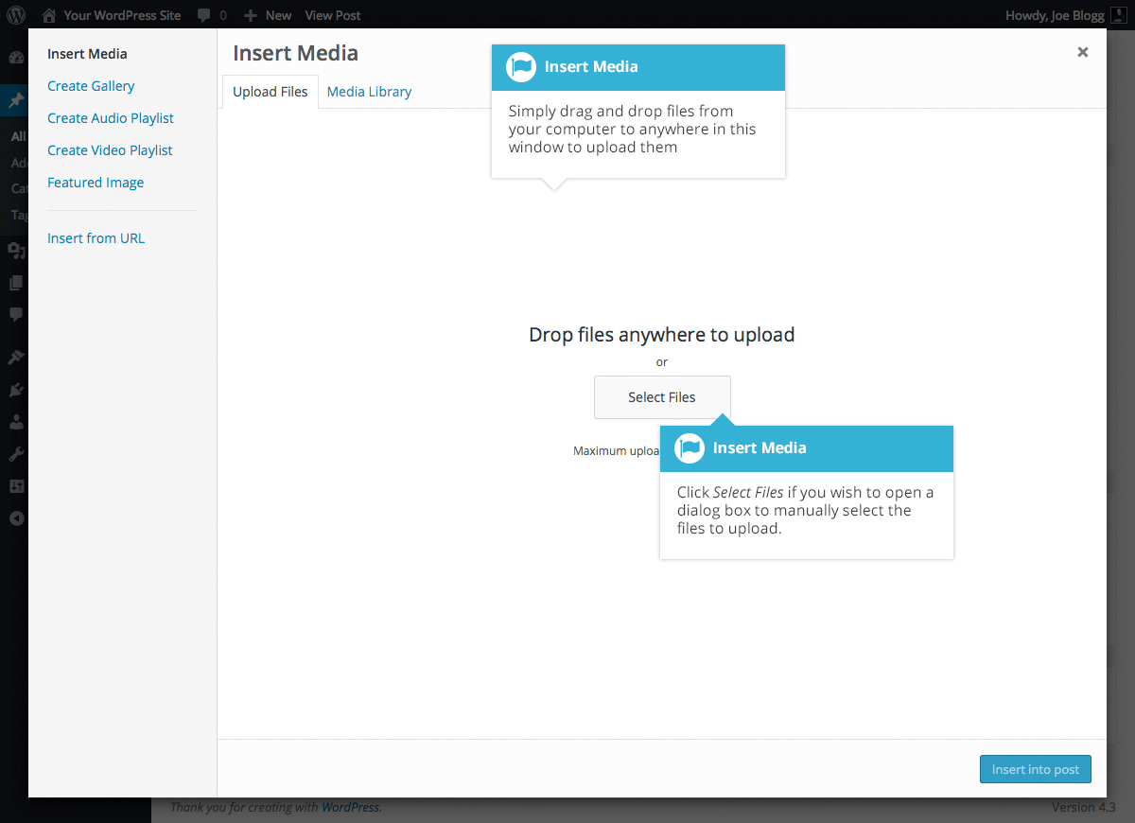
No matter whether you’ve clicked the Add Media button or simply dragged and dropped your image into the Visual Editor, once your image is uploaded, your Media Library is displayed, which contains all your previously uploaded images. The image(s) that you’ve just uploaded will be automatically ‘selected’ for easy insertion into your Page or Post. Selected images are shown with a ‘tick’ icon in the top right corner of the image.
After uploading your image(s), you can then select other previously uploaded images by holding down the Ctrl key (Cmd key on Macs) and simply clicking on them. To deselect an image, click the ‘tick’ in the top right corner of the image.
At the bottom of the window you will see a count of the number of images currently selected.
There are several options within this Insert Media window to help make it easier to add images into your Page or Post.
By default, all previously uploaded images are shown, starting with the most recent uploads. If you’d like to narrow this list down, at the top of the window is a dropdown list that allows you to filter your displayed images by All media items, items Uploaded to this post/page, or Images, Audio files, Video files or Unattached files. You can also filter your media files by selecting a date, or alternatively, there is also a Search field that allows you to search for specific images.
The properties of the currently highlighted image (i.e. The image with the blue border) will be shown on the right-hand side of the Insert Media window. These properties include the filename, the date the file was uploaded and the image size. It’s at this point you can also change the image Title, Caption, Alt Text and Description for each image, as well as the Alignment, Link and the Size at which the image is inserted.
- Title – is displayed as a tooltip when the mouse cursor hovers over the image in the browser
- Caption – is displayed underneath the image as a short description. How this displays will be dependent on the WordPress theme in use at the time. You can also include basic HTML in your captions
- Alt Text – is displayed when the browser can’t render the image. It’s also used by screen readers for visually impaired users so it’s important to fill out this field with a description of the image. To a small degree, it also plays a part in your website Search Engine Optimisation (SEO). Since search engines can’t ‘read’ images they rely on the Alt Text
- Description – is usually displayed on the attachment page for the media, however this is entirely up to the theme that is currently in use
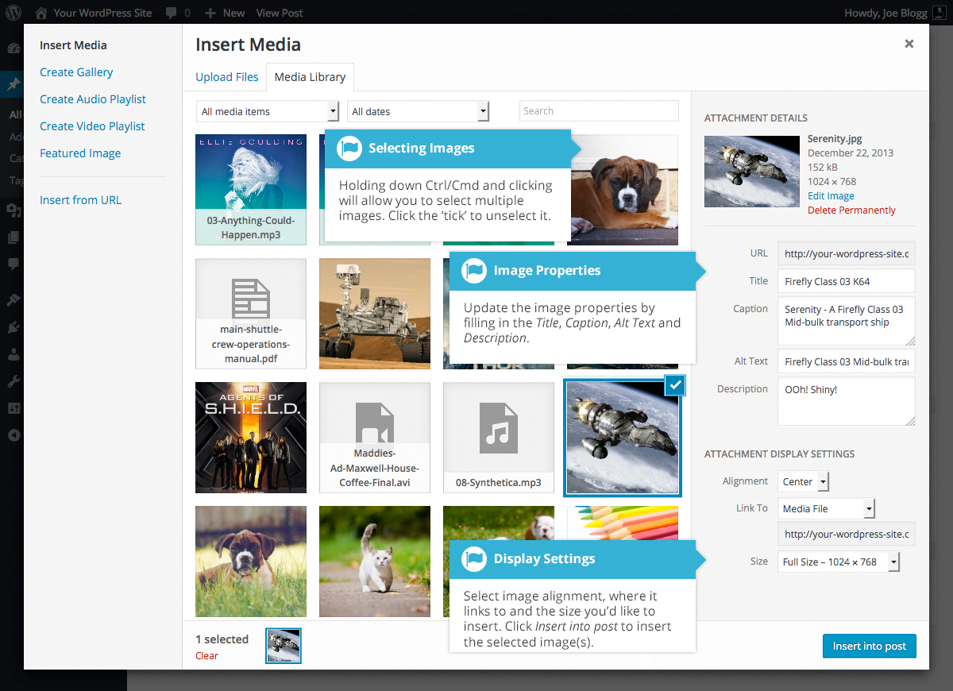
For each image, you can select how you would like the image aligned, either Left, Center or Right aligned, using the Alignment dropdown list. You can also select None for no alignment which will mean the image will display using the default alignment setting for your Theme.
You can also change what your inserted image(s) will link to using the Link To dropdown list. You have the choice of linking to the image’s attachment page by selecting Attachment Page, or you can link to the full size image by selecting Media File. You can also link to any URL by selecting Custom URL. When you do this, a new field will appear that allows you to enter in the custom URL. You can also choose not to link to anything by selecting None.
When your image(s) are uploaded, WordPress will also create several copies of your file at various sizes. You can choose which one you’d like to insert into your Page or Post using the Size dropdown list. To insert the image at the exact size you uploaded, simply select Full Size. Next to each size listed in this dropdown will be the actual dimensions of the image, in pixels (e.g. 300 x 225).
Once you’ve selected all your images, click the Insert into post button to insert the selected image(s) into your Post at the current cursor position (when editing a Page, this button will say Insert into page).
If you’d like to change the order of your images, click the Edit Selection link at the bottom of the Insert Media window. The window will change so that only the selected images are shown. Alternatively, clicking the Clear link will deselect all images.
After clicking the Edit Selection link at the bottom of the Insert Media window, all the currently selected images are shown. You can change the order in which the images will appear in your Page or Post by clicking and dragging each image to reorder them. You can also update the image Title, Caption, Alt Text and Description for each image. To remove one of your selected images, click the small ‘-’ that appears in the top right corner of the image when you hover your cursor over the tick.
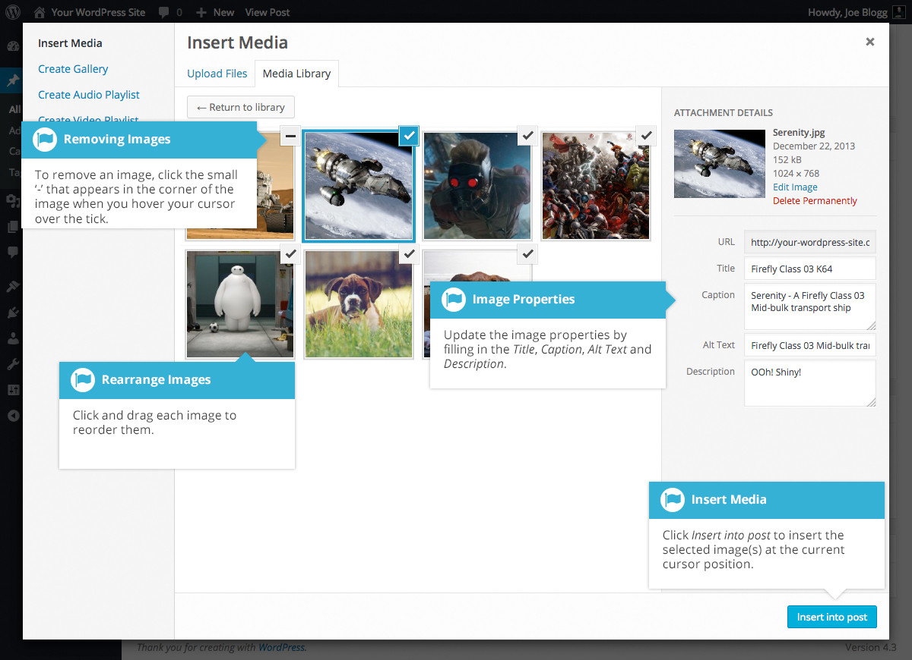
Clicking the Return to library button will take you back to the previous screen that allows you to select or deselect your images.
When you’re editing your Post/Page, if you wish to insert an image that you uploaded earlier (as opposed to uploading a new image), click the Add Media button again (). Once the pop-up window displays, click the Media Library tab at the top of the pop-up window rather than dragging a new file into the upload window. All your previously uploaded images will be displayed, with the most recent ones shown first.
Select the image(s) that you’d like to insert into your Page or Post and then simply click the Insert into post button (or if you’re editing a Page, this button will say Insert into page). As mentioned earlier, you can also click the Edit Selection link at the bottom of the window if you’d like to change the order the images are inserted.

Edit or Delete an Image
There are various options available for adjusting the layout of inserted images.
After clicking on an image that has already been inserted into your Page or Post, a small toolbar will appear over the image. By selecting one of the alignment buttons () you can change the alignment of the inserted image. Clicking the Edit button () allows you to edit the image properties. Clicking the Remove button () will remove the image from your content. It will only remove the image from your Page or Post, it will not delete the image from your Media Library.
When you click on an image in your Page or Post, as well as the alignment, edit and delete icons mentioned above, the image also displays ‘resizing handles’. These are the small squares you see around the edge of the image. To resize your image, simply click and drag one of the corner resize handles.
As with any image editing software though, if you try to enlarge a small image, it will tend to get quite pixelated. It’s always best to insert a large image and then resize down.
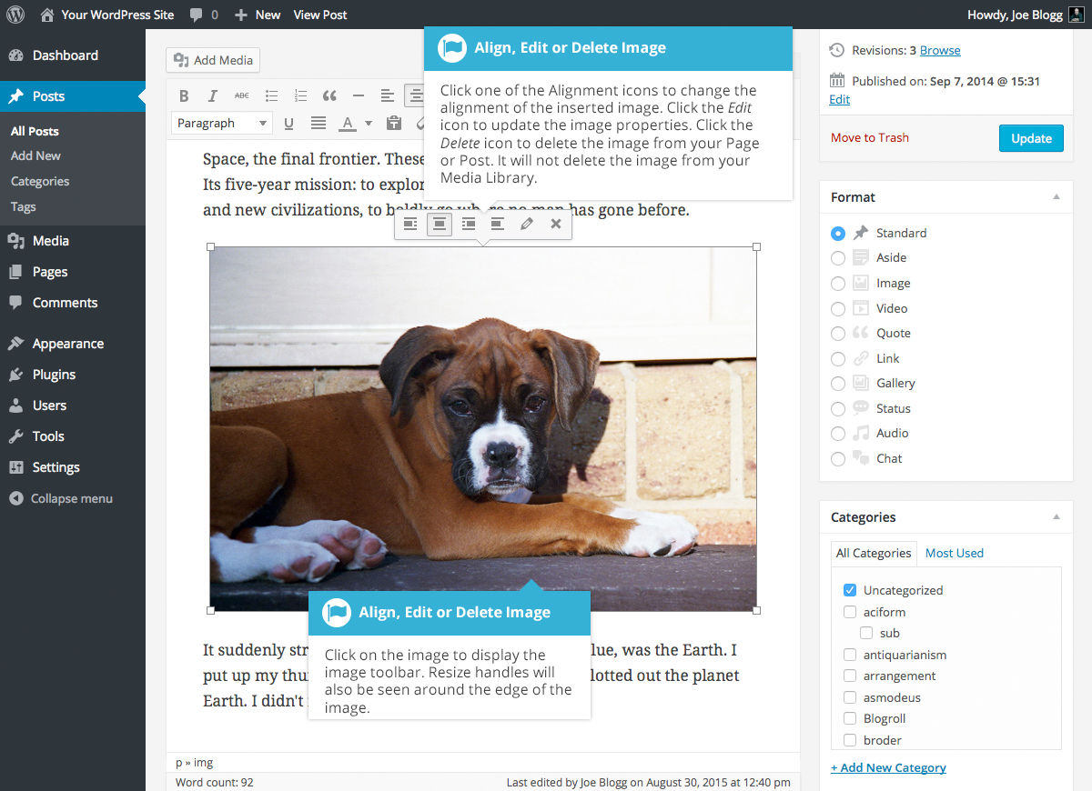
After clicking the Edit button () the following pop-up window will appear.
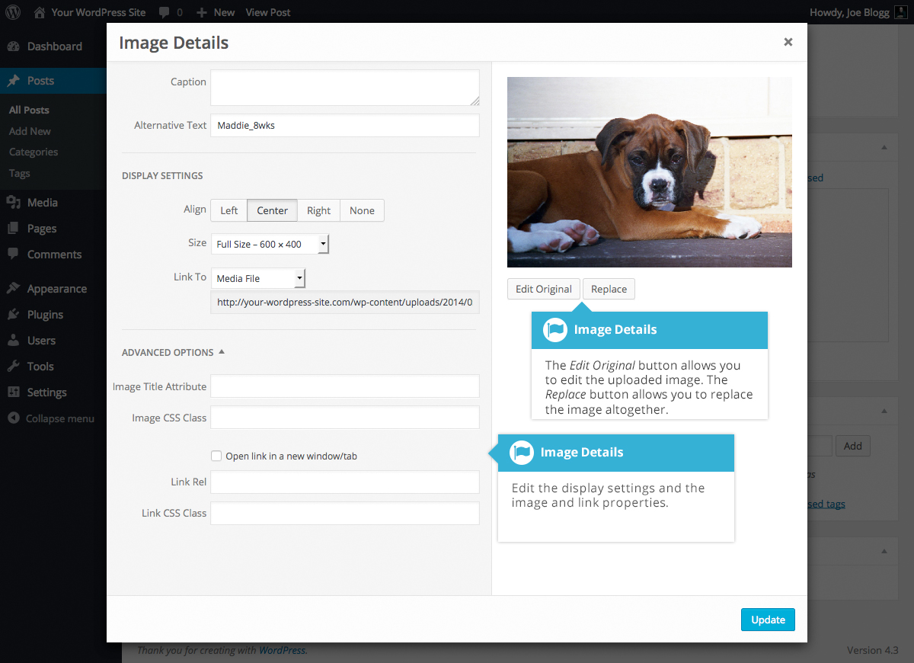
The Image Details pop-up window allows you to edit the various image and link properties:
- Caption – Displayed underneath the image as a short description. How this displays will be dependent on the WordPress theme in use at the time. You can also include basic HTML in your captions
- Alternative Text – Displayed when the browser can’t render the image. It’s also used by screen readers for visually impaired users so it’s important to fill out this field with a description of the image. To a small degree, it also plays a part in your website Search Engine Optimisation (SEO). Since search engines can’t ‘read’ images they rely on the Alt Text
- Align – Allows you to select how you would like the image aligned. They can be either Left, Centered or Right aligned. Setting alignment to None will remove the other alignment settings. How this affects your image within your content will depend on the current theme in use
- Size – Select a specific size from the dropdown list or select ‘Custom Size’ and then enter the Width and Height (in pixels) in the input fields that appear
- Link To – Select where you would like to link your image to from the dropdown list. You have the choice of linking to the image attachment page by selecting Attachment Page, or you can link to the full size image by selecting Media File. You can also link to any URL by selecting Custom URL. When you do this, a new field will appear that allows you to enter in the custom URL. You can also choose not to link to anything by selecting None
- Image Title Attribute – Displayed as a tooltip when the mouse cursor hovers over the image in the browser
- Image CSS Class – By default, WordPress will assign several CSS Classes to your image. If, for some reason, there’s other CSS Classes that you’d like to assign to your image then you can add them into this input field
- Link Rel – Describes the relationship from the current document to the specified link. More information on the rel HTML attribute can be found on Wikipedia
- Link CSS Class – If there is a specific CSS Class that needs to be set on the HTML link then you can add it into this input field
Clicking the Edit Original button allows you to perform some simple manipulation with your uploaded image. You’re able to rotate and flip your image as well as scale and crop it to different sizes.
If you’d like to replace the image entirely, click the Replace button and you’ll be shown your Media Library where you can select a new image.
Once you have updated the image properties, click the Update button to save your changes. Alternatively, click the small ‘x’ in the top-right of the pop-up window to close the pop-up without saving any changes.

Setting a Featured Image
Some themes allow you to specify a Featured Image for your Page and Post. A Featured Image, often called a Post/Page Thumbnail, is usually some sort of image that is representative for that particular Page or Post. How these images are displayed is dependent entirely on the Theme that is currently in use.
If your Theme allows you to set a Featured Image, the following Featured Image panel will be displayed when you’re editing your Page or Post. If Featured Images can’t be set then this panel won’t be displayed.
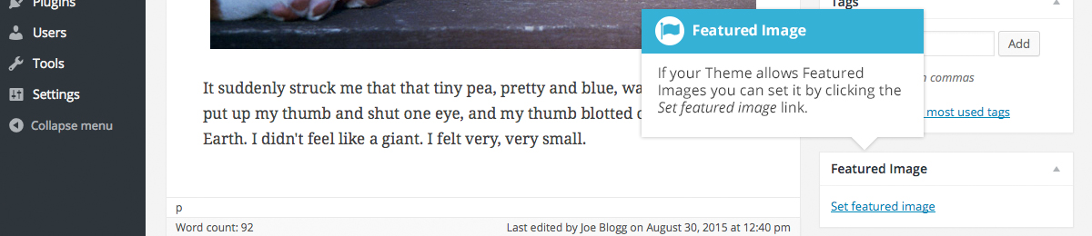
Setting your featured image is very similar to adding an image into your Page or Post. After clicking the Set featured image link a pop-up window will display that looks similar to the one that displays when you add an image to your Page/Post. You can upload a new image to use as your Featured Image or you can simply choose from one of your previously uploaded images.
By default, you’ll be shown a list of the previously uploaded images. If you’d like to upload a new image, click on the Upload Files link at the top of the pop-up window. After clicking the image you’d like to use as your featured image you can then update the Title, Caption, Alt Text and Description. To set the image as your Featured Image, click the Set featured image button. Your chosen image will then appear in the Featured Image panel.
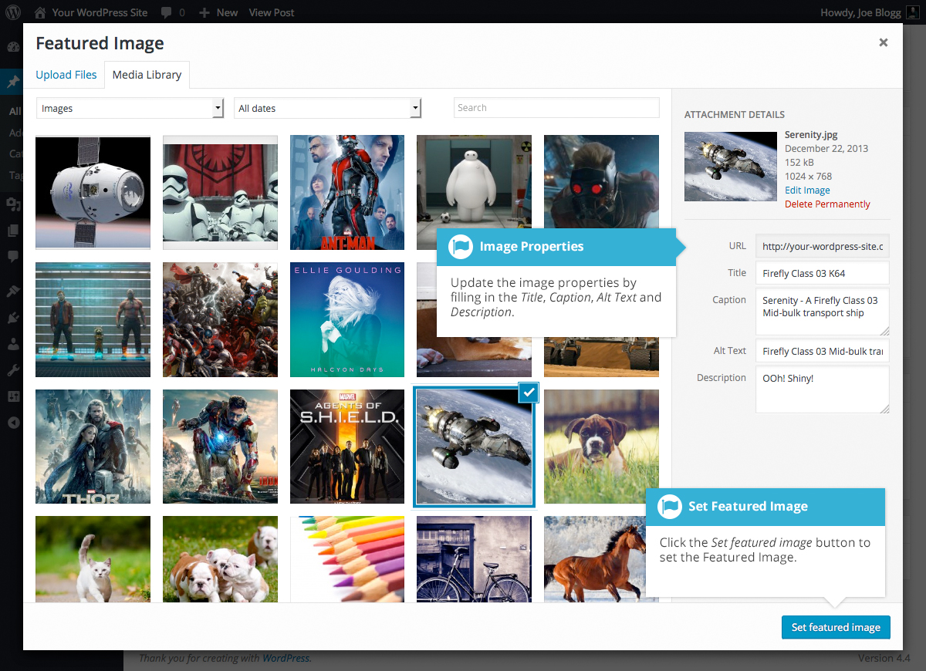

Insert an Image Gallery
WordPress has its own simple built-in Image Gallery that allows you to add multiple images to a page in one easy step.
To insert an image gallery into your Page/Post, click the Add Media button (). A pop-up window will display that looks the same as the one that displays when you add an image to your Page/Post. You can upload new images to use in your gallery or you can simply choose from your previously uploaded images.
By default, you’ll be shown a list of your previously uploaded images. If you’d like to upload a new image, click on the Upload Files link at the top of the pop-up window.
Click the Create Gallery link in the left-hand navigation then select the images that you’d like to insert into your gallery.
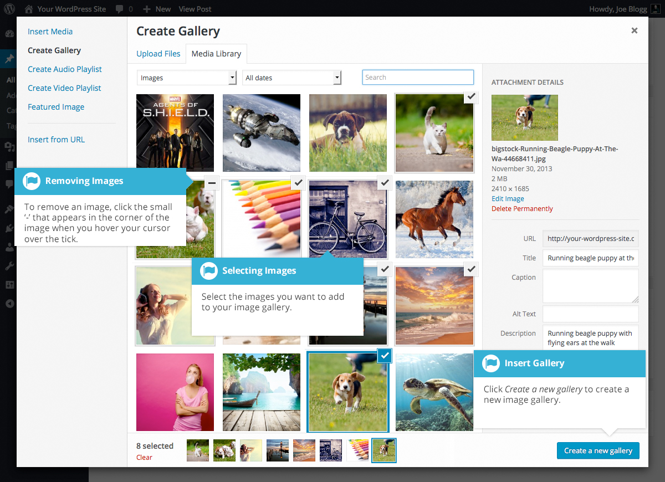
After selecting your images, click the Create a new gallery button at the bottom of the pop-up window. The window will change so that only the selected images are shown.
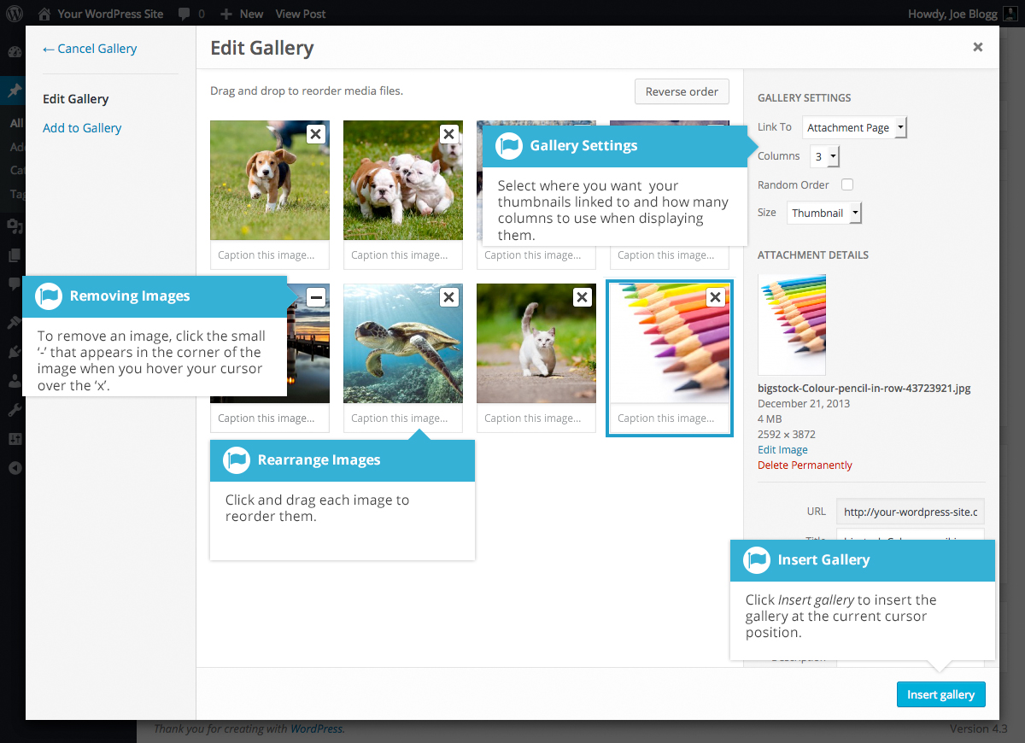
All the images that appear will be used within your Image Gallery. To reorder the images simply click on an image and drag it to its new position. If you’d like to add captions to your images, click the ‘Caption this image..’. text below each image and then type in your caption. Alternatively, click each image and then update the Title, Caption, Alt Text and Description on the right-hand side of the pop-up window. You can also include basic HTML, such as links, in your captions.
If you decide you no longer want a certain image to appear in your gallery, click the small ‘-’ that appears in the top right corner of the image when you hover your cursor over the ‘x’.
Since the built-in gallery is quite simple, there aren’t that many options to choose from when setting it up.
- Link to – This sets what happens when the thumbnail image is clicked. Selecting Media File will open the full size image directly in your browser window. Selecting Attachment Page will open the image within one of your WordPress formatted pages
- Columns – Specifies the number of columns to use when displaying your thumbnail images. Ultimately, this will be dependent on your Theme and how wide your page is. If you find the gallery isn’t displaying properly after changing this number you may need to change it to another number
- Random Order – Click this checkbox to display your images in a random order
- Size – Selects the size of the image to use in your gallery

Edit or Delete an Image Gallery
Editing or Deleting an Image Gallery is much like editing or deleting an image. After clicking on an Image Gallery that has been inserted into your Page or Post, two icons will appear on top of the gallery. Clicking the Edit button () allows you to edit the image gallery properties. Clicking the Remove button () will delete the image gallery from your content. It will only remove the image gallery from your Page or Post, it will not delete any images from your Media Library.
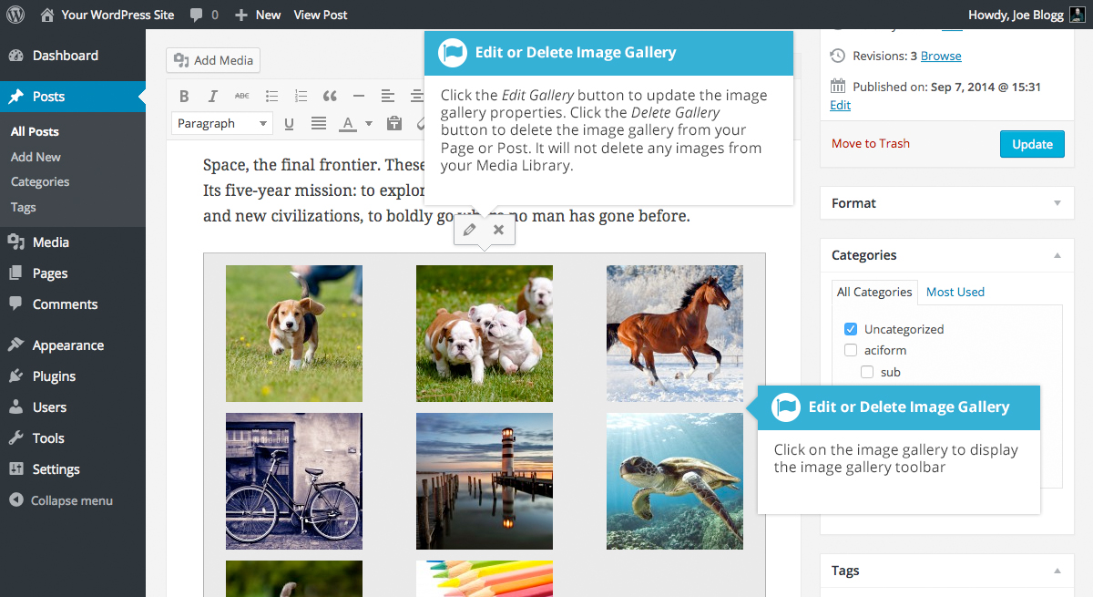
After clicking the Edit icon you will be shown the same pop-up window and options as when your image gallery was inserted into your Page/Post.

Insert an Audio or Video Playlist
Inserting an audio or video playlist is almost identical to inserting an image gallery. Click the Add Media button (). A pop-up window will display that looks the same as the one that displays when you add an image to your Page/Post. You can upload new media files to use in your playlist or you can simply choose from your previously uploaded files.
By default, you’ll be shown a list of your previously uploaded files. If you’d like to upload a new media file, click on the Upload Files link at the top of the pop-up window.
To create an audio playlist, click the Create Audio Playlist link in the left-hand navigation. The pop-up window will display a list of your audio files.
Alternatively, to create a video playlist, click the Create Video Playlist link in the left-hand navigation. The pop-up window will display a list of your video files.
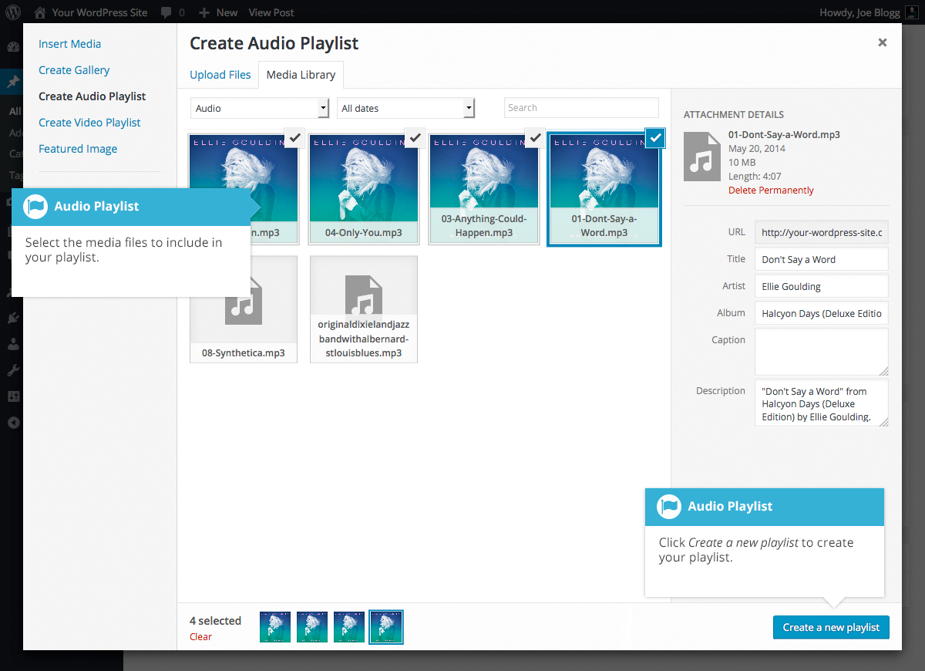
After selecting your media files, click the Create a new playlist button at the bottom of the pop-up window. The window will change so that only the selected media files are shown.
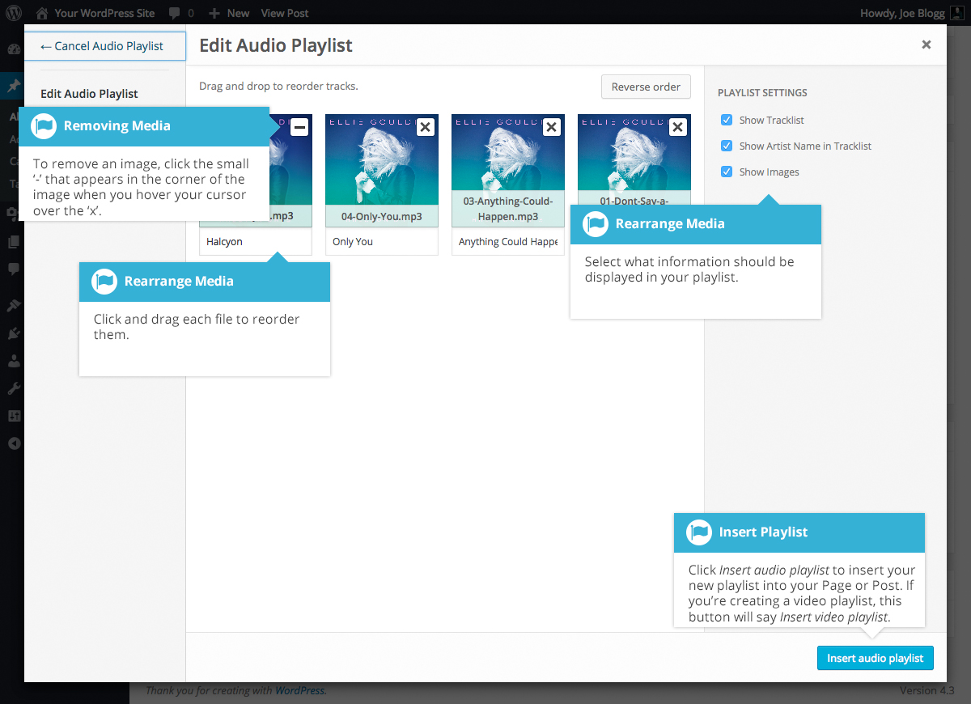
All the media files that appear will be used within your playlist. To reorder the files simply click on a file and drag it to its new position. You can change the title for each file by clicking the text below each file and then typing in your new title. Alternatively, click each file and then update the Title, Caption and Description on the right-hand side of the pop-up window.
If you decide you no longer want a certain media file to appear in your playlist, click the small ‘x’ that appears in the top right corner of the file when you hover your cursor over it.
You can change how your playlist appears in your page by selecting which items you’d like to appear.
When inserting an audio playlist you have the following display settings.
- Show Tracklist – Ticking this checkbox will show a list of all the audio files within your playlist
- Show Artist Name in Tracklist – Ticking this checkbox will show the artists name next to each track name
- Show Images – Ticking this checkbox will show any associated audio file images
When inserting a video playlist you have the following display settings.
- Show Video List – Ticking this checkbox will show a list of all the video files within your playlist
- Show Images – Ticking this checkbox will show any associated video file images

Inserting Video, Audio or Other File Type
The procedure for inserting any other type of file into your Page/Post is exactly the same as Inserting an Image. Simply click the Add Media button (). Once the relevant pop-up window displays, perform the same steps to upload your file to your site and to insert it into your Page or Post.
When inserting video or audio files, you can select Embed Media Player from the Embed or Link dropdown list in the Insert Media pop-up window to use the new audio and video players that are now built into WordPress. Supported audio/video formats include M4a, MP4, OGG, WebM, FLV, WMV, MP3, WAV and WMA files.

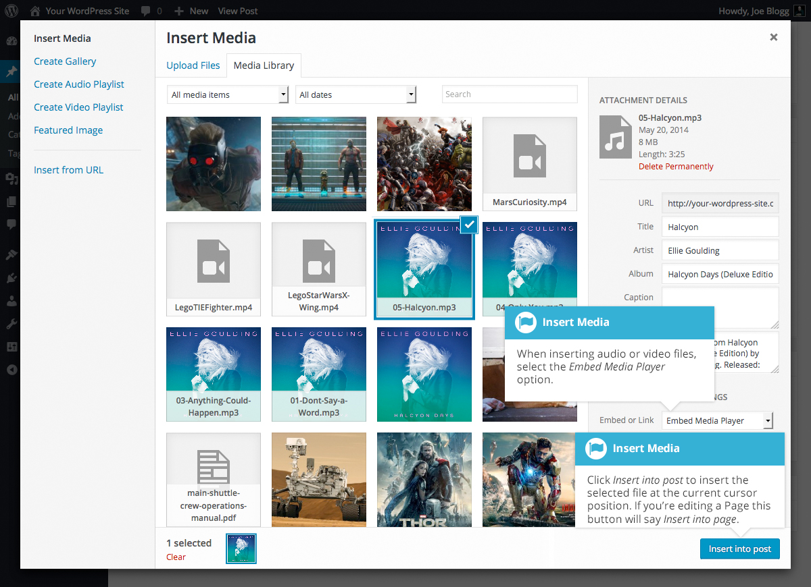

It’s recommended that you make your filename ‘server friendly’. Make sure the filename has no spaces, apostrophes, slashes or other non-alphanumeric characters (such as $, % and &). Rename the file before uploading if it does. To preserve readability, some people replace spaces with the underline character or hyphen. For instance, My File Name.txt becomes My_File_Name.txt or My-File-Name.txt

Embedding a Video, Image or Other Content
Another way to add video or other content into your pages is through embedding. A popular example of this is embedding a YouTube video into your page.
When you’re embedding a file, there’s no need to upload the file to your site. You’re basically just creating a link to the file, from within your own page. WordPress is able to automatically embed files from a number of different services.
To embed something into your Post or Page, simply paste the URL into your content area. The URL needs to be on its own line and not hyperlinked.
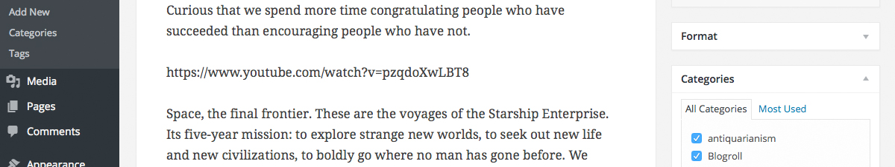
When embedding content in this manner (as opposed to using the embed shortcode mentioned below), your url will change to show a preview of that content. For example, when embedding a video from YouTube, after pasting in the URL to the editor, it will magically change to show the actual video content, right there in the editor.
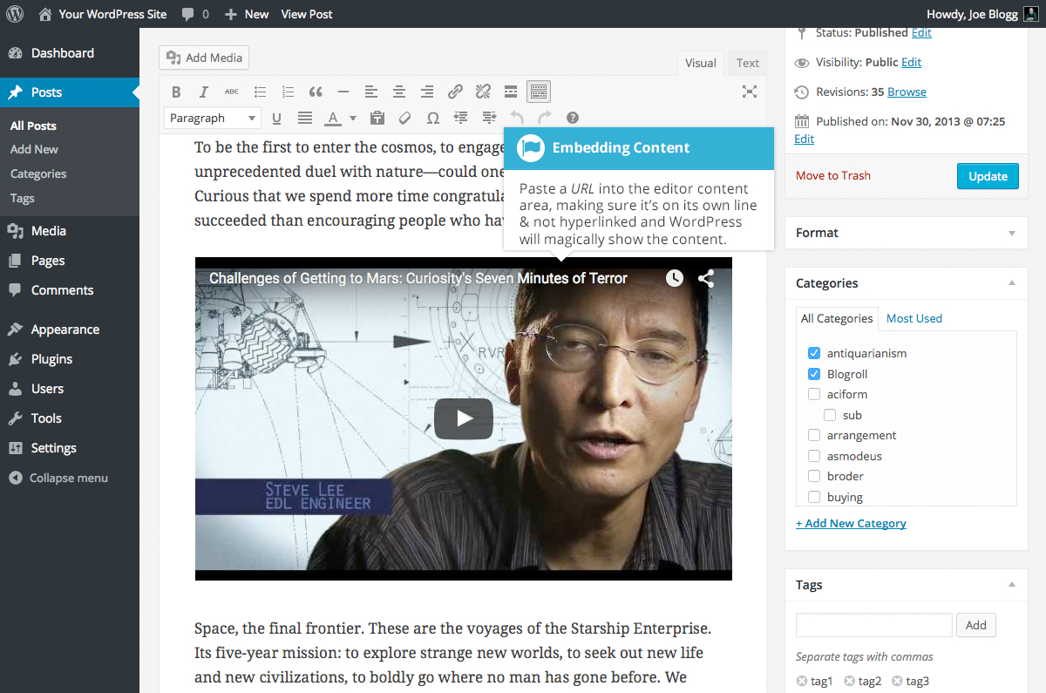
If you’d like to specify the width and height, you can wrap the URL in the [embed] shortcode. Embedding your link using this shortcode does not require the URL to be on its own line. The format for using the shortcode is:
[embed width= “123” height= “456”] url [/embed]
WordPress will automatically embed content from the following sites:
- Animoto
- blip.tv
- Cloudup
- CollegeHumor
- DailyMotion
- Flickr
- FunnyOrDie.com
- Hulu
- Imgur
- Instagram
- Issuu
- Kickstarter
- Meetup.com
- Mixcloud
- Photobucket
- Polldaddy
- Reddit Comments
- ReverbNation
- Scribd
- SlideShare
- SmugMug
- SoundCloud
- Speaker Deck
- Spotify
- TED
- Tumblr
- Twitter
- VideoPress
- Vimeo
- Vine
- WordPress.tv
- YouTube (only public and "unlisted" videos and playlists)

Adding HTML Links
HTML links allow your site visitors to easily navigate around your site. They’re also used when you want to allow people to download files from your site, such as PDFs or other documents, for viewing images or even just linking to other websites. HTML links will frequently be shown with an underline to differentiate it from other text, but this may vary depending on the theme you’re currently using.

Inserting an HTML Link
Inserting an html link in your Page/Post to one of your own pages or another site is extremely easy. Simply click and drag the cursor and highlight the text that you want turned into a link and then click the Insert/edit link button (). A small inline link toolbar will display where you can enter your link URL. If you enter a URL without including ‘http://’ in front of it, WordPress will automatically correct it for you. As an example, if you type ‘google.com’ it will automatically correct this to ‘http://google.com’. After you’ve entered your link url, hit your Enter key or click the Apply button () to save your changes.
If you don’t select any text prior to clicking the Insert/edit link button, it will use the URL that you enter as the link text.
You can also insert a link to one of your existing Posts or Pages by simply typing the Post or Page name and then selecting it from the list that displays. As you type the Post/Page name the list will re-populate based on matching results.
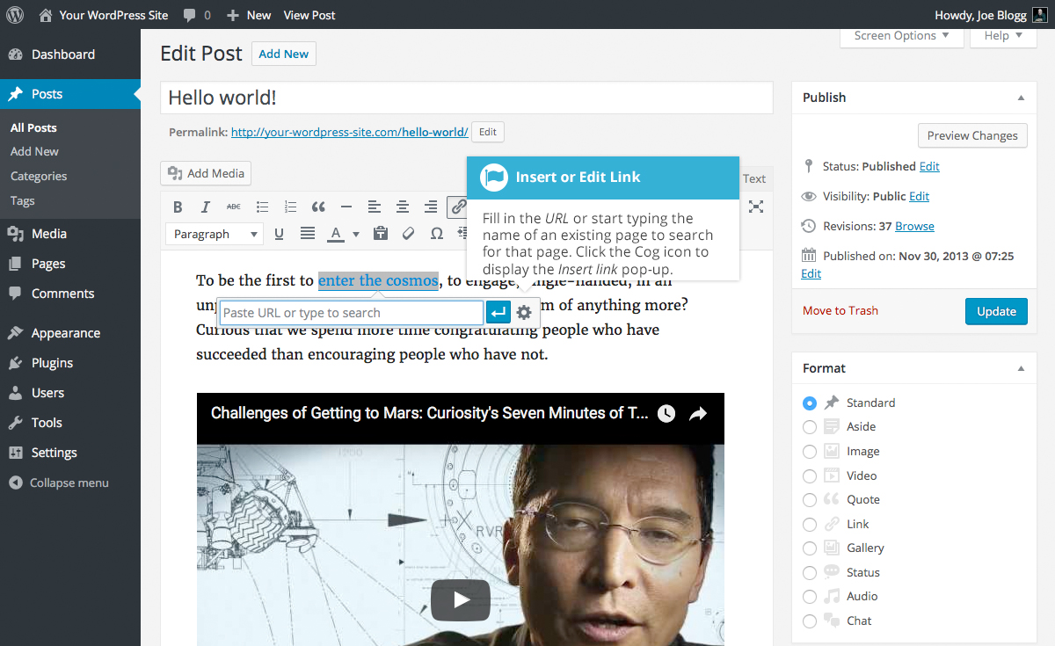

If you wish to display the pop-up window that previously displayed prior to WordPress 4.5, click the Link options icon (). This pop-up is also useful if you wish to have your link open in a new tab/window when clicked as it gives you access to the Open link in a new tab checkbox.
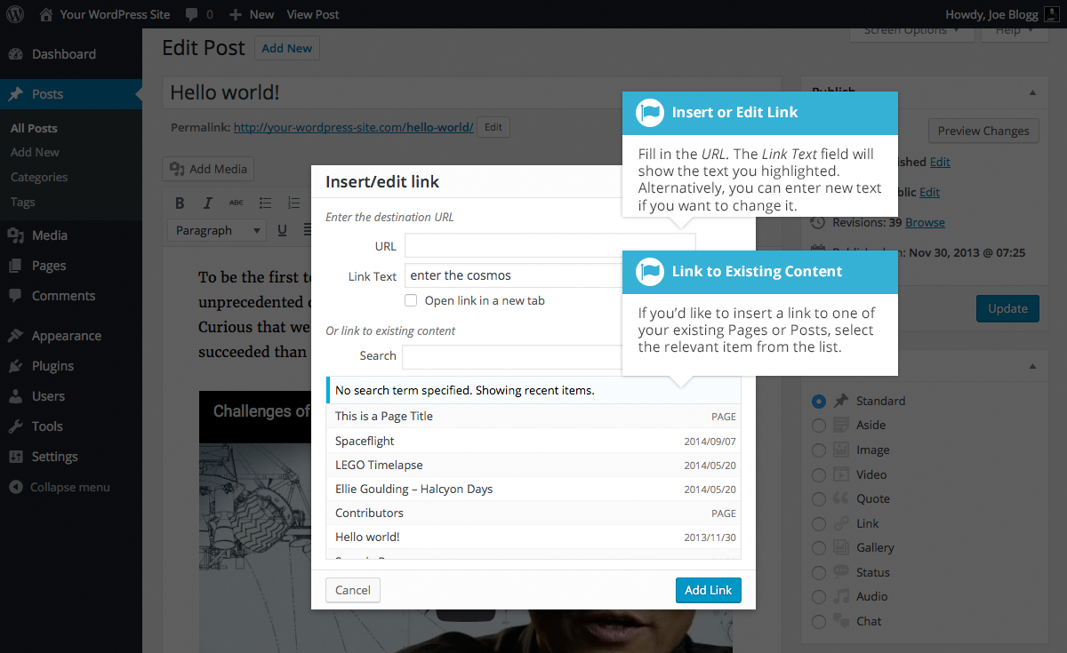
If you’re displaying the pop-up window, simply fill in URL and the Title and then click the Add Link button.
- URL – URL of the page or website that you would like to create a link to
- Link Text – The text that you highlighted prior to clicking the Insert/edit link button will be automatically displayed
- Open link in a new tab – When someone clicks the link you can have it open in the same window (default setting) or have it open in a new browser window/tab
Alternatively, if you’d like to add a link to one of your existing Posts or Pages, select the relevant page from the supplied list. If you have a large number of pages within your site, you can type the Page or Post name in the Search field to make it easier to find. As you type, the list will re-populate based on matching results. After selecting one of your existing pages, the link will be updated in the URL field. Click the Add Link button to add your link.

Inserting Links to Media Files
Adding a link to media files such as documents or PDF’s is just as easy as adding a standard html link. There are a couple of ways you can go about it.
Click the Add Media button () and then simply drag your file from wherever it is on your computer, into the browser window. Your file will be automatically uploaded.
Alternatively, click the Select Files button and then select the file that you’d like to upload, using the dialog window that is displayed.
Once your file is uploaded, your Media Library, which contains all your previously uploaded files, is displayed. The file that you’ve just uploaded will be automatically ‘selected’ for easy insertion into your Page or Post.
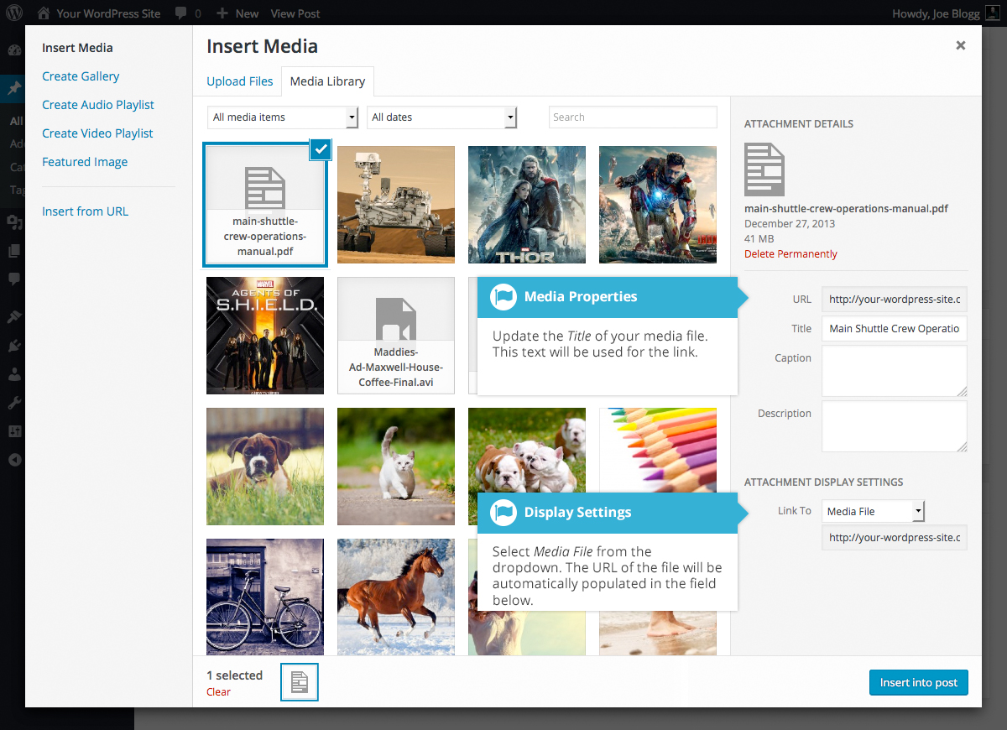
Update the Title for your file. The Title will be used for the text link when it’s inserted into your content. From the Link To dropdown list, select Media File. The field just below this will be automatically populated with the URL for the file.
Click the Insert into post button to insert a link to the selected file in your Post at the current cursor position (when editing a Page, this button will say Insert into page).
If you happen to know the URL for the media file that you’d like to link to or if you’d like to create a link on some existing text, simply click and drag the cursor and highlight the text that you want turned into a link and then click the Insert/edit link button (). Just like previously, when adding a simple HTML link, enter the URL to your media file and then click the Add Link button. A standard html link will be created that links to the media file that you specified.

Editing an HTML Link
To edit an html link, click the link within your Page/Post that you’d like to edit to display the inline link toolbar. Once the toolbar appears, click the Edit button () to display the edit field. Alternatively, click the link to position the cursor somewhere within it and then click the Insert/edit link button () on the main Visual Editor toolbar.

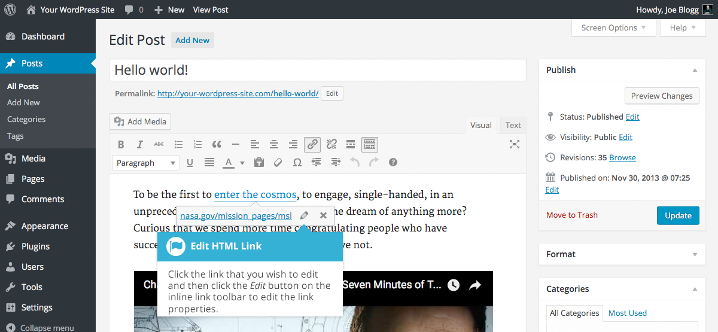
After you’ve updated the link url, hit your Enter key or click the Apply button () to save your changes. If you wish to display the Insert/edit link pop-up window click the Link options icon ().
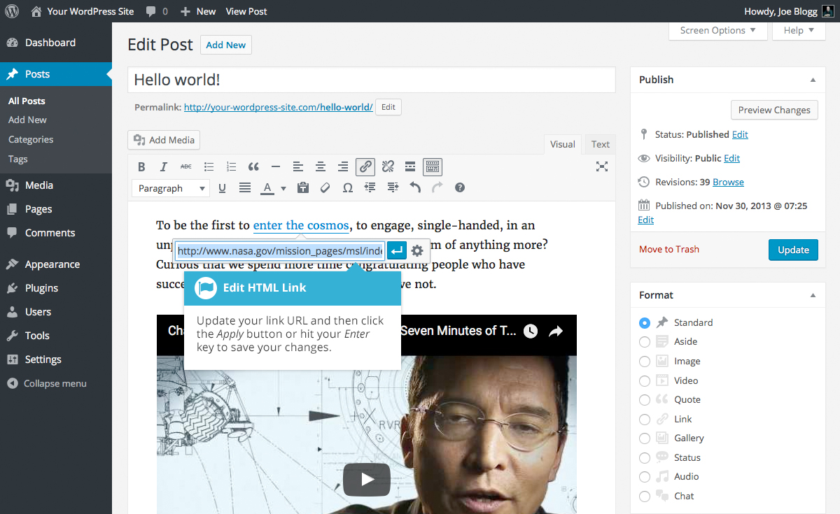

Removing an HTML Link
To remove an html link, click the link within your Page/Post that you’d like to remove to display an inline link toolbar. Once the toolbar appears, click the Remove button () to remove the link. Alternatively, click the link to position the cursor somewhere within it and then click the Remove link button () on the main Visual Editor toolbar. If you want to remove a link from an image, simply click the image once to select it and then click the Remove link button () on the main Visual Editor toolbar. If the html link is linking to an uploaded file or image, clicking the Remove link button won’t remove or delete that file, it will simply remove the hyperlink.
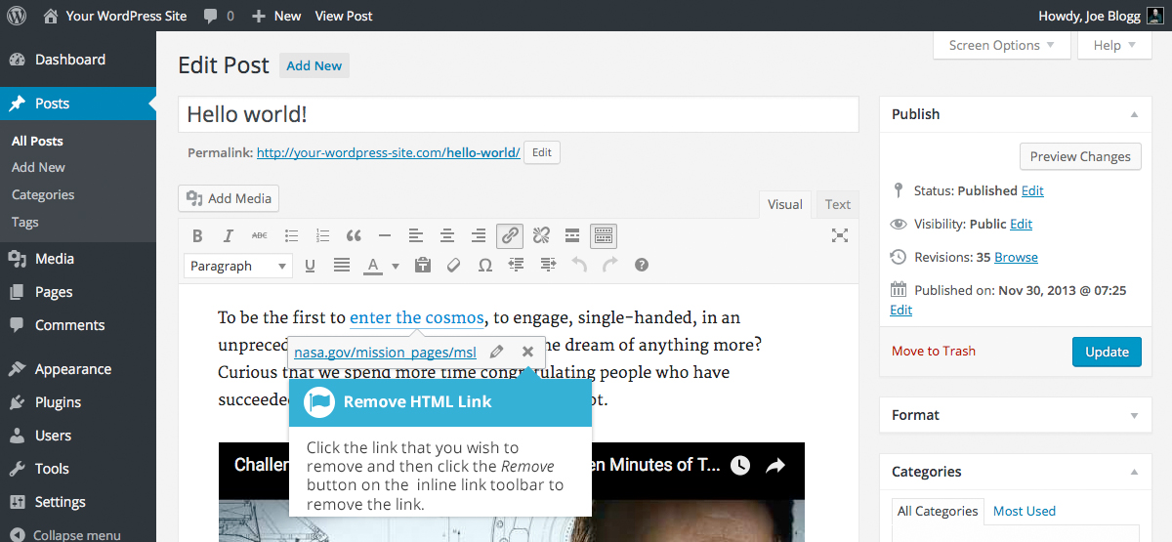

Editing Existing Content
To edit an existing page, simply click on the relevant Page/Post title, when viewing your list of Pages or Posts. Alternatively, click on the Edit link that appears beneath the title when hovering your cursor over each row.
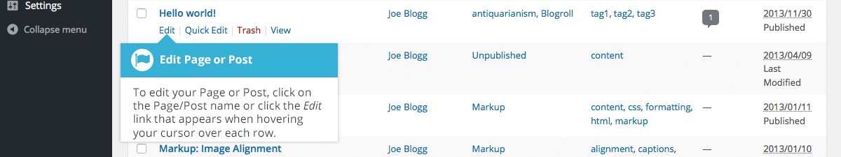
The screen that appears will be exactly the same as the Add New Page/Add New Post screen, only with the existing content displayed. When you’ve finished editing your Page/Post, click the Update button.

Deleting Content
If you wish to delete one of your Pages or Posts, click on the Trash link that appears beneath the title when hovering your cursor over each row. This will move the Page/Post to the Trash.
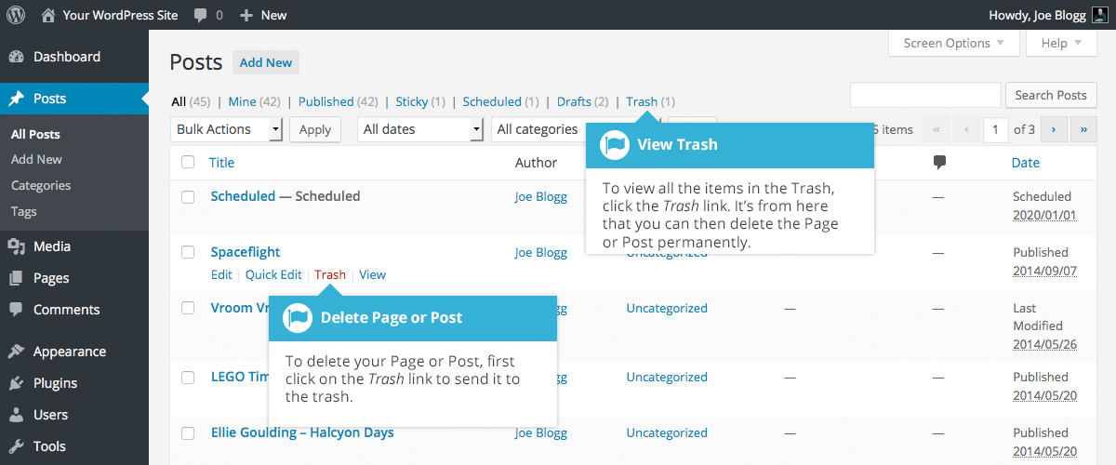
To delete the Page/Post permanently or to restore the Page/Post, click the Trash link at the top of the screen. When the cursor is hovering over each item in the Trash, the Restore and Delete Permanently links appear. Click Delete Permanently to permanently remove a single Page or Post. Clicking Restore will restore the Page or Post.
If you would like to permanently delete or restore numerous items at once, click the checkboxes next to the items you would like to delete or restore and then choose either Restore or Delete Permanently from the Bulk Actions dropdown list at the top of the page. After selecting the appropriate action click the Apply button to make your change. Alternatively, click the Empty Trash button to delete all the items in the Trash.

Fullscreen Editing
WordPress allows for fullscreen composing. It provides for complete distraction free editing of your Page or Post. To enter fullscreen mode simply click on the Distraction Free Writing button (). With the Distraction Free Writing button turned on, the left-hand menu and the right-hand side panels fade out of view, leaving the screen with just the minimal required to compose your content.
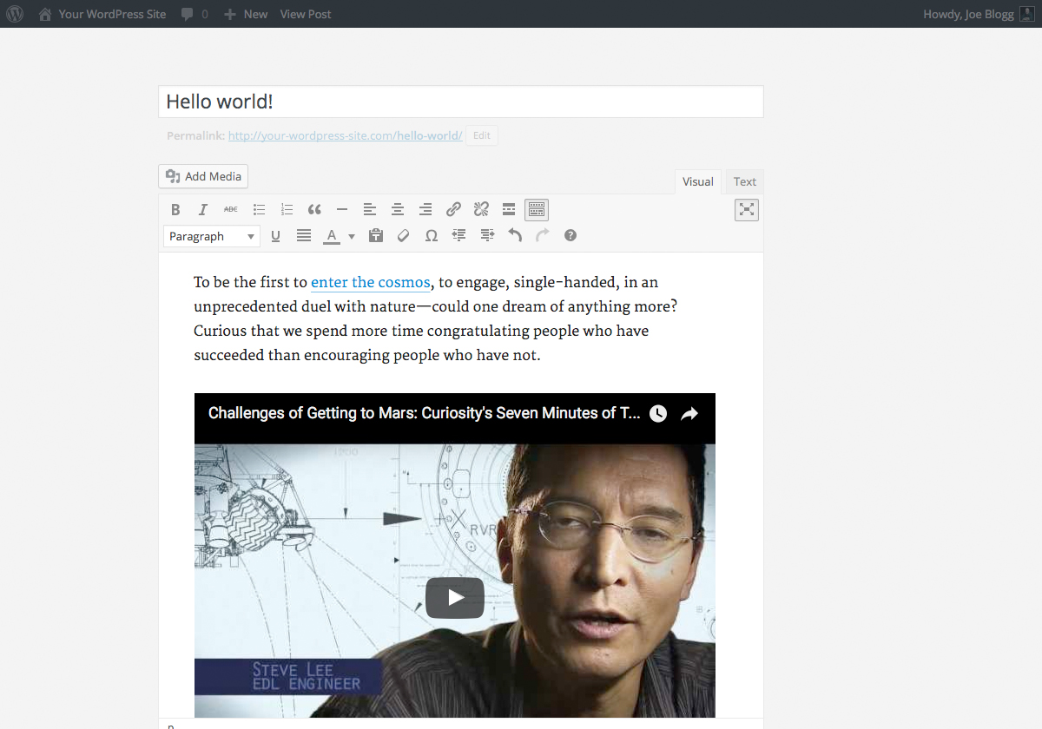
In Distraction Free Writing mode, only the Title field and Visual Editor is displayed until you move your cursor outside of the editor. Once you move your cursor outside of the editor, the menu and side panels fade back into view.
To exit from Distraction Free Writing mode, click on the Distraction Free Writing button again.

Saving and Publishing Content
Once you’ve added all your content to your Page or Post you have the option of Saving the Page as a Draft or Publishing the page. Clicking the Save Draft button will simply save your Page/Post. This is handy if you would like to come back at a later date to add more content or if you’re simply not ready to publish yet.
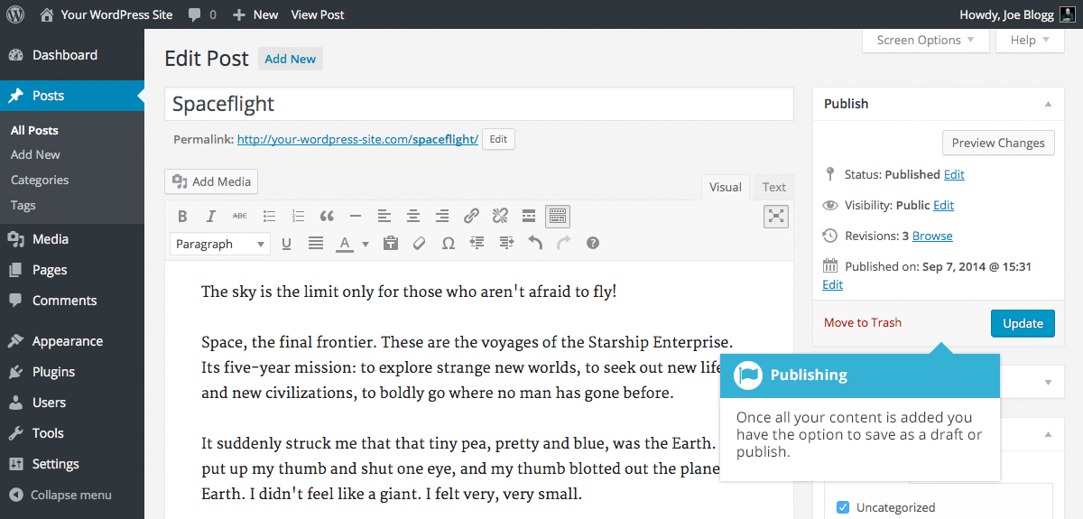
Clicking the Publish button will save your Page/Post and publish it on your website.
Clicking the Preview button will show you a preview of the current Page/Post.
There are also several options available when saving. By default the Status is set to Draft but this can be changed by clicking the Edit link just to the right of Status: within the Publish panel.
- Pending Review means the draft is waiting for review by an editor prior to publication.
- Draft means the post has not been published and remains a draft for you.
You can also change the visibility of the Page by clicking the Edit link just to the right of Visibility: within the Publish panel.
- Public is the default and means the page is viewable to all. There is also an option to make the Post ‘sticky’. Sticky posts are placed at the top of all blog posts and stay there even after new posts are published.
- Password Protected allows you to assign a password to your page. Only people who have the password will be able to access the page.
- Private hides the content from the public completely. Normal users and visitors will not be aware of private content. You will only see the private content when you are logged into your WordPress blog.
Just below the Title for your content is the full URL for your Page or Post. Clicking this will take you to the published page, or if the page hasn’t been published yet, a preview of the page. Clicking the Edit button next to the URL allows you to change the Permalink (i.e. the URL) of the Page or Post. You might decide to do this for improving SEO (Search Engine Optimisation). Most times though, you’ll simply leave the default URL which WordPress automatically generates based on your Page/Post Title.
By default, when you click the Publish button your Page/Post is published immediately. To change this, click the Edit link just to the right of Publish immediately within the Publish panel. You can then select the date and time that you’d like to schedule your Page/Post to be published. You must also click the Publish button when you have updated the date and time fields to publish at the desired date and time.

Categories
You can use categories to define sections of your site and group related posts. The default category is Uncategorized but this can be easily changed in your Settings. Pages cannot be associated with Categories. You can only associate Categories to Posts.
There are two ways to add Categories. They can be added whilst adding or editing your Post or they can be added via the Categories menu option. Adding Categories whilst editing your Post, will automatically assign those Categories to your Post. Adding Categories using the Categories menu option will simply add them to the list of available Categories.
When you click on the Categories menu option you’ll be shown a list of Categories that have already been added along with some blank fields that allow you to add a new Category.
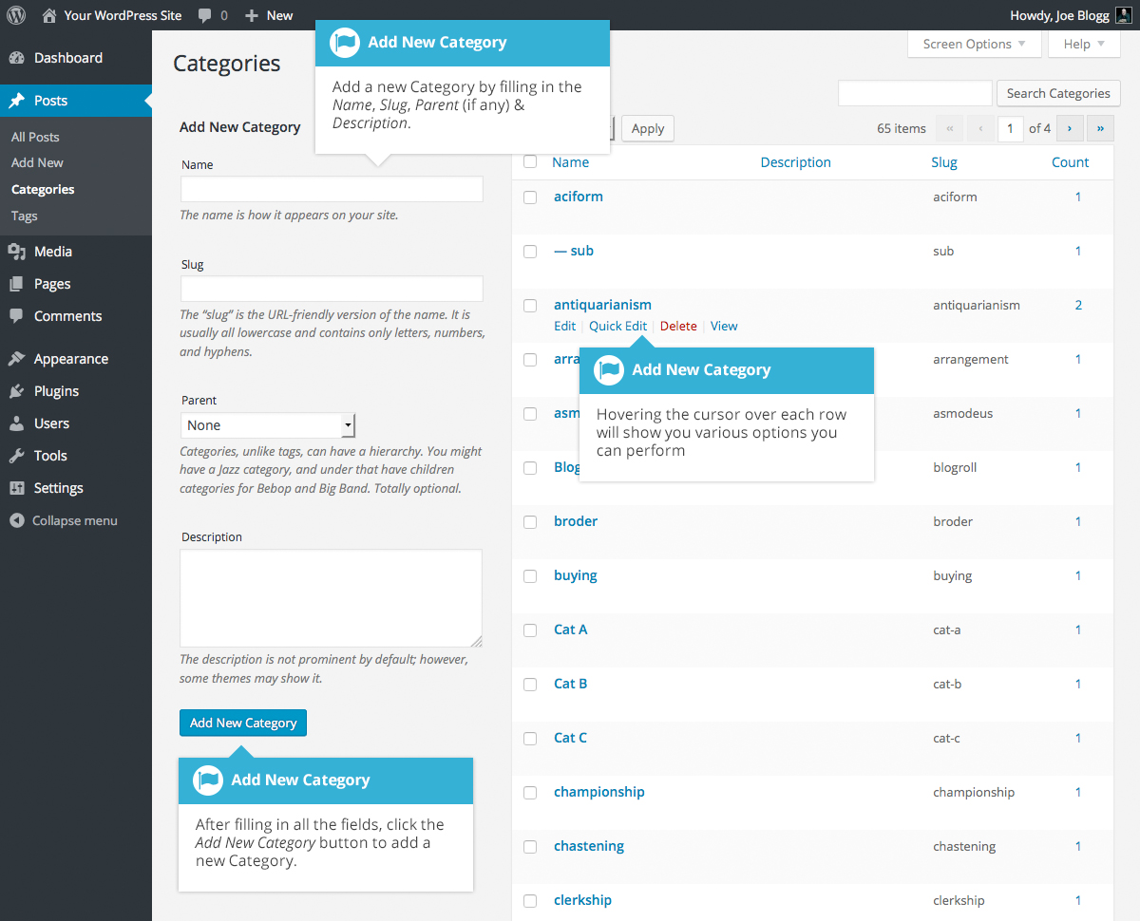
To add a new Category, fill in the blank fields and then click the Add New Category button:
- Name – The name is how it appears on your site
- Slug – The Slug is the URL-friendly version of the name. It’s usually all lowercase and contains only letters, numbers, and hyphens
- Parent – Categories, unlike tags, can have a hierarchy. You might have a Car category, and under that have children categories for Ford, General Motors and Toyota. Totally optional. To create a subcategory, just choose another category from the Parent dropdown
- Description – The description is not prominent by default; however, some themes may display it
Once you add a new Category it will appear in the list of Categories on the right side of the screen.
When hovering your cursor over each row in the list of Categories, a few links will appear beneath the Category name.
- Edit – Allows you to edit the Category properties such as Name, Slug, Parent and Description
- Quick Edit – Allows you to quickly edit the Category Name and Slug
- Delete – Deletes the Category permanently from the list of Categories. After clicking Delete you will be prompted to confirm your choice. Click OK to delete the Category or Cancel if you don’t want to delete it
- View – This will list all the Posts that are currently using this Category
If you would like to permanently delete numerous Categories at once, click the checkboxes next to the Categories you would like to delete and then choose Delete from the Bulk Actions dropdown list at the top of the page. After selecting Delete, click the Apply button to immediately delete the selected Categories (you will not be prompted to confirm your choice).
Deleting a Category does not delete the posts in that Category. Instead, posts that were only assigned to the deleted Category are set to the default Category, which is set to Uncategorized by default. The Default Post Category can be configured within the Settings > Writing section.

Adding Categories within your Post
Adding Categories whilst editing your Post will automatically assign those Categories to your Post.
When adding or editing your Post, the Categories panel can be found just below the Format panel if your Theme supports Post Formats. Alternatively, it will reside just below the Publish panel. To add an existing Category, simply tick the checkbox(es) next to the Categories you’d like to assign to the Post.
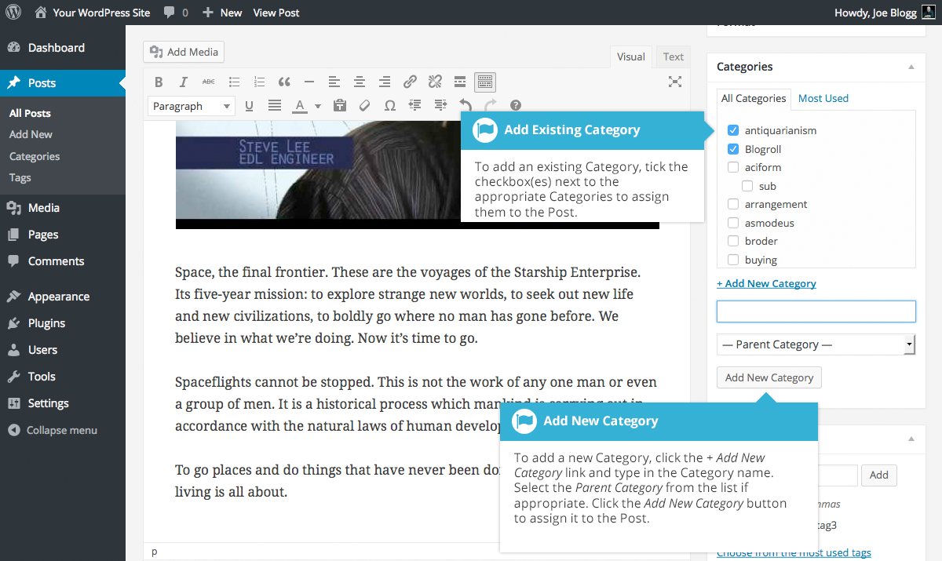
If you would like to create a new Category and assign it to the Post at the same time, click the + Add New Category link. Two fields will then appear. Type the name of the Category that you’d like to add into the empty input field. If you’d like the new Category to have a Parent, select it from the Parent Category dropdown list. Click the Add New Category button when done to create the Category and automatically assign it to the Post.

Tags
Tags are ad-hoc keywords that identify important information in your post (names, subjects, etc) that may or may not recur in other posts. Unlike Categories, Tags have no hierarchy, meaning there’s no relationship from one Tag to another. Pages cannot be assigned Tags and cannot be associated with Categories. You can only associate Tags and Categories to Posts.
Like Categories, there are two ways to add Post Tags. They can be added whilst adding or editing your Post or they can be added via the Tags menu option. Adding Tags whilst editing your Post, will automatically assign those Tags to your Post. Adding Tags using the Tags menu option will simply add them to the list of available Tags.
When you click on the Tags menu option you’ll be shown a list of Tags that have already been added, along with some blank fields that allow you to add a new Tag. A list of popular Tags is also displayed in ‘cloud’ format. That is, the Tags are displayed in alphabetical order and the more often a Tag has been used, the larger the font it’s displayed in.
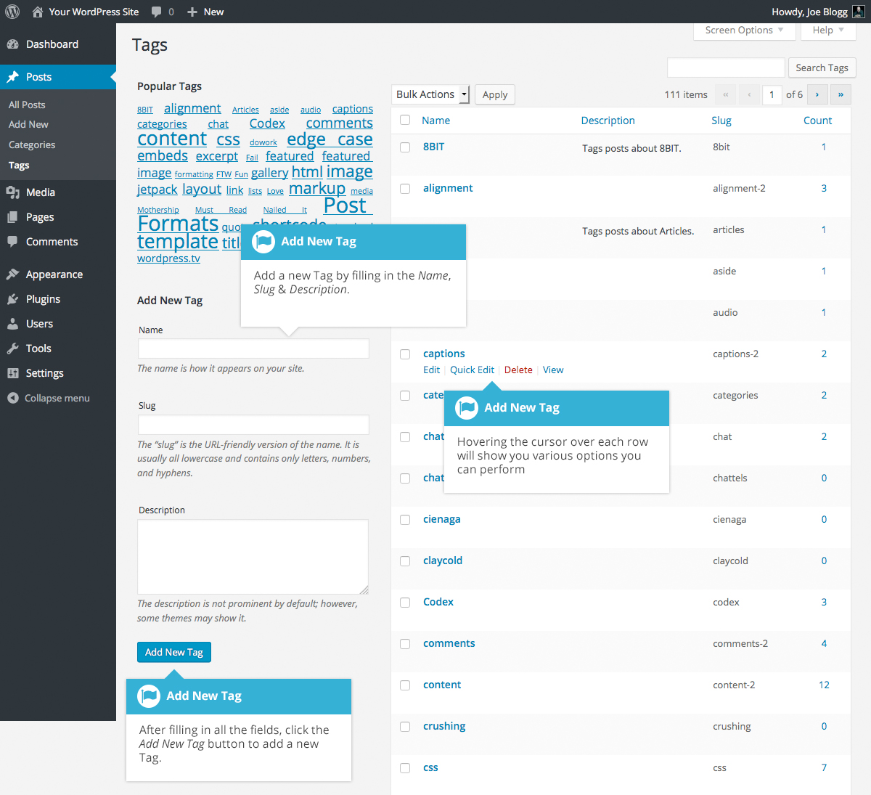
To add a new Tag, fill in the blank fields and then click the Add New Tag button:
- Name – The name is how it appears on your site
- Slug – The Slug is the URL-friendly version of the name. It’s usually all lowercase and contains only letters, numbers, and hyphens
- Description – The description is not prominent by default; however, some themes may display it
Once you add a new Tag it will appear in the list of Tags on the right side of the screen.
When hovering your cursor over each row in the list of Tags, a few links will appear beneath the Tag name.
- Edit –Allows you to edit the Tag properties such as Name, Slug and Description
- Quick Edit – Allows you to quickly edit the Tag Name and Slug
- Delete – Deletes the Tag permanently from the list of Tags. After clicking Delete you will be prompted to confirm your choice. Click OK to delete the Tag or Cancel if you don’t want to delete it
- View – This will list all the Posts that are currently using this Tag
If you would like to permanently delete numerous Tags at once, click the checkboxes next to the Tags you would like to delete and then choose Delete from the Bulk Actions dropdown list at the top of the page. After selecting Delete, click the Apply button to immediately delete the selected Tags (you will not be prompted to confirm your choice).

Adding Tags within your Post
Adding Tags whilst editing your Post, will automatically assign those Tags to your Post.
When adding or editing your Post, the Tags panel can be found just below the Categories panel. To add an existing Tag, click the Choose from the most used tags link. This will display a list of previously used Tags (if available). They are arranged alphabetically and in ‘cloud’ format. That is, the more often a Tag has been used, the larger the font it’s displayed in. To add a previously used Tag, simply click on the Tag name and it will be assigned to your Post. To add a new Tag, simply write the Tag or Tags (separated with commas) into the edit field and click the Add button. Tags that are assigned to the Post will be displayed below the edit field. To remove a Tag from your Post, click the small ‘x’ icon next to the Tag name.
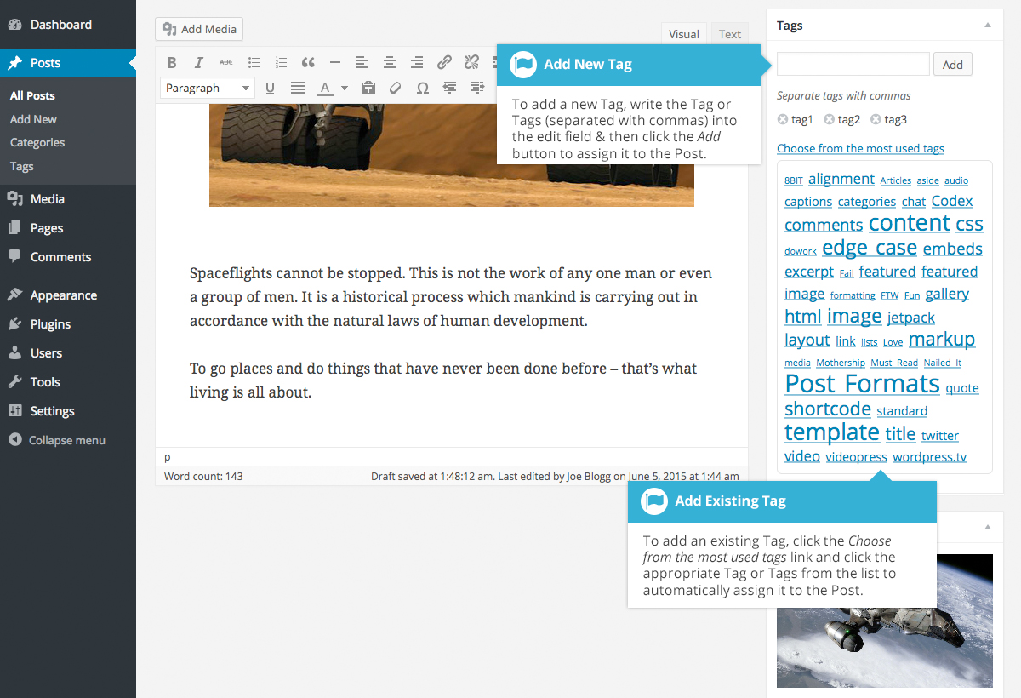

Media Library
The Media Library is where you can find all the files that you’ve uploaded. There are two different types of views you can select from when viewing your media library. You can click the List View icon () to display your images in a list, or you can click the Grid View icon () to view your images in a Grid layout.
The Grid View will display a grid of thumbnail images for each of your media files. The Grid View employs infinite scrolling, rather than displaying your images over multiple pages. To view more images, simply scroll to the bottom of the page and more thumbnails are automatically loaded.
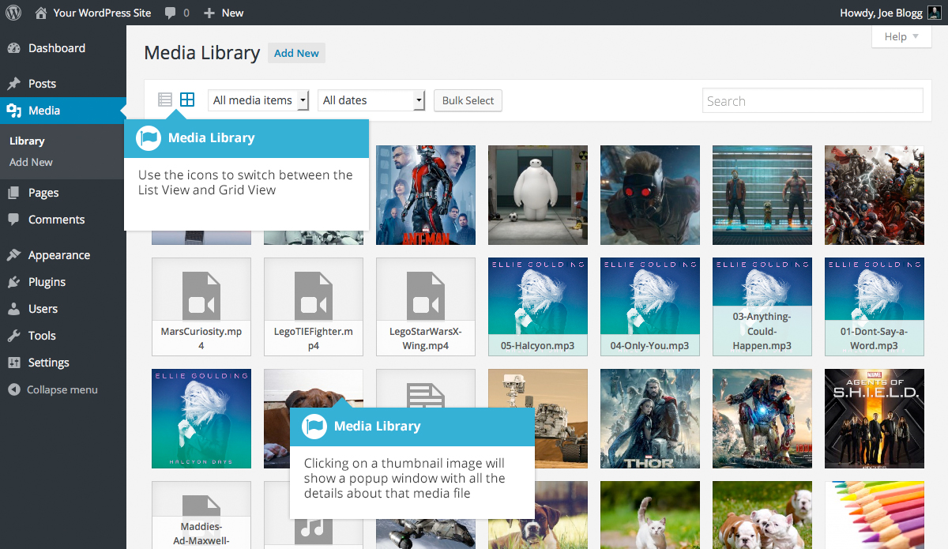

The List View will display your images similar to how they’ve been displayed in previous versions of WordPress, in a list over multiple pages.
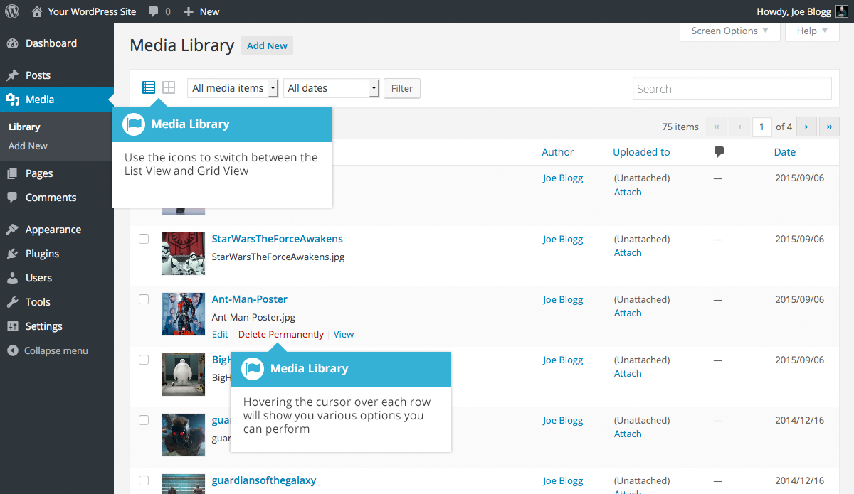
Both views show the most recently uploaded files first. There are also dropdown lists that allow you to filter the list of files that are currently being displayed, along with a search field to help search for files.
Within the List View, the list of files contains a small thumbnail version of the image or file, the file title and the file name along with the file extension which shows the type of file (JPG, MP3, etc.), the name of the Author who uploaded the file, the Page or Post which the image was uploaded to, the number of comments and the date the file was uploaded.
When hovering your cursor over each row in the List View, a few links will appear beneath the file name.
- Edit – Allows you to edit the file properties such as Title, Alt Text, Caption and Description. You can also perform some basic image manipulation
- Delete Permanently – Deletes the file permanently from the Media Library
- View – Will take you to the display page for that file

Viewing a File in the Media Library
The Grid View will display a grid of thumbnail images for each of your media files. Depending on the file type, you’ll either see a thumbnail image for that particular file or an icon representation.
After clicking on a thumbnail within the Grid View, a pop-up window will display the properties for that particular file, along with giving you the ability to update certain properties. If the file is an image, you’ll also see a larger version of that image. For supported audio and video files (M4a, MP4, OGG, WebM, FLV, WMV, MP3, WAV and WMA) you’ll see the appropriate media player. For other file types such as PDF’s or Word Documents, there is a link to view the attachment page which in turn has a link to the actual file.
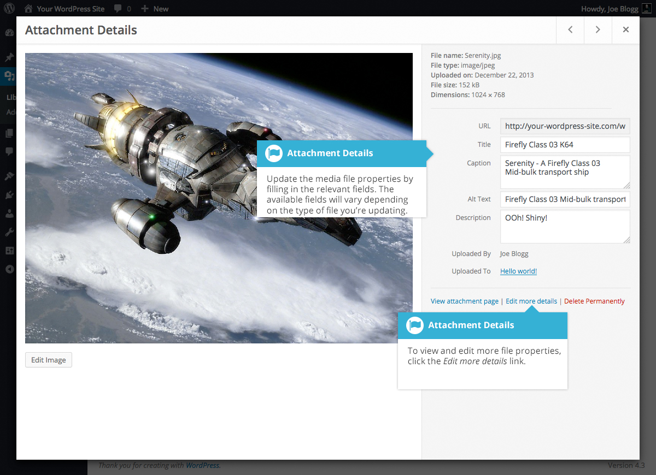
Within the List View, you can click the thumbnail image, the media file title or you can hover the cursor over the row and click the Edit link. The various file properties will be displayed, along with giving you the ability to update certain properties. If the file is an image, you'll see a larger version of that image. For supported audio and video files (M4a, MP4, OGG, WebM, FLV, WMV, MP3, WAV and WMA) you’ll see the appropriate media player. For other file types such as PDF’s or Word Documents, you’ll simply see the file properties along with a button to view the attachment page which in turn has a link to the actual file.
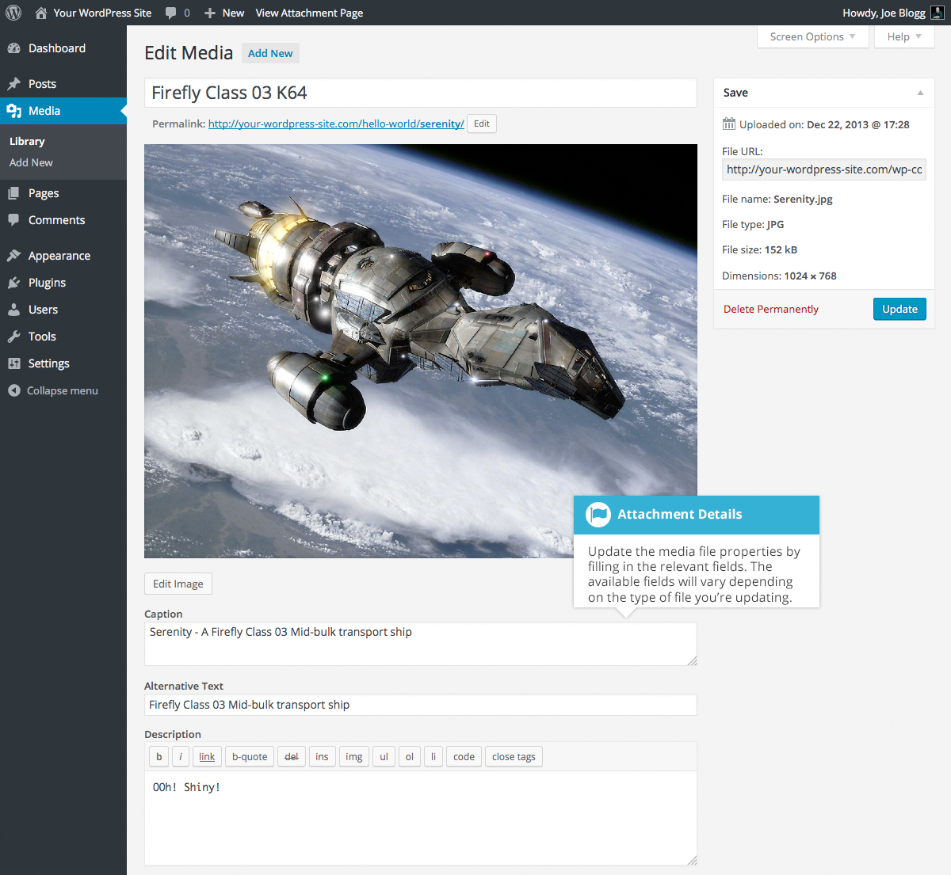
Clicking the View link, when hovering your cursor over a row, will display the attachment page for that particular media file. If the file is an image, you'll see a larger version of that image. For supported audio and video files you’ll see the appropriate media player and for other file types such as PDF’s or Word Documents, you’ll see a link to the actual file.
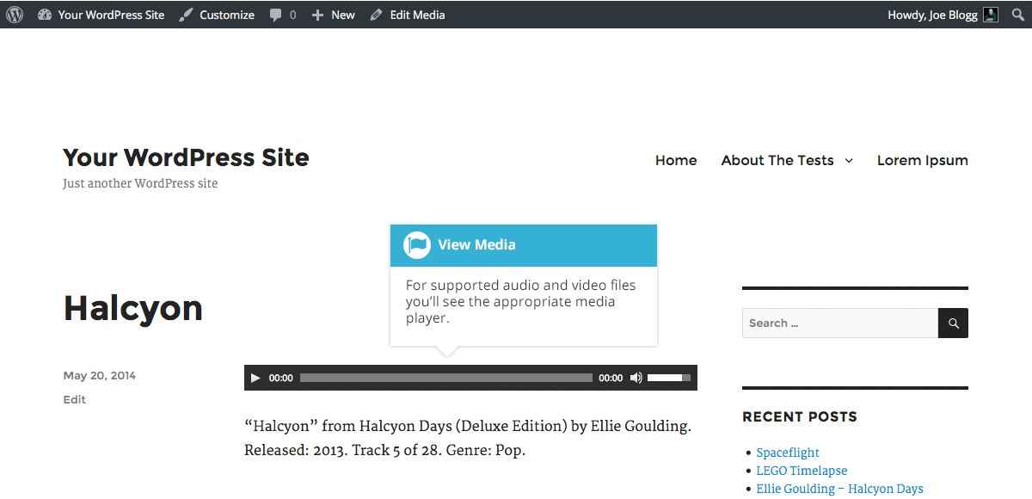

Adding a File to the Media Library
To add a new file to the Media Library, click on the Add New link in the left-hand navigation menu or the Add New button at the top of the page.
If you click the Add New button when you’re viewing the Media Library in the List View, or click the Add New link in the menu, simply drag your images from wherever they are on your computer, into the area marked Drop files here. Your file(s) will be automatically uploaded.
Once your images or files are uploaded, they’re listed below the file uploader. If you’d like to edit the file properties, click the Edit link next to the file.
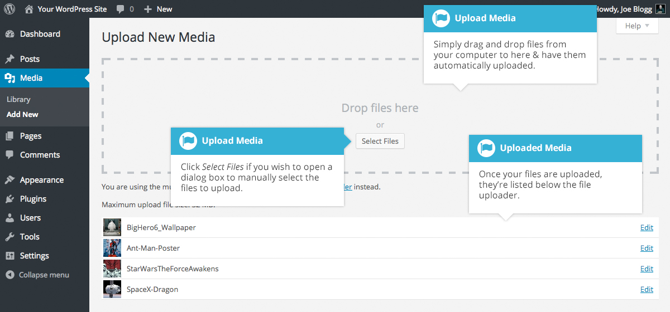
If you click the Add New button when you’re viewing the Media Library in the Grid View, you can drag your images from wherever they are on your computer, to anywhere on the screen. Your file(s) will be automatically uploaded.
Once your images or files are uploaded, they’re displayed below the file uploader, with the rest of your media.
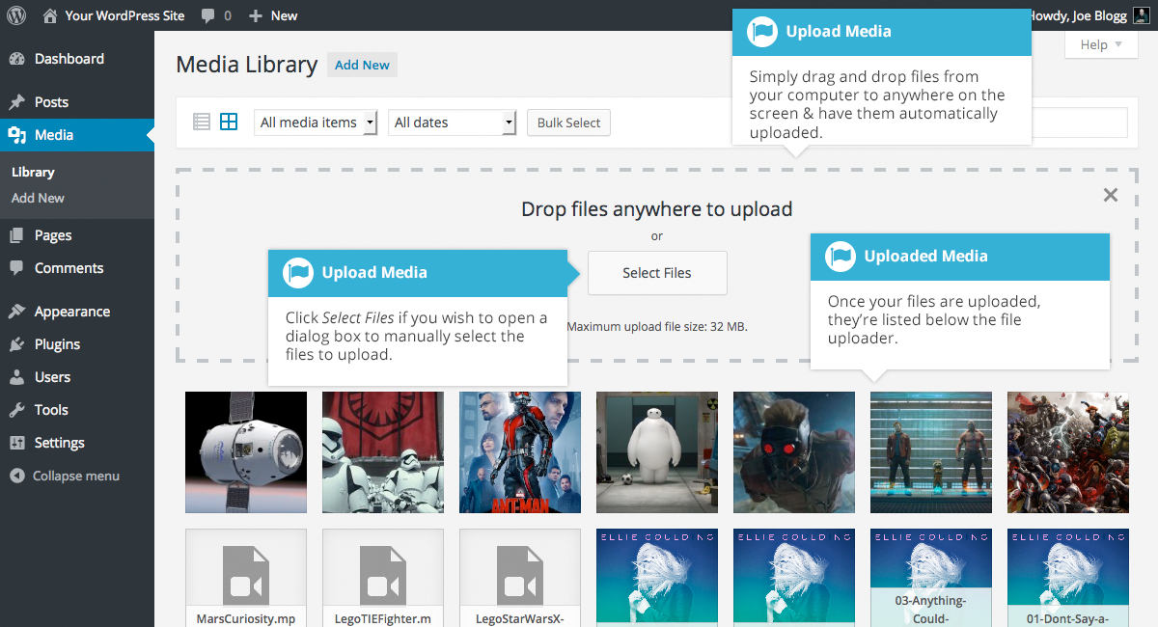

When uploading files, you can also click the Select Files button and then select the files that you’d like to upload, using the dialog window that is displayed.

Editing the File Properties
If you’re viewing your files using the Grid View, simply click on one of your media files and you’ll be presented with a pop-up window that displays the relevant properties for that particular file.
After updating each field your changes will be automatically saved. You can use the arrow buttons at the top of the pop-up window to navigate to the previous or next image. Click the ‘x’ in the top-right of the pop-up window to return to the media Grid View.
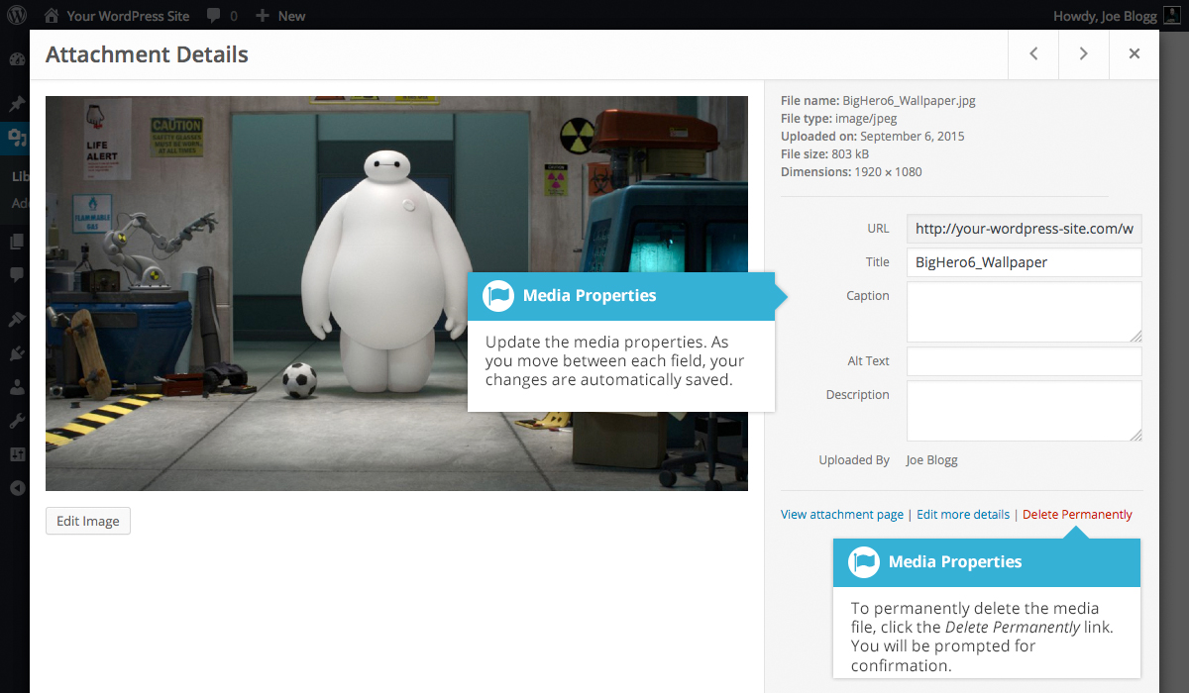
To edit the properties of an existing file when using the List View within the Media Library, hover the cursor over the particular row that contains the file you wish to edit and click the Edit link. Alternatively, you can also click the file title or the thumbnail image. Clicking the Edit link next to the file after it’s just been uploaded, will also allow you to edit its properties.
After clicking Edit, the relevant properties for that particular media file are displayed, including the title, URL, filename, file type and in the case of an image, the file dimensions. When editing the file properties, the Alternative Text field will only be displayed for images.
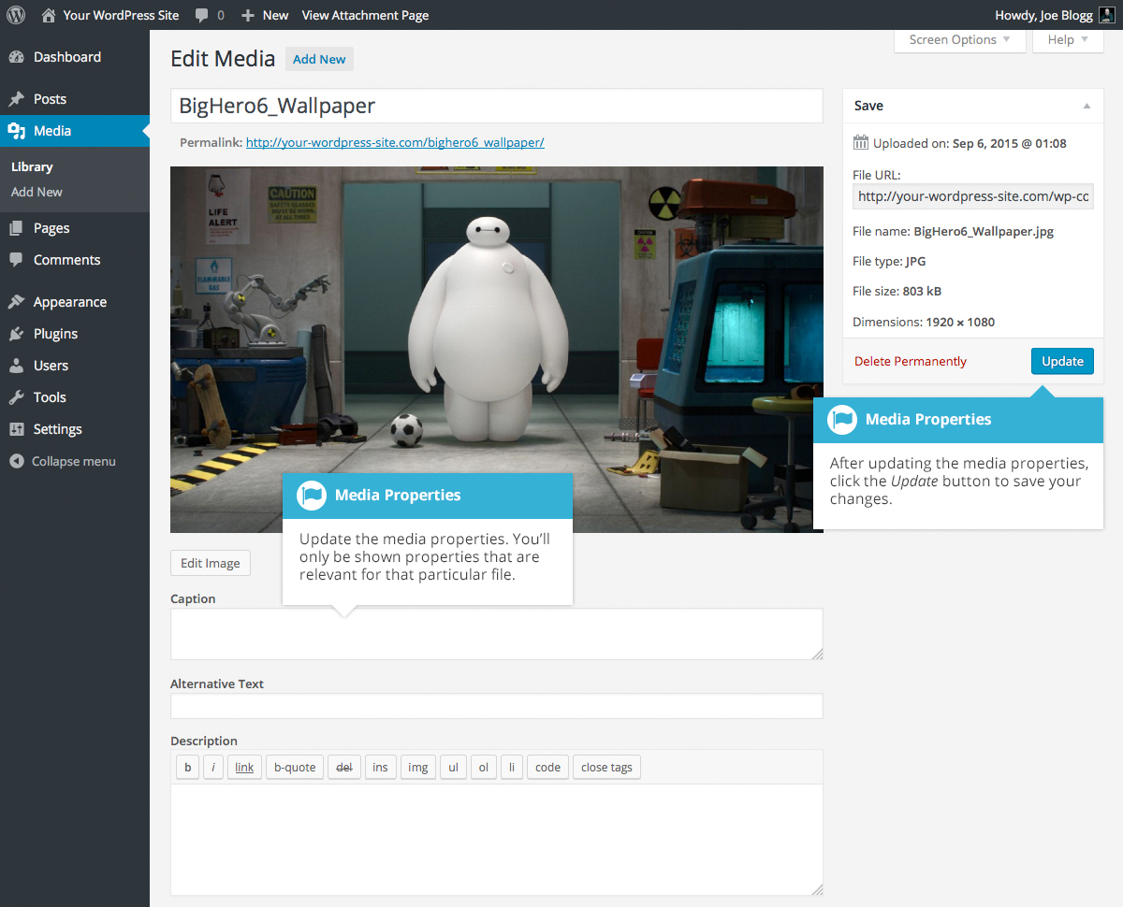
- Title – Although the field isn’t labelled, the Title is the field at the very top of the page (when editing the image from the List View). The Title is displayed as a tooltip when the mouse cursor hovers over the image in the browser
- Caption – is displayed underneath the image as a short description. How this displays will be dependent on the WordPress theme in use at the time. You can also include basic HTML in your captions
- Alternative Text – This field is only displayed for image files. The Alternative Text is displayed when the browser can’t render the image. It’s also used by screen readers for visually impaired users
- Description – This content is displayed on the file’s attachment page
- Metadata - Artist – This field is only displayed for audio files. It allows you to specify the recording artist
- Metadata - Album – This field is only displayed for audio files. It allows you to specify the album to which the audio file belongs to
Once the file properties are updated click the Update button to save your changes.

Editing an Image
WordPress has a basic image editing tool that allows you to perform some simple manipulation with your uploaded images. You’re able to rotate and flip your images as well as scale them and crop them to different sizes.
When editing the file properties of an image (as opposed to other file types like documents or PDFs), click the Edit Image button that appears just below the image to show the image editing tools.
If you click the Edit Image button whilst using the Grid View, the image editing tools will appear in the pop-up window.
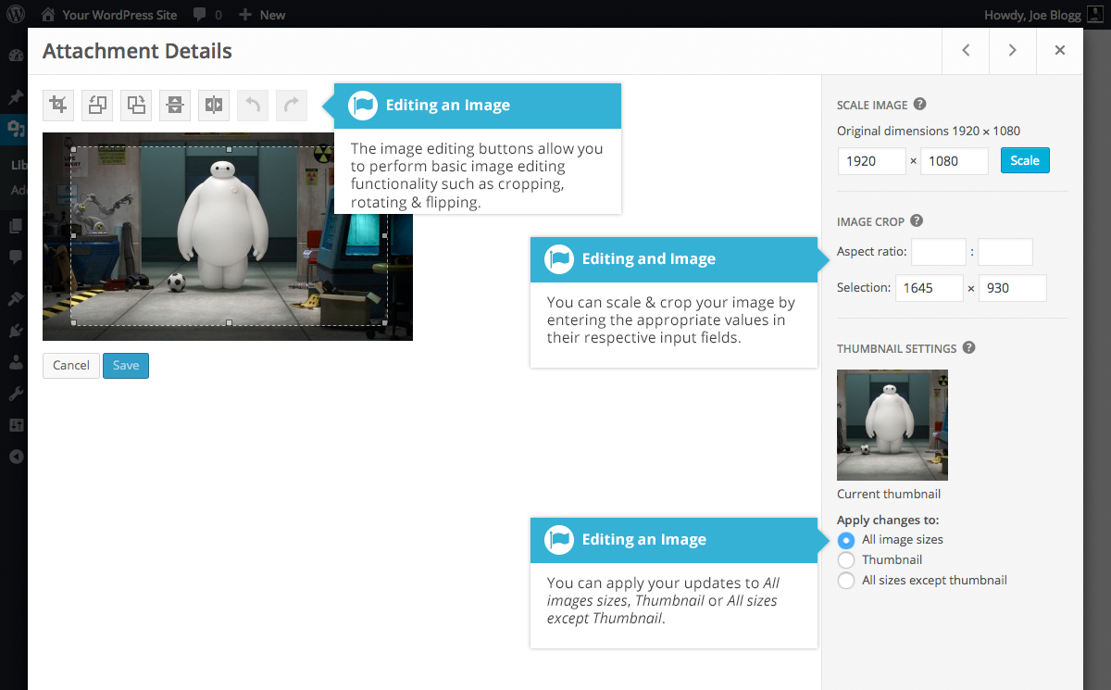
If you click the Edit Image button whilst using the List View, your page will look slightly different to the above Grid View. As well as the image editing tools, you’ll also see the properties of the file such as the file size and dimensions. You can also still update the Caption, Alternative Text and Description.
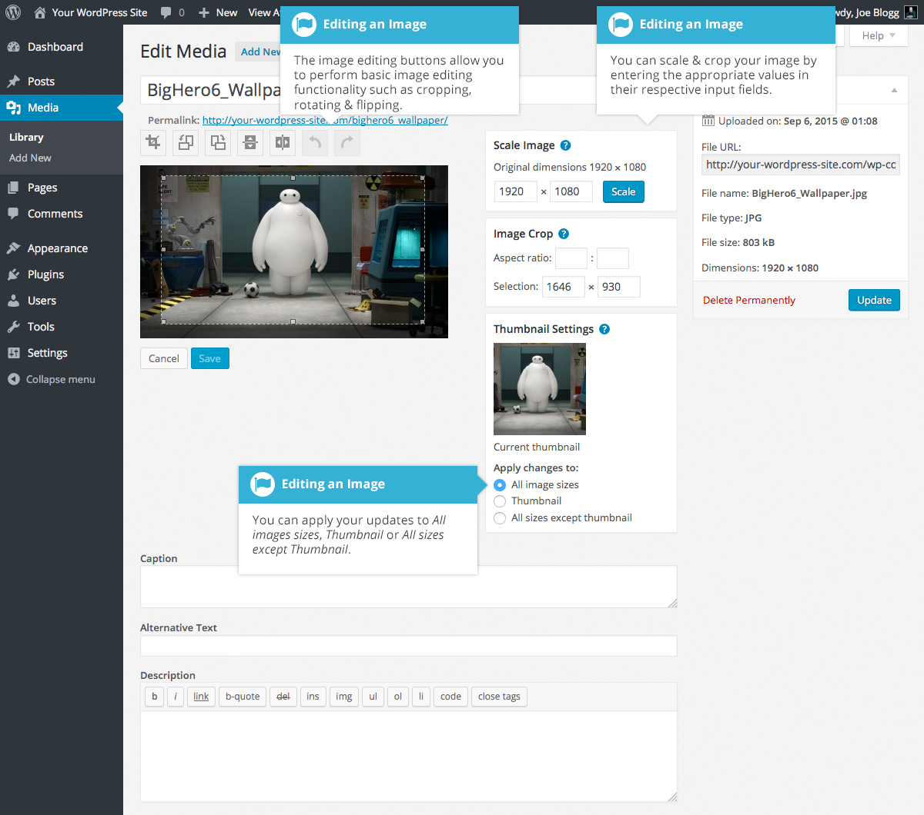
No matter what view you’re using, just above the image you’ll find the following image editing buttons:
Crop – Click on the image and drag the selection box to the size that you’d like the image cropped. Click the Crop button to crop the image to the new size
Rotate counter-clockwise – Rotate the image 90° counter-clockwise
Rotate clockwise – Rotate the image 90° clockwise
Flip vertically – Flip the image vertically
Flip horizontally – Flip the image horizontally
Undo – Undo the last change
Redo – Redo the last change
To scale your image to a new size, simply enter the width or height dimensions in the appropriate field and click the Scale button. For best results, scaling should be done before performing any other operations like cropping, flipping or rotating the image. It’s important to note that images can only be scaled down, not up.
After entering one scale value, the other value will change automatically so as to keep the image in proportion. The original image dimensions are displayed just above the input fields, for your reference.
There are several ways to crop your image. The easiest is to simply click on the image and drag the selection box to the appropriate size. If you’d like your image cropped to a specific ratio, enter the values in the Aspect Ratio input fields (e.g. 1:1 (square), 4:3, 16:9 etc.). You can then hold down the shift key and drag one of the edges of your selection to enlarge or reduce the size, while keeping this aspect ratio locked. If there is already a selection made, specifying the aspect ratio will automatically change the selection to match it.
Whenever the selection box is adjusted, the dimensions are displayed in the Selection input fields. You can also manually enter the dimensions of the selection box (in pixels) by entering values into these two fields. Once your selection box is adjusted, simply click the Crop button just above the image to crop the image to this new size.
By selecting one of the options in the Thumbnail Settings panel, you have the option to apply your changes to All image sizes, just the Thumbnail image or All sizes except Thumbnail.
Click the Save button to save your changes.
Click the Update button to return to the main Media Library page.
If you’d like to revert back to your original image, click the Edit Image button again to return to the image editor. A new Restore Original Image link is displayed just below the Scale Image link. Click the Restore Original Image link and then click the Restore image button to discard your changes and restore your original image.
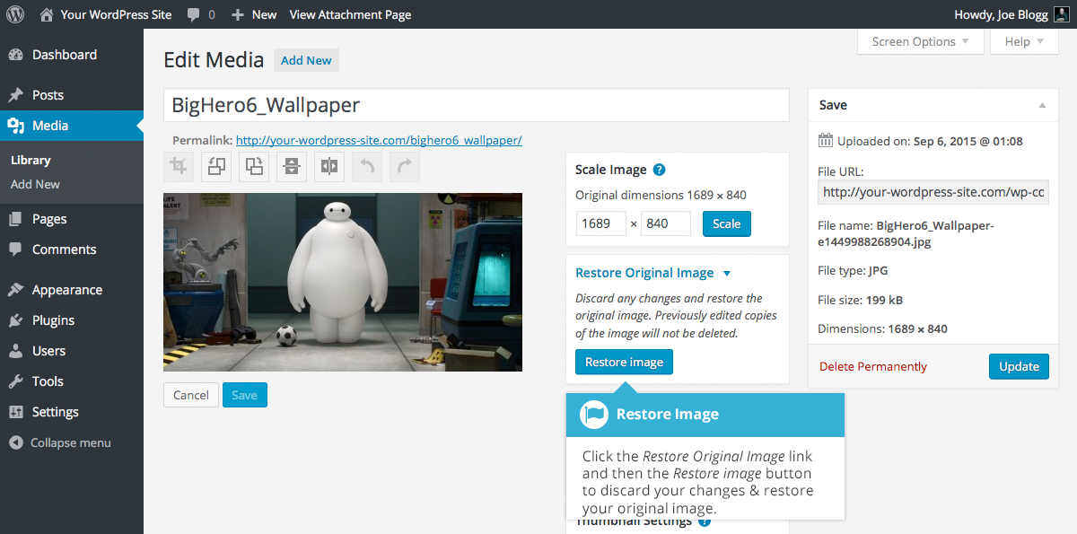

Deleting a File from the Media Library
To delete a file from the Media Library when using the Grid View, first click an image to view the File Properties, then click on the Delete Permanently link that appears in the pop-up window.
To delete a file from the Media Library when using the List View, click on the Delete Permanently link that appears beneath the file name when hovering your cursor over each row.
After you click the Delete Permanently link in either view, you’ll be prompted with a confirmation message.
Click the OK button to delete the file or click the Cancel button to return to the Media Library.

Comments
Comments are a feature of blogs which allow readers to respond to Posts. Typically, readers simply provide their own thoughts regarding the content of the post, but they may also provide links to other resources, generate discussion, or simply compliment the author for a well-written post. Comments allow you to interact more with your site visitors as well as generate feedback and discussion on your Posts.
Comments can be controlled and regulated through the use of filters for language and content, and if you prefer, can also be queued for approval before they are visible on the web site. This is useful in dealing with comment spam.
When you click on the Comments menu option, you’ll be shown a list of all the comments on your site.
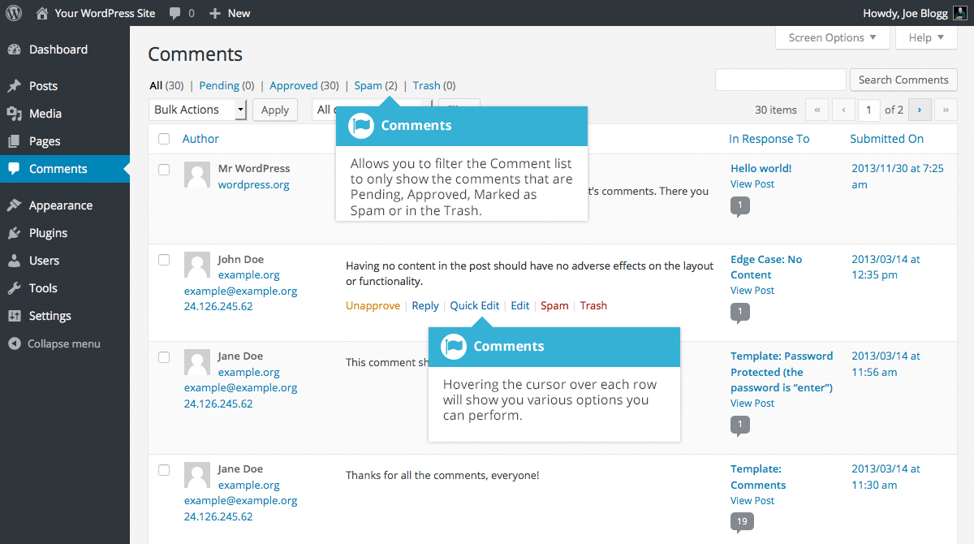
At the top of the screen there are links that allow you filter the comment list to only show the comments that are Pending, Approved, Marked as Spam or that are in the Trash. The number in brackets will advise how many there are for that particular type.
As well as the standard settings that allow you to manage your comments, the default WordPress install comes with an excellent plugin that helps to filter out spam from your comments. This plugin is called Akismet.
After activating the Akismet plugin, you need to supply it with an API Key. You can grab an API key and find out more information on the Akismet website.
When hovering your cursor over each row in the list of Comments, a few links will appear beneath the comment.
- Unapprove/Approve – Allows you to unapprove the comment. This will stop it displaying on your site. If the comment is already unapproved then this link will change to Approve, to allow you to approve the comment
- Reply – Allows you to write a reply comment
- Quick Edit – Allows you to quickly edit the commenter’s Name, Email or URL as well as the actual comment
- Edit – Allows you to edit the commenter’s Name, Email or URL as well as the actual comment. It also allows you to mark the comment as either Approved, Pending or Spam and change the Date and Time
- Spam – Allows you to mark the comment as spam
- Trash – Allows you to mark the comment as Trash. Once it’s in the Trash, you can either restore it if you made a mistake, or delete it permanently
If you would like to change the status of numerous Comments at once, click the checkboxes next to the Comment(s) you would like to change and then choose either Unapprove, Approve, Mark as Spam or Move to Trash from the Bulk Actions dropdown list at the top of the page. After selecting the appropriate option, click the Apply button.

Replying to a Comment
To respond to a comment that someone has written on one of your Posts, simply hover the mouse over the comment and click the Reply link when it appears. An edit field will then appear beneath the comment where you can type your reply.
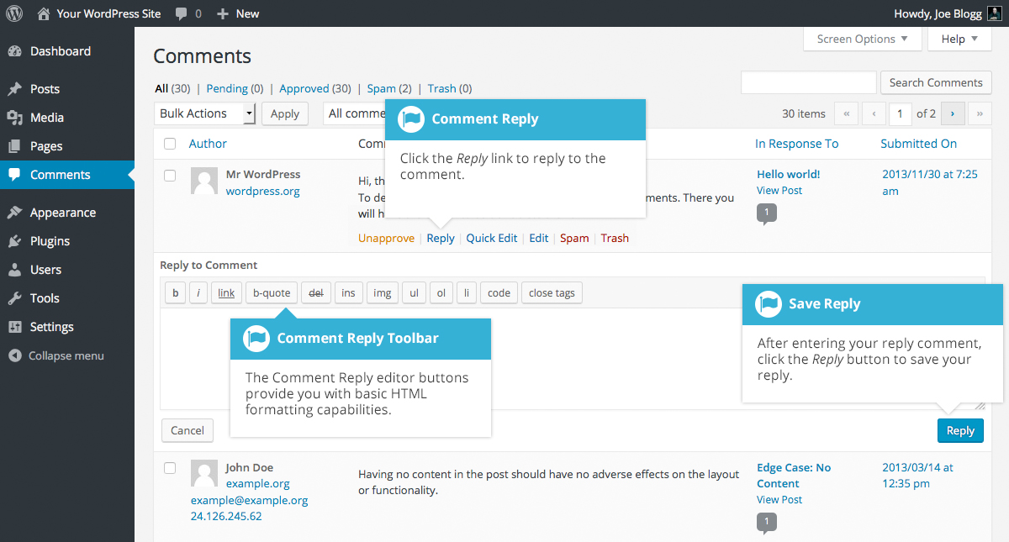
When you’ve written your comment, click the Reply button or alternatively, click Cancel to stop replying and cancel your editing.
The editor that appears when replying or editing a comment (using either the Reply, Quick Edit or Edit links) is much like the editor when creating or editing a Page or Post, only not as intuitive. At the top of the editor there are numerous formatting buttons. These buttons provide you with basic html formatting capabilities when composing a new reply comment or editing an existing comment.
The buttons work in two ways. Clicking a button without highlighting any text first, will simply insert the opening html tag relevant for that button. As an example, clicking the Bold button will insert the <strong> html tag into your comment. Clicking the Bold button again will close the tag by inserting the closing </strong> tag. If you highlight some text prior to clicking a button, both the opening and closing tags will be inserted around that highlighted text. For example, highlighting the text, ‘bold text’, prior to clicking the Bold button will insert ‘<strong>bold text</strong>’.
Bold – Bold text
Italic – Italicise text
Link – Used to insert a website link. When the button is clicked a pop-up window will appear where you type in the URL that you would like to link to
Blockquote – Used as a way of showing a quote. How this looks will be entirely dependent on the Theme that your site is currently using
Delete - Used as a way of showing deleted text. How this looks will be dependent on the Theme but is usually done by showing the text with a strikethrough
Insert - Used as a way of showing inserted text. How this looks will be dependent on the Theme but is usually done by showing the text with an underline
Image – Used to insert an image into the comment. When the button is clicked a pop-up window will appear where you type in the URL of the image that you would like inserted
Unordered List – Used to insert an unordered (or un-numbered) list
Ordered List – Used to insert an ordered (or numbered) list
List Item – Used to insert a list item into your ordered or un-ordered list
Code – Used for indicating a piece of code
Close Tags – Used to close open tags. If for example, you clicked both the Bold and Italic buttons to insert their opening tags, clicking the close tags button will insert both of the matching closing tags, in the correct order

Editing a Comment
There are two ways to edit a comment. Once you hover over an individual comment you can click the Quick Edit link or the Edit link. Both perform a similar function except that the Edit option also allows you to mark the comment as either Approved, Pending or Spam as well as change the Date and Time.

Quick edit
Clicking Quick Edit will replace the comment with an editor that allows you to update the comment, the comment authors name, email address and URL.
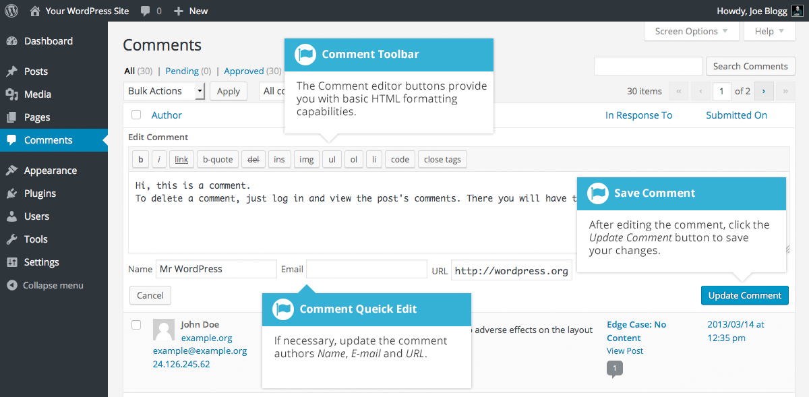
Once you have finished, click Update Comment to save your changes or click Cancel to cancel your changes and return to the list of comments.

Edit
Clicking Edit will display the editor on a new page. Like the Quick Edit option, you can update the comment, the comment authors name, email address and URL. The Edit option also gives you the ability to set the comment Status and change the comment Date and time. The comment status can be set to Approved, Pending or Spam. You also have the option to move the item to the Trash by clicking on the Move to Trash link.
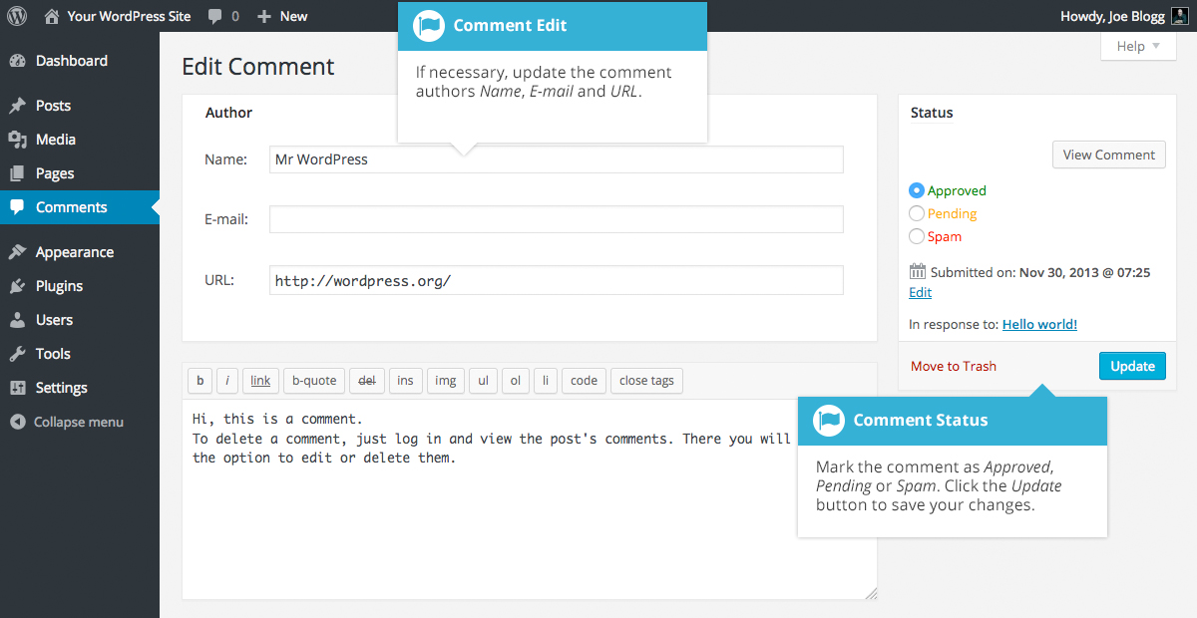
You can change the date and time that the comment was submitted by clicking on the Edit link next to the date and time. After clicking Edit, several fields appear below the original date and time. Update the fields if required and click the OK button to save the new date and time.
Once you have finished updating the comment, click the Update button to save your changes. If you want to cancel your changes, click the browser Back button or click on the Comments menu option to return to the list of comments.

Unapproving and Approving Comments
If an inappropriate comment has been submitted, you may wish to Unapprove it. This will stop the comment from displaying on your site. Hover your cursor over the comment and click the Unapprove link to unapprove the comment.
Comments that are already Unapproved will be displayed with a different coloured background within your list of comments. They will also be highlighted with a red vertical bar down the left side of the row. Hovering your cursor over the comment will display an Approve link instead of an Unapprove link.
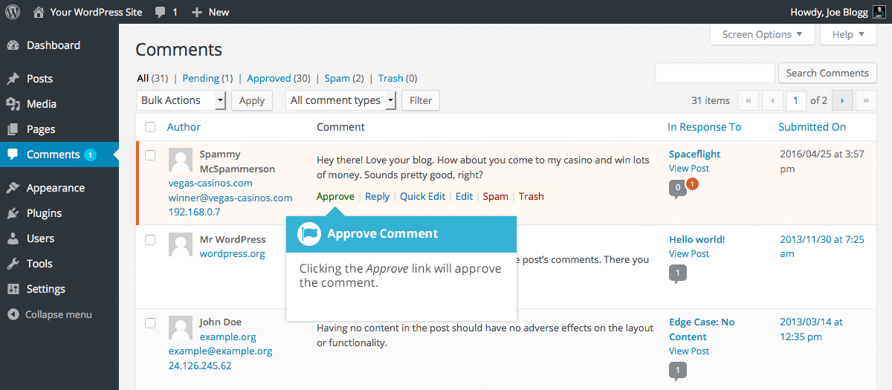

Marking Comments as Spam and Trash
If a spam comment has been posted to your site you can mark it as spam simply by hovering your cursor over the comment and clicking the Spam link. If you’re using the Akismet plugin and you come across a spam comment that Akismet missed, marking it as spam will help Akismet learn and it will be less likely to miss similar spam in the future.
If you simply want to remove a comment, hover your cursor over it and click the Trash link.
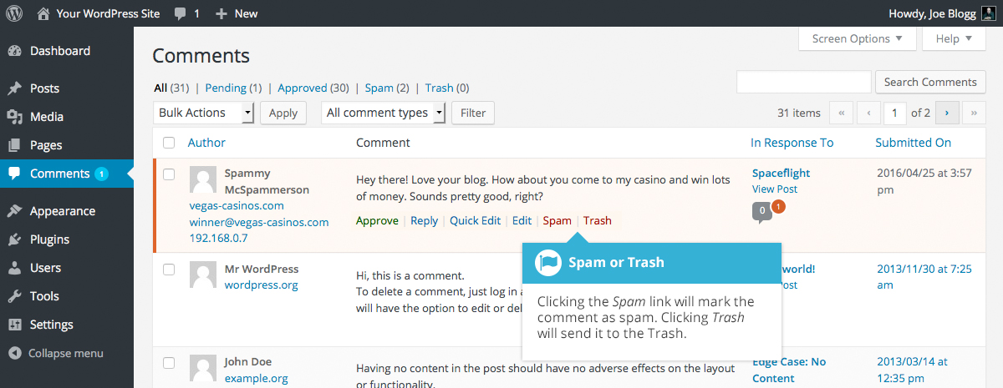
To empty the Trash, click on the Trash link at the top of the page to display all the comments that have been marked as Trash. This link will be displayed along with a number within brackets which indicates how many comments are marked as Trash. To permanently remove all these comments, click the Empty Trash button. You will not be prompted for confirmation.
To remove all the spam comments, click on the Spam link at the top of the page to display all the comments that have been marked as spam. This link will be displayed along with a number in brackets which indicates how many spam comments there are. To permanently remove all these comments, click the Empty Spam button. You will not be prompted for confirmation.
You can also delete a single spam comment permanently by clicking on the Delete Permanently link that appears when hovering your cursor over each row. You will not be prompted for confirmation.
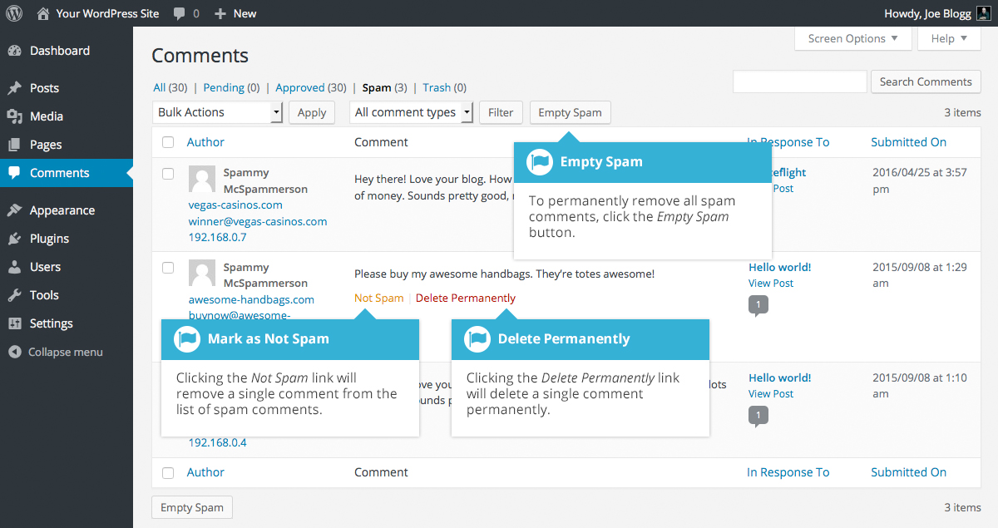
If you find there are comments that have been marked as spam that shouldn’t be, click the checkboxes next to them and select Not Spam from the Bulk Actions drop down at the top of the page. Click the Apply button to confirm your choice. Alternatively, click the Not Spam link that appears when hovering your cursor over each row.

Appearance
The various Appearance menus allow you to change how your site looks and behaves. If your site has been setup for you by a third party then it’s more than likely that you won’t need to change any of the settings in here.
Depending on the theme that your site is running, you may find that you don’t have all the menu options listed here, or you may have a couple of different ones. The reason for this is that a couple of the options under the Appearance section are theme based. For example, the default Twenty Fourteen theme allows you to customize options for how your theme displays. Not all themes will have these option pages, or if they do, they may be under another menu entirely.

Selecting your Theme
The overall appearance of a WordPress site is controlled by the Theme. Although there is a default theme that comes installed with WordPress, most people will either download a new theme, purchase one, or have one custom designed and built. There are hundreds of places where themes can be downloaded for free and/or for a small fee. One of the best places to start looking for themes is in the official WordPress Themes Directory.
Clicking on the Appearance menu option will default you at the Themes screen. The theme that is currently active is shown at the top left of the screen. The other themes shown are ones that are installed, but not currently in use. To see a preview of your site in another theme (that isn’t currently active), you can click the Live Preview button associated with each theme. While the preview screen is displayed, you’re able to click your site links to view your various pages in the new theme layout as well as make various theme changes. To change your site to another Theme, hover your cursor over the theme you’d like to activate and click the Activate button that appears underneath the Theme. Alternatively, if the preview window is displaying, you can click the Save & Activate button in the top left corner of the window to activate the theme.
To view more details about a particular theme, hover your cursor over a theme thumbnail image and click on Theme Details. A pop-up window will appear that displays a larger image along with the theme description and other details.
Clicking on the Add New button at the top of the page allows you to upload a new theme to your site as well as search the WordPress Themes Directory for new themes and install them directly from within your Dashboard.
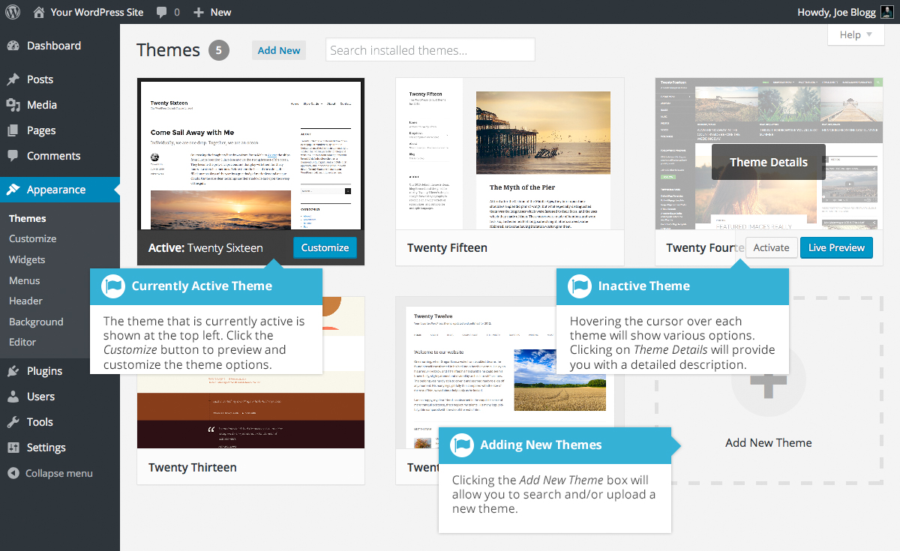

Previewing and Customizing your Theme
As well as the ability to preview a theme, you can also update various theme settings all while previewing the changes live. The options that you can change will be dependent on the individual theme.
For the currently active theme, clicking the Customize button allows you to update various settings whilst also previewing those changes. Until you click the Save & Publish button, only the theme preview window is updated, not the theme on your live site.
For all other installed themes that are not currently active, click the Live Preview button to preview the theme, update its settings and activate the theme. Until you click the Save & Activate button, only the theme preview window is updated, not the theme on your live site.
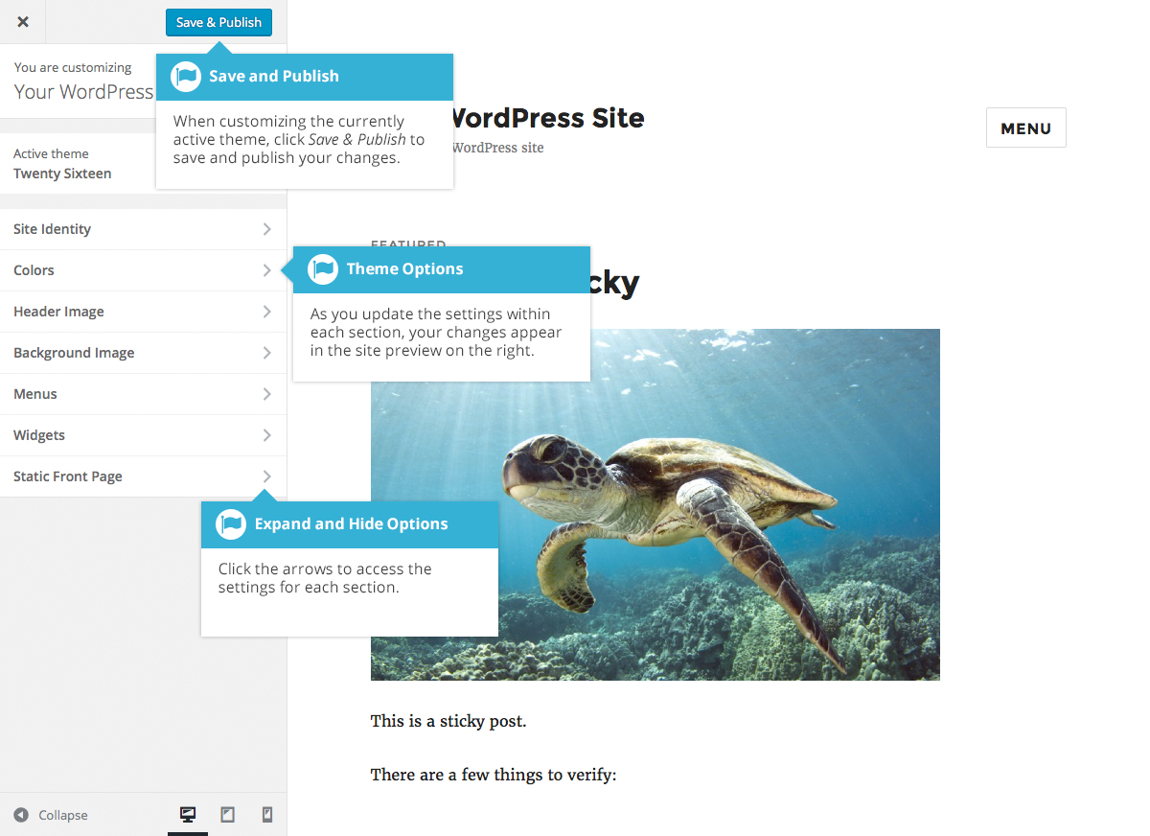

Adding a new Theme
You’re able to add new themes to your site right within the WordPress Dashboard. At the top of the Themes screen there is an Add New button. Click this button to search and add new themes into your site.
After clicking the Add New button, you’ll be shown the Add Themes screen. It should look similar to the screen below. The Add Themes screen allows you to search and install themes directly from the official WordPress Themes Directory. By default, the screen will show a list of Featured themes.
You can use the links at the top of the page to filter the results to see Featured themes, Popular themes or the Latest themes. Click the Feature Filter link to filter the results based on the Tags you specify. There are Tags for Colors, Layout, Features and Subject.
Alternatively, click the Search themes... input field and enter text to search for a specific theme.
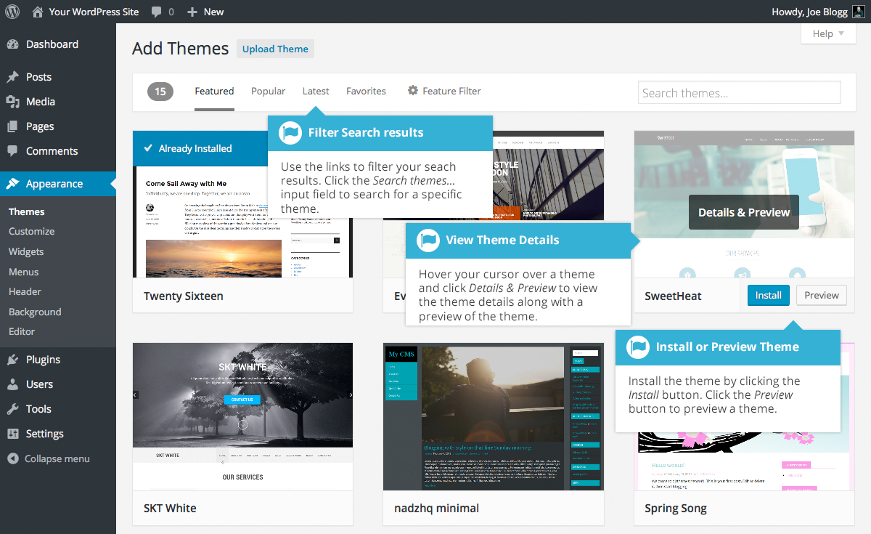
Hovering your cursor over each theme thumbnail will display extra buttons. To view the details of a theme along with a preview, click the large Details & Preview button or the smaller Preview button. Clicking the Install button will download and install the theme on your site. After the theme is installed, you will be given the choice to view a Live Preview, immediately Activate the theme or return to the Theme Installer.

Customizing your Site
Using the Customizer, you can modify certain parts of your website. When you click on the Customize menu option you’ll be shown the various theme options that you can change. Depending on the theme that is currently in use, you may see more or less options than those displayed in the following image.
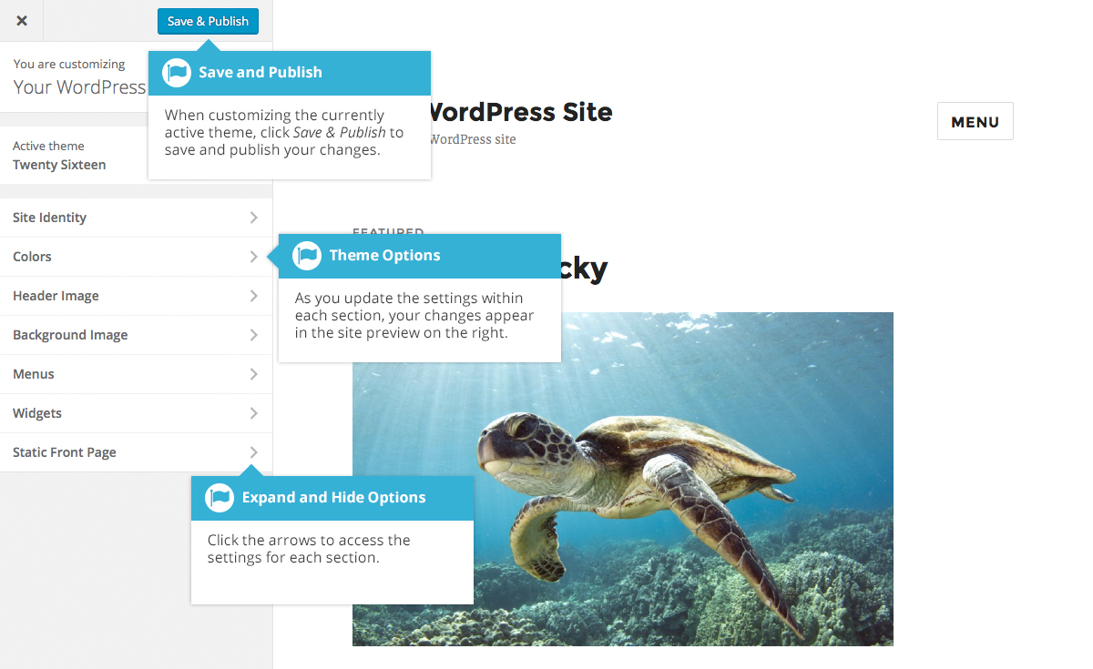
Clicking the small arrows will open and close each of the panels, giving you access to each of the various options. You’ll find that some of the options in the Customize screen are also available via other menu options. As an example, you can change the Site Title and Tagline using the General option under the Settings menu.
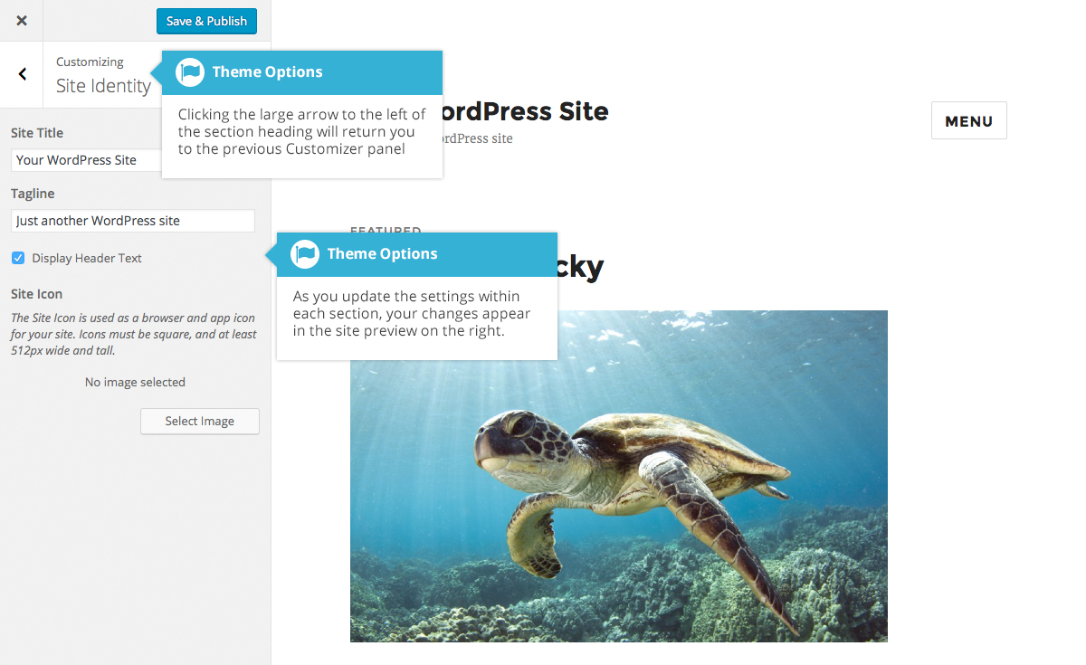
As you make your changes on the left-hand side of the Customize screen, the theme preview on the right-hand side is automatically updated.
Until you click the Save & Publish button, only the theme preview is updated, not the theme on your live site.
To help with testing your site across various devices, the Customizer also allows you to preview your site in mobile, tablet and desktop views. At the bottom of the Customizer panel, click one of the view icons () to change your site preview so that you can get an idea of how it will display on a regular desktop, a tablet or smartphone device.

Widgets
Widgets are independent sections of content that can be placed into any widgetized area provided by your theme. Although these widgetized areas are commonly called ‘Sidebars’ and are quite often located in the left or right-hand column, they can be also located anywhere within your site and are entirely dependent on the current theme as to their location. Lots of themes use these widgetized sidebars in the footer area.
There are numerous widgets available by default which allow you to add extra content to your site, such as Recent Comments, Categories or Custom Menus, just to name a few. New Widgets can also be installed via plugins and again, depending what the plugin is used for the extra functionality it brings to your site will vary.
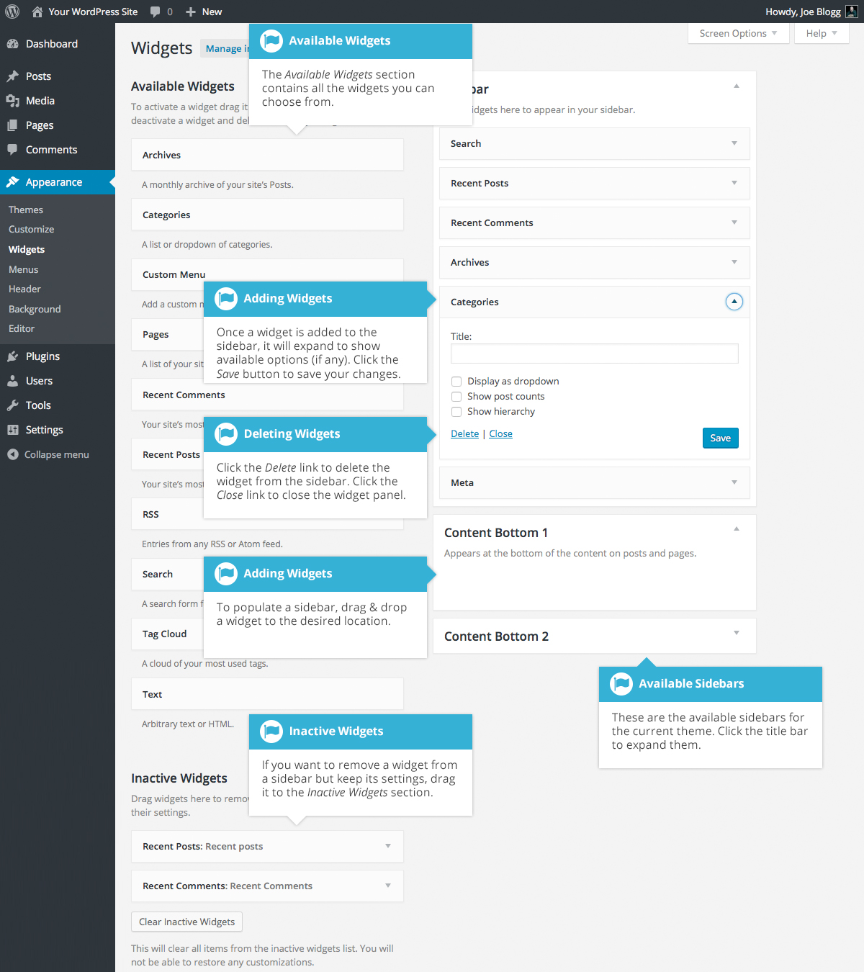
The Available Widgets section contains all the widgets you may choose from. To populate one of your Sidebars, drag and drop a widget to the desired location. Once the Widget is dragged to a Sidebar, the widget will open up to allow you to configure its settings. Click the Save button within the Widget to save your settings.
If you want to remove a widget from a Sidebar but save its settings for future use, drag it into the Inactive Widgets section. If you simply want to delete the Widget from your Sidebar, click the Delete link within the Widget.
The small arrow next to the Sidebar title will toggle the sidebar open and closed. If you drag and drop a widget onto a closed sidebar, the sidebar and widget will automatically open.

Updating the Menu
If your theme supports custom menus, you can make modifications to them from the Menus option. Menus can contain links to Pages, Posts, Categories, Custom Links or other content types.

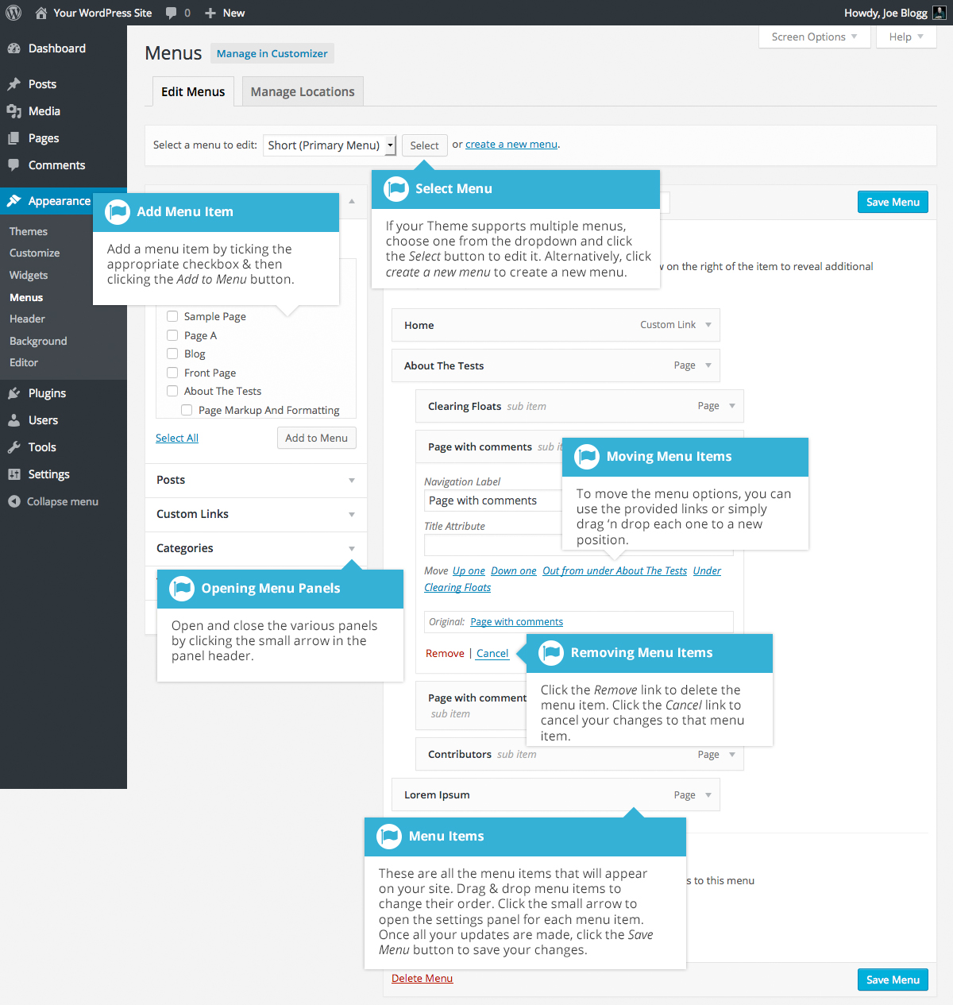

Adding a New Menu
Depending on the current Theme being used, your site may make use of more than one navigation menu. Sometimes you might have multiple menus in your site header, other times you may even have menus located in the sidebar or footer of your site.
To add a new menu, hover your cursor over the Appearance menu option in the left-hand navigation menu and in the fly-out menu, click the Menus link. Alternatively, click the Appearance menu option and then click the Menus link underneath.
On the screen that’s displayed, click the create a new menu link. You’ll be presented with a screen similar to below. Enter a name for your new menu in the Menu Name input field. Click the Create Menu button to create your new menu.
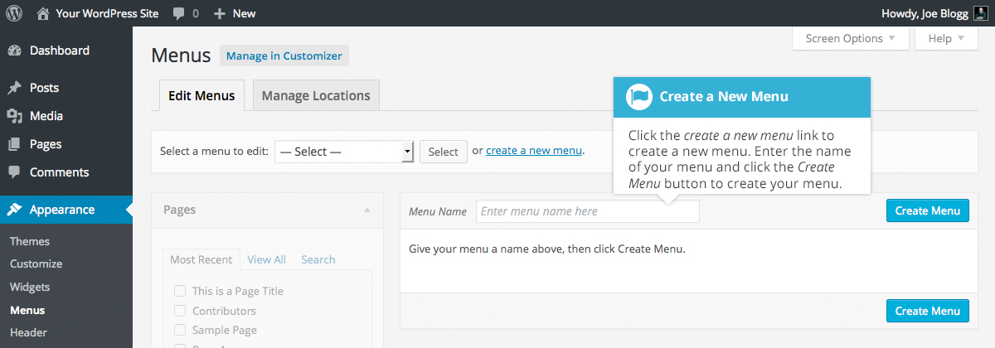

Editing an Existing Menu Item
Your current list of menu items resides in the right-hand column on the menu screen. If there are multiple menus on your site, there will be a dropdown list displayed at the top of the page that enables you to select the menu that you would like to edit. Simply select the menu you would like to edit from the Select a menu to edit dropdown list and then click the Select button. The menu items for your selected menu will then be displayed.
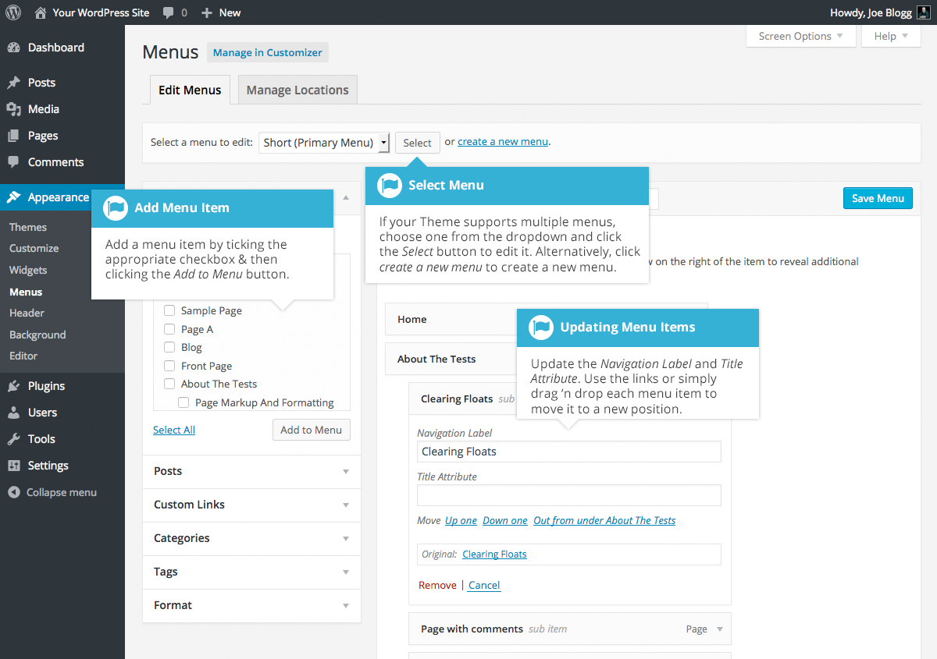
The items in this right-hand column on the Menus page will match the menu items that appear on your website. Clicking on the down arrow next to each menu item name will show an options panel for that particular menu item. In this options panel, there are several items that can be updated. You can show or hide extra fields such as Link Target, CSS Classes, Link Relationship (XFN) or Description using the Screen Options tab at the very top-right of the screen.
- URL – Only displayed for Custom Links and will contain the URL to navigate to when that menu item is clicked
- Navigation Label – This is the label that will display within the actual menu on your website
- Title Attribute – This is the tooltip that appears when the mouse cursor hovers over the menu item
- Open link in a new window/tab – (Hidden by default) You can set the menu item to open in the same window or tab (which is the default) or in a new window or tab. This option is made visible by ticking the Link Target option on the Screen Options panel
- CSS Classes – (Hidden by default) Optional CSS Classes to add to this menu item. This option is made visible by ticking the CSS Classes option on the Screen Options panel
- Link Relationship (XFN) – (Hidden by default) Allows for the generation of XFN attributes so you can show how you are related to the authors/owners of site to which you are linking. This option is made visible by ticking the Link Relationship (XFN) option on the Screen Options panel
- Description – (Hidden by default) The description for the link. This may or may not appear, depending on the theme This option is made visible by ticking the Description option on the Screen Options panel
Each menu item can be moved to a new location in the menu hierarchy by using either the links underneath the Navigation Label input field or by clicking on the title area of the menu item and dragging ‘n dropping the menu to new location. If you choose to drag ‘n drop your menu items, the cursor will turn into a four-pointed arrow when you’re hovering over the correct area.
After making updates to your menu items, click the Save Menu button at the top or bottom of the screen.

Adding a New Menu Item
By default, only the Pages, Links and Categories panels are shown. If you’d like to add Posts, Tags or Post Formats as menu items, you simply use the Screen Options tab at the top-right of the screen to enable these panels as well.
To add a new Page as a menu item, tick the checkboxes in the Pages panel, next to each of the Pages that you’d like to add. You can select one Page at a time or multiple. After selecting your Pages, click the Add to Menu button. The new menu items will append to the bottom of the current list of menu items. The menu item name will default to the Page name. To change this, simply click on the down arrow next to the menu item name to view the options panel and then update the Navigation Label to your preferred name. After making your updates, click the Save Menu button at the top or bottom of the screen. The steps to add a Post, Post Format, Category or Tag as a menu item are exactly the same as adding a Page.
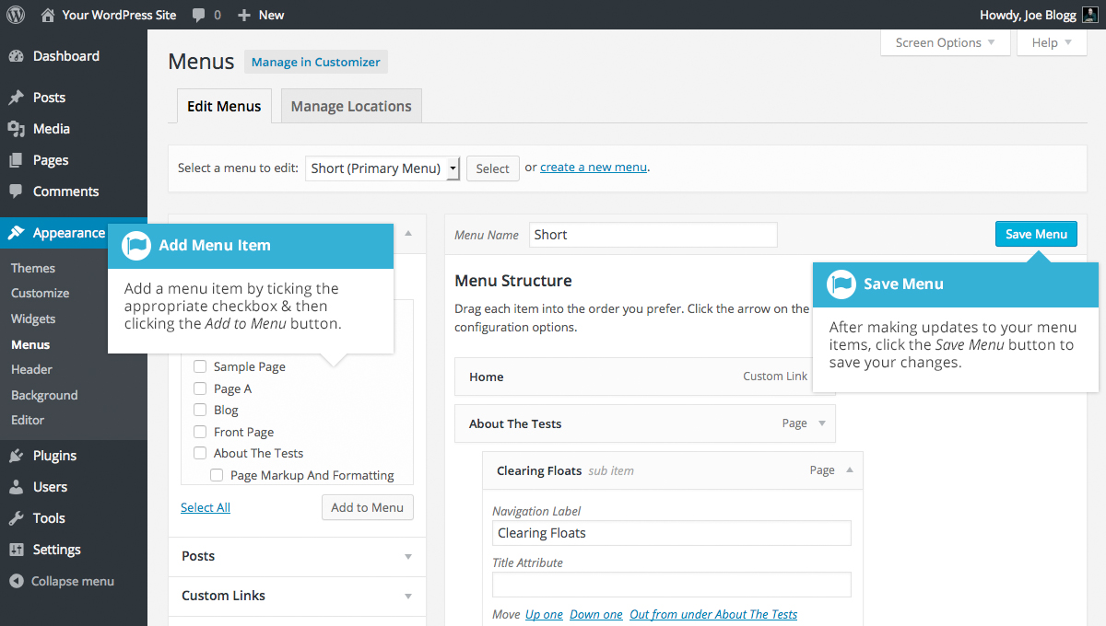
To change the order that the menu options appear in, simply place your cursor over the title area of the menu item you’d like to move. When the cursor changes to a four-pointed arrow, click and drag the menu item to its new location. Depending on how your menu is configured within your theme, it’s even possible to create the multi-level hierarchy required for dropdown menus. After moving your menu items around, don’t forget to click the Save Menu button at the top or bottom of the screen to save your changes.

Adding a Custom Link Menu Item
Use the Links panel to add a custom link to your menu, such as a link to an external website. Simply type in the website URL in the URL field and the menu name in the Link Text field. Click the Add to Menu button when done. Use the same steps outlined previously to adjust the order of the menu item and click the Save Menu button at the top or bottom of the screen to save your changes.
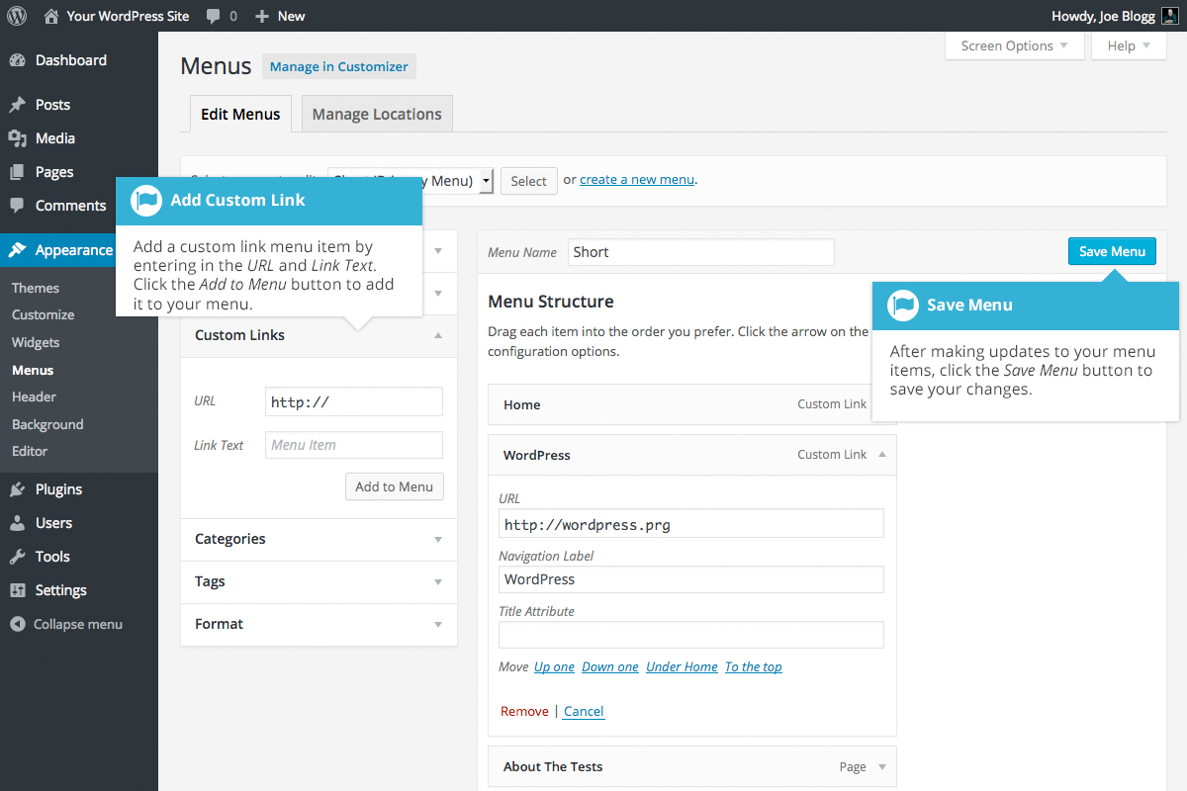

Deleting a Menu Item
To delete a menu item click on the down arrow next to the menu item name to view the options panel for that item and then click the Remove link. After making your updates, click the Save Menu button at the top or bottom of the screen.
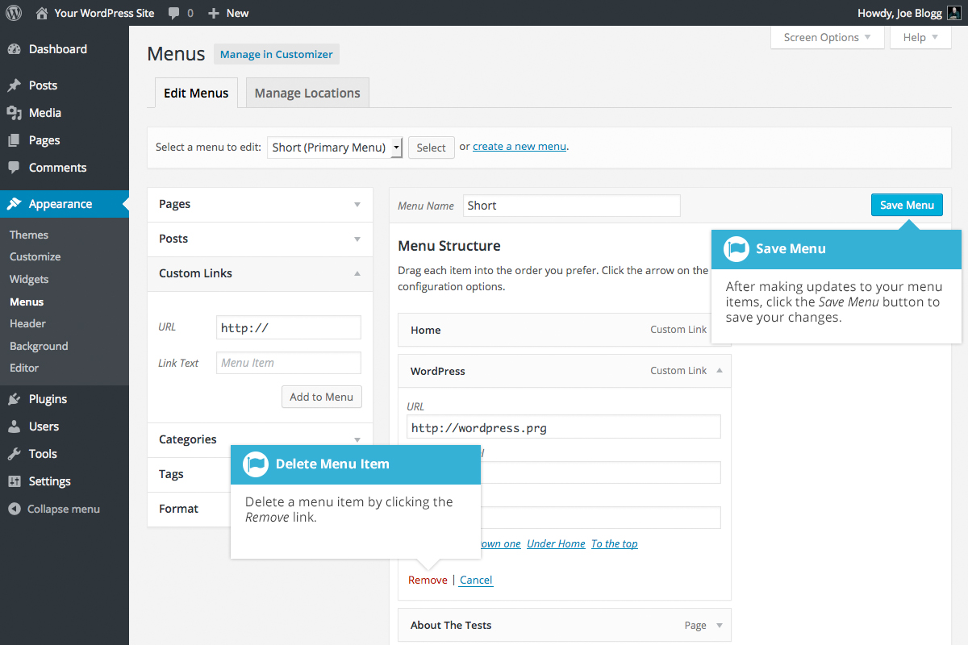

Managing Menu Locations
After you create a menu, you also need to tell WordPress where to use it. This is where the Manage Locations tab on the Menus page comes in.
After clicking the Manage Locations tab on the Menus page, you will be shown a page similar to below, with a list of the various menu locations used in your Theme. You may have one menu location or you may have multiple, depending on the Theme currently in use. Your menu location won’t necessarily be called ‘Primary Menu’ either, as shown below. Again, that will depend entirely on your Theme.
Assign an existing menu that you’ve created to the appropriate location by selecting it from the dropdown list. Click the Save Changes button to save your changes.
Alternatively, you can choose to create a new menu and automatically assign it to the location by clicking the Use new menu link.
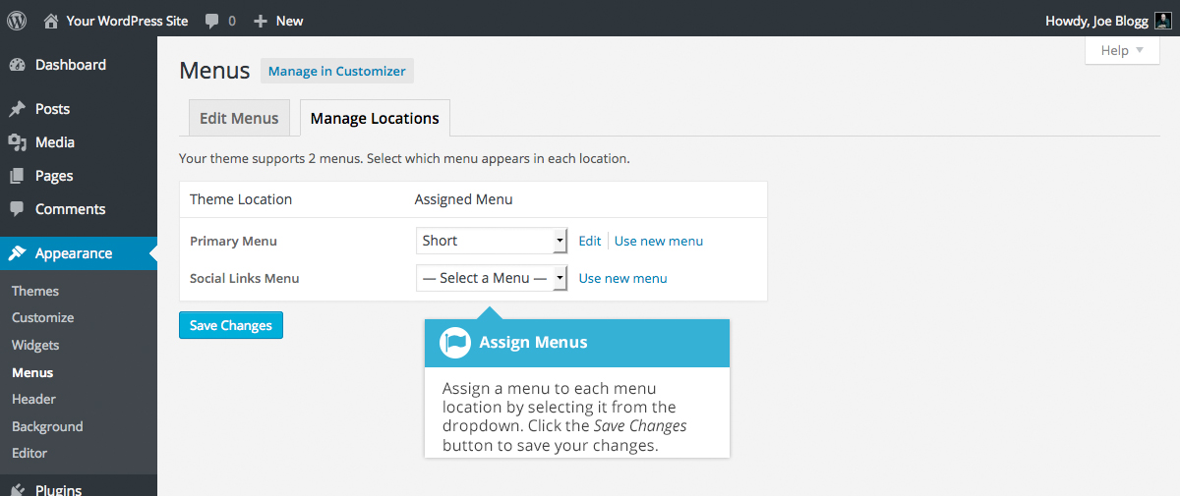

Header
The Header menu option will only be available if your current Theme is making use of this option. It allows you to choose an image to display in the header area of your site. Clicking the Header menu option will take you to the Header Image option in the Customizer. You can select one of your previously uploaded images or you can upload a new image by clicking the Add new image button. To save your changes, click the Save & Publish button at the top of the page. Again, depending on the theme you’re using you may or may not have this Header option.
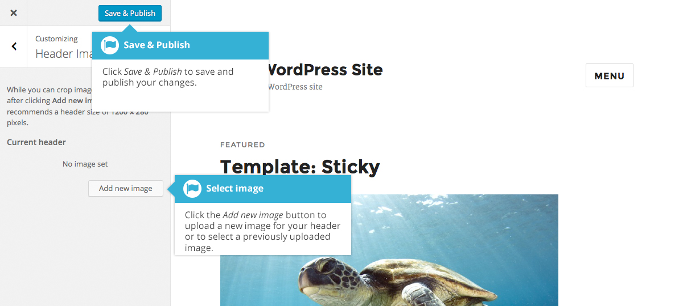

Background
The Background menu option is another theme specific menu. It allows you to choose a background image for your site. Clicking the Background menu option will take you to the Background Image option in the Customizer. You can select one of your previously uploaded images or you can upload a new image by clicking the Select Image button. To save your changes, click the Save & Publish button at the top of the page. Again, depending on the theme you’re currently using you may or may not have this Background option.
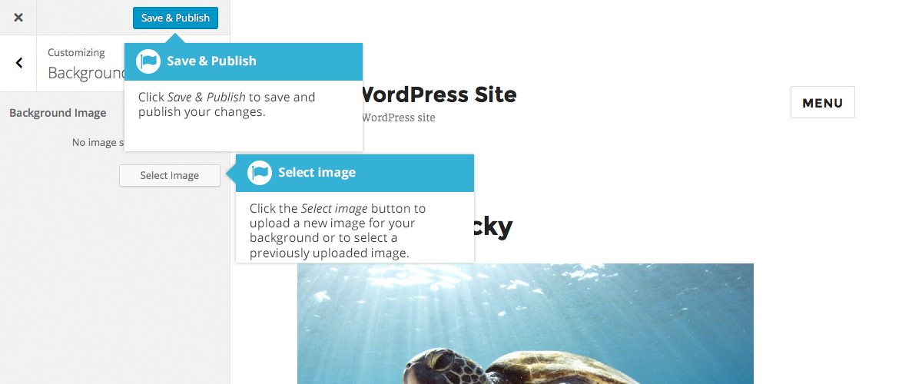

Editor
The Editor menu allows you to edit the individual CSS and PHP files which make up your Theme. Normally once a theme is installed and configured on your site, there's no need to make any changes within here. Extreme care should be taken with this option to avoid making changes to files that will affect how your site is displayed. Incorrectly modifying any files within this section can cause your site to display incorrectly or at worst, not at all. Extra caution must be taken if you intend to make any changes here.
It cannot be stressed enough how dangerous this option is if you know nothing about HTML, CSS or PHP. Modifying your theme files can drastically change how your site displays and depending on what gets changed, can even stop your site from displaying altogether.

Plugins
Plugins extend and expand the functionality of WordPress. Once a plugin is installed, you may activate it or deactivate it here. There are thousands of plugins available that provide a huge range of functionality. The easiest place to find them is within the official WordPress Plugin Directory. You can search and install new plugins by clicking on the Add New button at the top of the page or the Add New link in the left-hand navigation menu.
Once a plugin has been added to your site, it needs to be ‘turned on’. To do this, click the Activate link to activate it. Depending on the plugin, you might also find that there are settings that need to be configured.
Activated plugins will be displayed with a different coloured background within your list of plugins. They will also be highlighted with a blue vertical bar down the left side of the row. If an activated plugin also has an updated version available, the background colour will change and the vertical bar will be red.
If any of your installed plugins have available updates, a small number will appear next to the Plugins menu option. The number will advise you as to how many plugins have updates available. A message will also be displayed just below the plugin name and description, advising that it has an update, along with a link that allows you to view the details for the new version and another link for updating the plugin.
Prior to updating a plugin, it’s wise to verify that the plugin functionality hasn't changed significantly as to adversely affect your site. It’s also recommended to check that the plugin and your site still works as expected, once it has been updated.
When you click the update now link just below the plugin description, the plugin will automatically update whilst you remain on the Plugins page. You will be notified when the plugin has completed updating and the background will also change colour to indicate that it no longer needs to be updated.
If you have plugins that have been deactivated because you’re no longer using them, it’s good practice to remove them from your site. You can do this by clicking the Delete link underneath the plugin name.
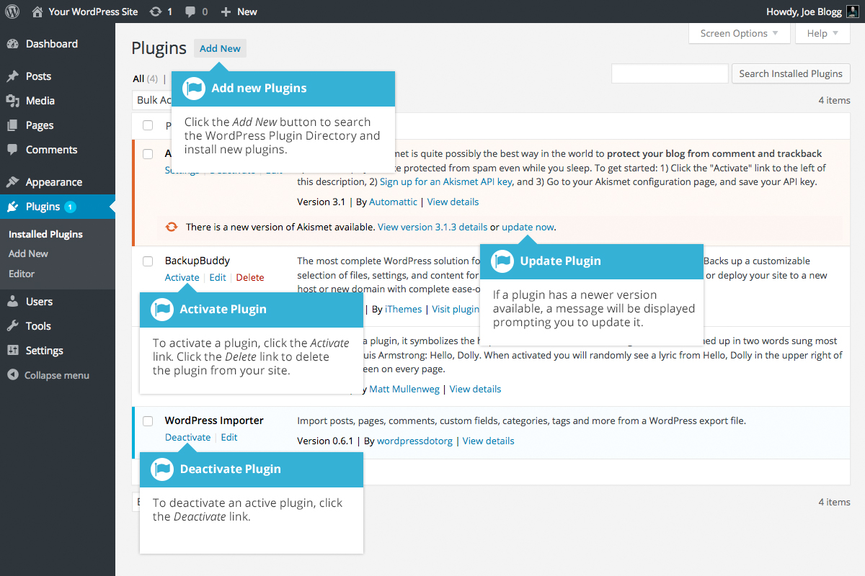

Adding a New Plugin
To add a new plugin, click on the Add New link in the left-hand navigation menu or the Add New button at the top of the page.
The Add Plugins page will display a list of the current featured plugins from the WordPress.org Plugin Directory. You can use the links at the top of the page to filter the results to see Featured plugins, Popular plugins, Recommended plugins or a list of the plugins that you’ve marked as ‘Favorite’ within the WordPress.org Plugin Directory. If you click the Favorites link, you’ll need to enter in your WordPress.org username and then click the Get Favorites button so that it can retrieve your list.
You can also click the Search Plugins input field and enter text to search for a specific plugin.
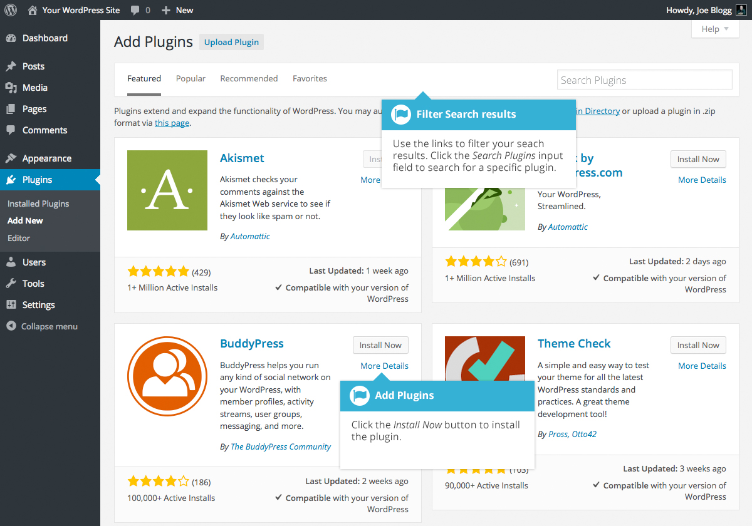
To view more information about a particular plugin, click the thumbnail image, the plugin name or the More Details link. A pop-up window will display more information about the plugin such as the plugin Version, Author and the date it was Last Updated. You can also read the full plugin description, installation notes, view screenshots and read any reviews that have been left.
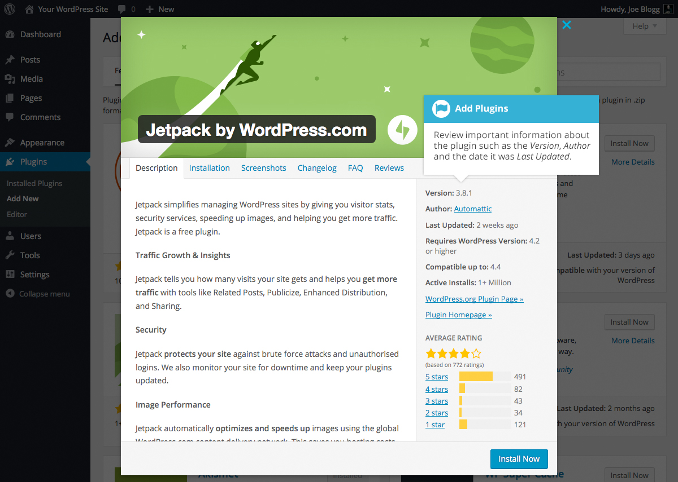
After clicking the Install Now button, the plugin will be automatically downloaded to your site and installed. You are then given the option to activate the plugin or return to the plugin installer page.
On the Add Plugins page, you also have the option to manually upload a plugin to your site. To upload a plugin, click the Upload Plugin button at the top of the page.
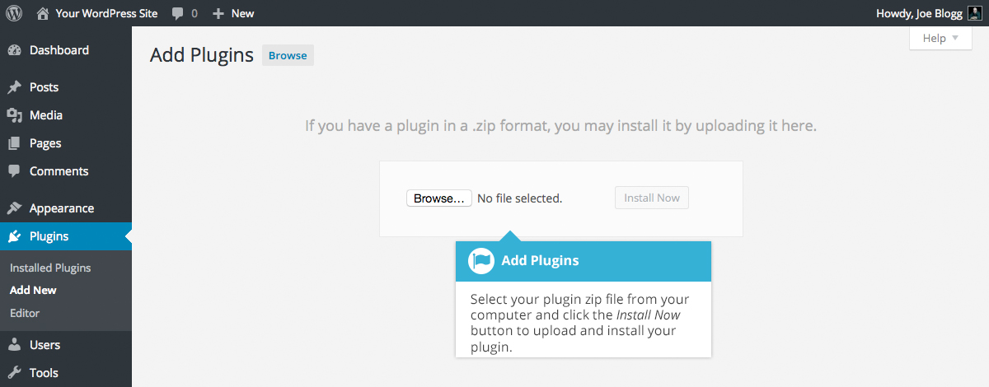
Select your plugin file from your computer by clicking the Browse... button. Your plugin file must be uploaded in .zip format.
After clicking the Install Now button, your plugin will be automatically uploaded to your site and installed. You are then given the option to activate the plugin or return to the plugins page.

Users
This screen lists all the existing users for your site. Users with roles other than Administrator will see fewer options when they are logged in. Depending on your Role, you can also add new users as well as manage their Roles.
At the top of the screen there are links that allow you to filter the list of Users based on the User Roles. The number in brackets will advise how many there are for that particular type.
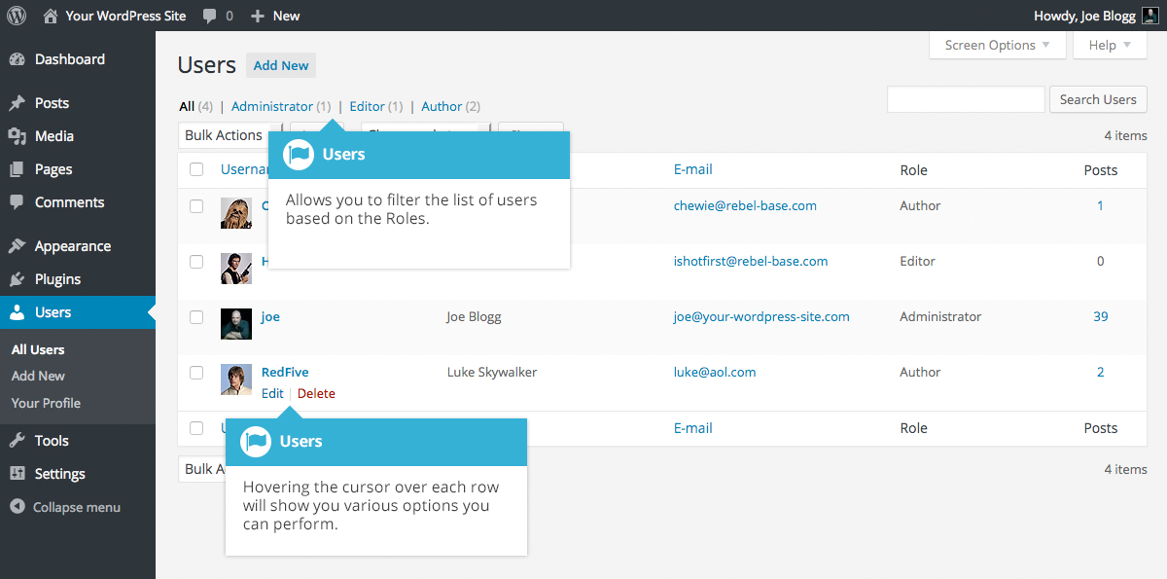
When hovering your cursor over each row in the list of Users, links will appear beneath the user name.
- Edit – Allows you to edit the user profile
- Delete – Allows the User to be deleted. This link won’t be available for your own profile
A User can have one of five defined roles as set by the site admin: Site Administrator, Editor, Author, Contributor, or Subscriber.
- Super Admin – (Only relevant when running multiple sites from one WordPress installation). Someone with access to the blog network administration features controlling the entire network
- Administrator – Somebody who has access to all the administration features
- Editor – Somebody who can publish and manage posts and pages as well as manage other users' posts, etc.
- Author – Somebody who can publish and manage their own posts
- Contributor – Somebody who can write and manage their posts but not publish them
- Subscriber – Somebody who can only manage their profile
When WordPress is first installed, an Administrator account with all capabilities is automatically created.
The avatar that is displayed in the list of Users is using what's called a Gravatar. A Gravatar is a Globally Recognized Avatar. Gravatars are currently used by a huge number of blogs, forums, chat sites and the like. Rather than having to upload an avatar on each and every system you sign up to, Gravatars allow you to have one avatar that is viewable everywhere. To create a Gravatar, simply go to gravatar.com and sign up. To use your Gravatar within WordPress, simply add an email address to your Profile that you’ve configured within the Gravatar site and it will automatically display.

Adding a New User
To add a new user, click on the Add New link in the left-hand navigation menu or the Add New button at the top of the page.
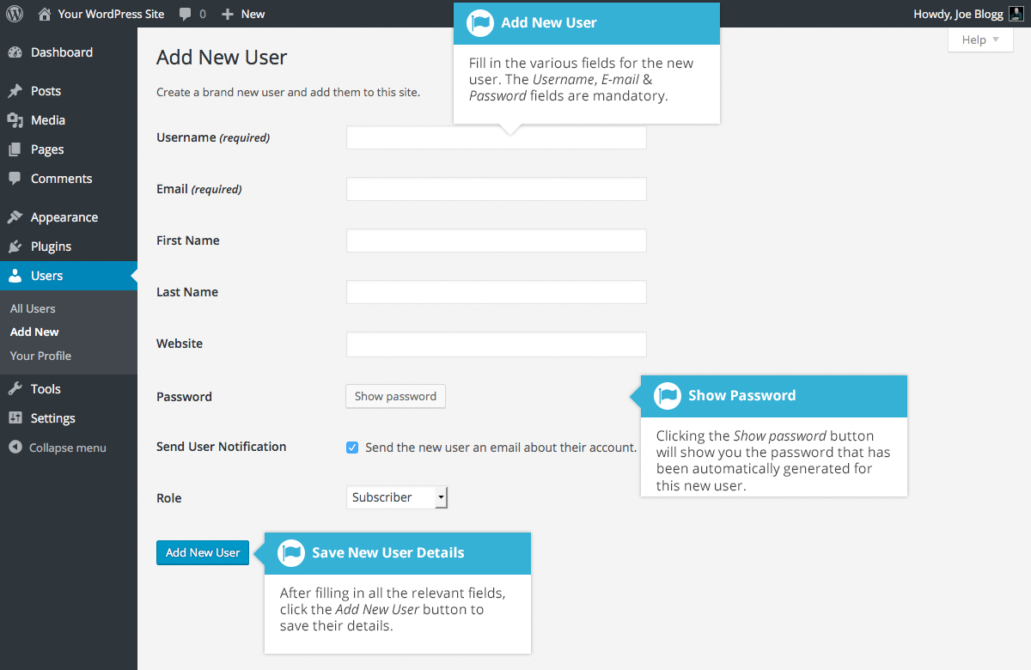
Once the above page is displayed, simply fill in the various fields and click the Add New User button.
- Username – (mandatory) Enter the username of the new user here. This will also be used as the Login name for the user. Once saved, the Username can’t be changed
- E-mail – (mandatory) Enter a valid email address of the new user here. The email address must be unique for each user. If a published Post or Page is authored by this user and approved comments are made to that post or page, a notification email is sent to this email address
- First Name - Enter the first name of the new user here
- Last Name – Enter the last name of the new user in this text box
- Website – You may enter the new user's website URL in this text box
- Password – Clicking the Show password button will show you the password that has automatically been generated for the new user
- Send User Notification – When ticked, WordPress will send your new user an email about their account
- Role – Select the desired Role for this user from the dropdown list
WordPress will now automatically generate a strong password when you create a new user. Clicking the Show password button will display the password that was generated and if you want, will also allow you to change it. The password strength indicator, shown just below the password field, must indicate at least Medium before WordPress will allow you to save the new user. It goes without saying, the stronger the password the more secure the login so it’s advisable that the strength indicator shows your password as being Strong. To make a password stronger, use upper and lower case letters, numbers and symbols like ! " ? $ % ^ & ).
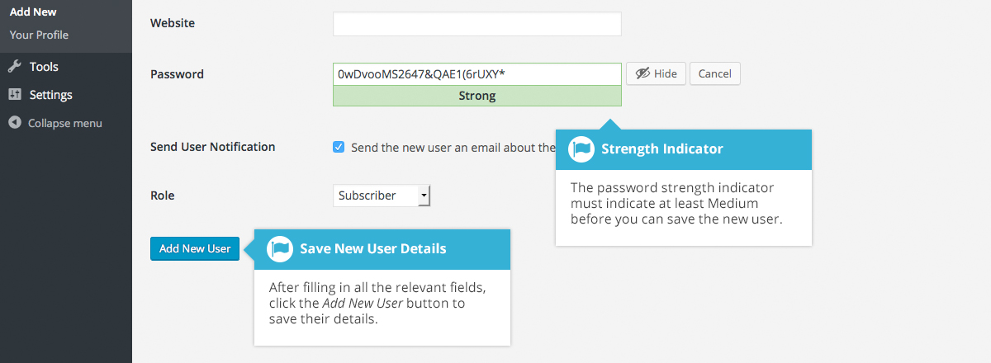

Deleting a User
To delete a user, click on the Delete link that appears beneath the user name when hovering your cursor over each row. The Delete link wont appear for the user that is currently logged in.
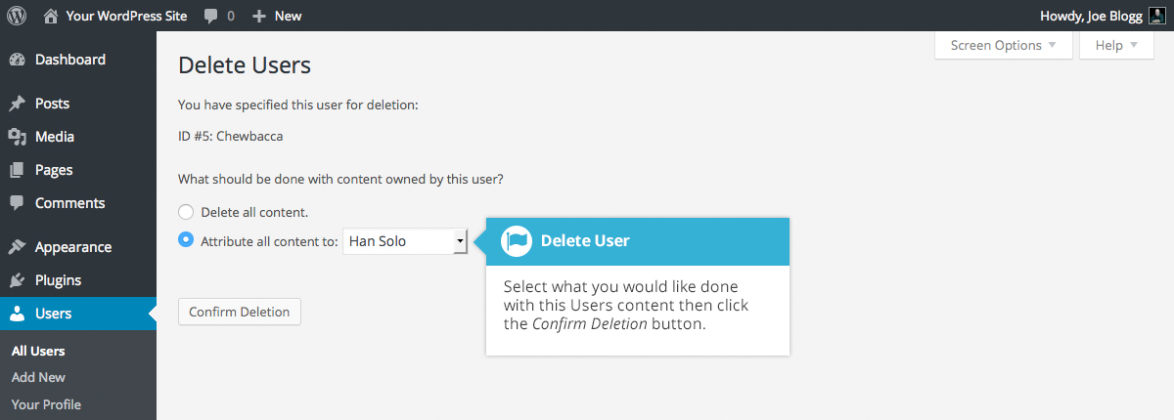
Along with deleting the user you will be given the choice of what to do with all the content currently assigned to that User. The available choices are:
- Delete all content – This will delete all the content which this user created
- Attribute all content to – This will assign all the content currently linked to this User, to another User of your choosing. Simply select the User from the dropdown list
After making your selection, click the Confirm Deletion button to remove the User.

Editing your Profile
To edit your profile details, simply click on your user name, when viewing the list of Users or click on the Edit link that appears beneath your user name when hovering your cursor over each row. Alternatively, click on the Your Profile link in the left-hand navigation.
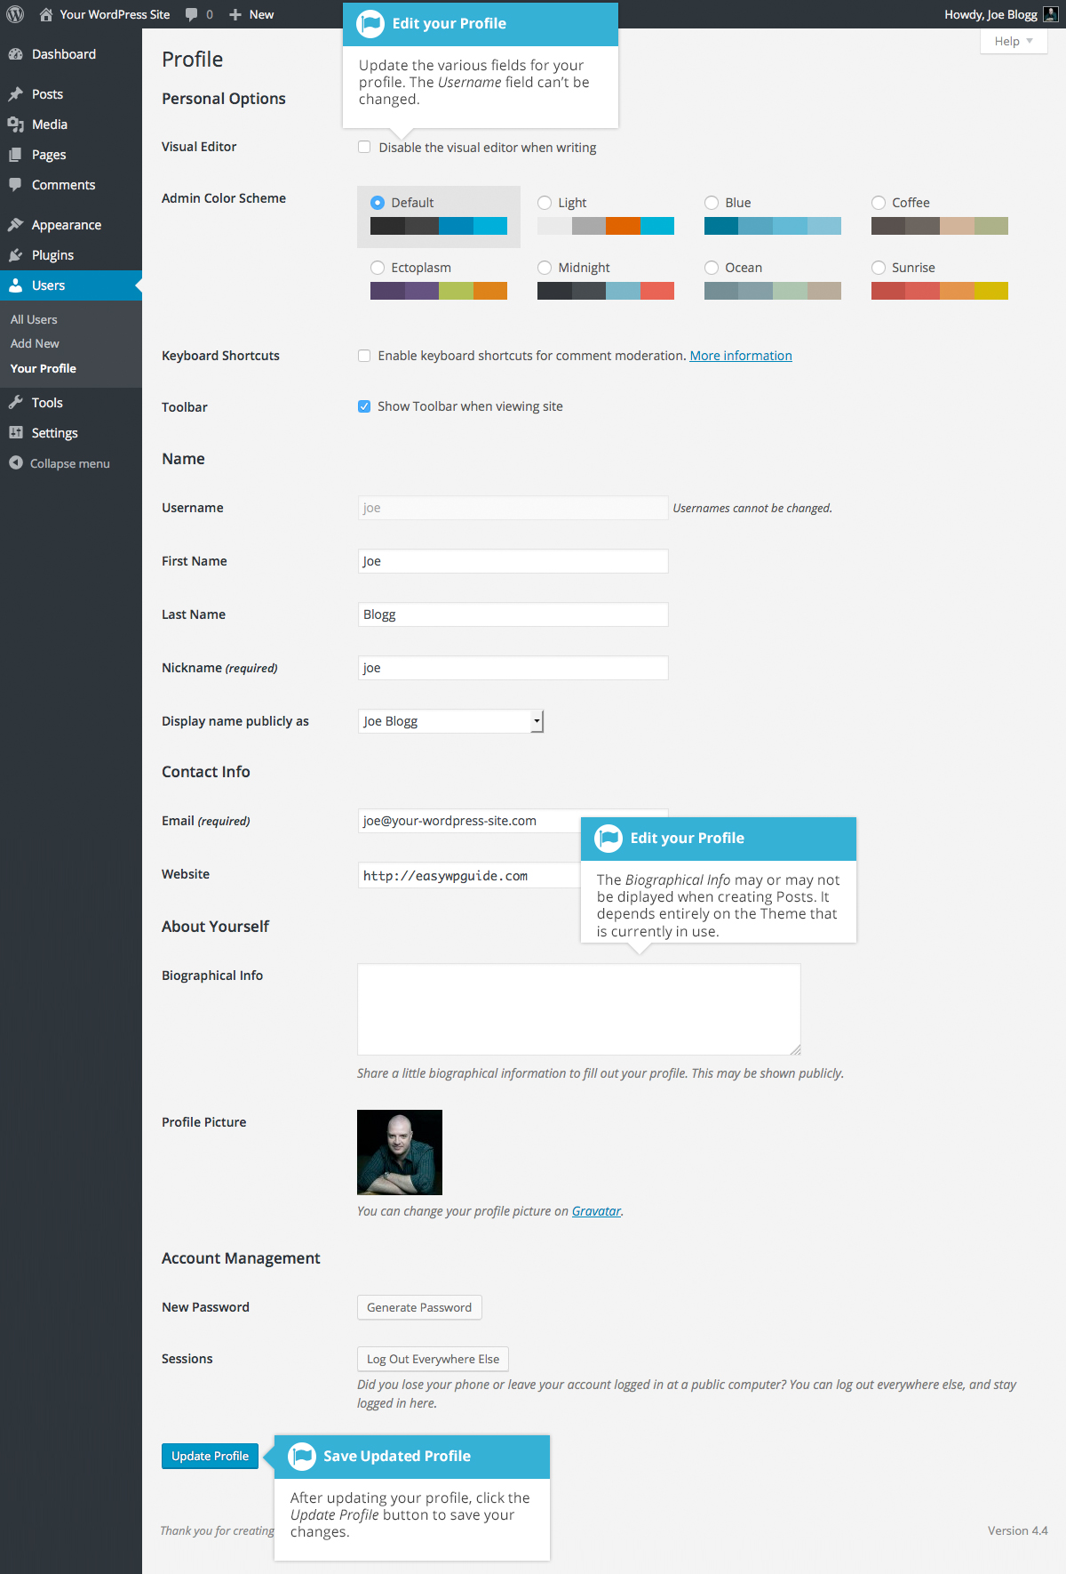
If you’re an Administrator and would like to edit someone else’s profile, click on their user name when viewing the list of Users or click on the Edit link that appears beneath their user name when hovering your cursor over each row.
Update the appropriate fields and then click the Update Profile button to save all your changes.

Personal Options
- Visual Editor – Checking this box disables the Visual Editor when writing and uses the plain html editor
- Admin Color Scheme – Check this radio button next to the colour scheme desired for the administrative panels. You have the choice of eight different color schemes
- Keyboard Shortcuts – Checking this box Enables keyboard shortcuts for comment moderation. Keyboard shortcuts are designed to allow you to rapidly navigate and perform actions on comments
- Toolbar – Checking this box will display the Admin Bar at the very top of your website (only for the person who is currently logged in)

Name
- Username – You cannot edit your Username because it is used as your Username during the login process. Even an Administrator cannot change your Username. Usually, no one else ever needs to see your Username
- First name – Enter your first name in this text box
- Last name – Enter your last name in this text box
- Nickname – (mandatory) The nickname is a requirement for every user. It may be the same as your Username or it can be different. If you don’t supply a Nickname, then the Username will be placed in this field
- Display name publicly as – Select how your name is cited on your blog, from the dropdown list. You can choose from several choices: Nickname, Username, First Name, Last Name, ‘First Last’, or ‘Last First’. If you prefer ‘Last First’, insert a comma after your last name in the Last Name text field and choose the last option from the dropdown list. For security reasons, it’s a good idea to keep this different from your Username

Contact Info
- E-mail – (mandatory) All users are required to list an email address in their respective Profiles. The email address must be unique for each user. Your blog will use this address to notify you of new comments to your posts and for other administrative purposes. Only other registered users of your blog will have access to this email address. It is never sent anywhere
- Website – Enter your website address

About Yourself
- Biographical Info – Enter a short description or profile of yourself here. Depending on your theme, this optional information may be displayed when creating new Posts
- Profile Picture – The avatar that is displayed is called a Gravatar. A Gravatar is a Globally Recognized Avatar. To create a Gravatar, simply go to gravatar.com and sign up. To use your Gravatar within WordPress, simply add an email address to your Profile that you’ve configured within the Gravatar site and it will automatically display

Account Management
- New Password – Click the Generate Password button to generate a new Strong password. A password strength indicator will be shown just below the password field
- Sessions – If you’ve left your account logged in at a public computer or you’ve lost your phone, you can click the Log Out Everywhere Else button to log you out of everywhere except for your current browser

Tools
The Tools menu provides some handy administration tools. Most of the time though, they're used when setting up or configuring your WordPress site and so as such, they won’t be covered here in great detail.

Available Tools
The Available Tools menu option gives you access to two different tools. The Press This bookmarklet and the Categories and Tags Converter. Press This is a little browser app that lets you grab bits of the web and easily create new posts. The Categories and Tags Converter is a tool for converting Categories to Tags or vice versa.

Press This
Press This is a bookmarklet: a little app that runs in your browser that lets you grab bits of the web. It provides you with a handy shortcut within your browser to creating new Posts. Simply Drag-and-drop the Press This link to your bookmarks bar or right click it and add it to your browser favourites for a posting shortcut.

Categories and Tags Converter
The Categories and Tags Converter is a tool to convert existing Categories to Tags or Tags to Categories. Before it can be used it must be installed via the Import menu option.

Import
The Import option provides you with various tools for importing content from other blogging systems. You can import content from Blogger, LiveJournal, Moveable Type, TypePad and Tumblr. You can also import content from Blogrolls that use the OPML Format, posts from an RSS feed or content from other WordPress sites. To import content from another WordPress site you first need to install the WordPress Importer plugin. To import content from another type of site other than WordPress, you’ll be prompted to install the relevant Importer plugin after selecting the type of site that you’d like to import your content from.

Export
The Export option is used to export your data in XML format, from your WordPress site. The export format is called WordPress eXtended RSS or WXR and will contain your posts, pages, comments, custom fields, terms, navigation menus and custom posts. Once you’ve saved the download file, you can use the Import function on another WordPress site to import the content from this site.

Settings
The various Settings screens are used to configure your WordPress site. Normally, once your WordPress site is set up there’s no reason to change any of these settings. These Settings options will only be touched upon very briefly. You can find out lots more information in regards to configuring your site within the WordPress Codex.

General
The General settings configure your basic site preferences such as the Site Title and Tag Line, the WordPress Address and Site Address, the administrators email address and the date and time format, among other things.
The WordPress Address (URL) is the location of your main WordPress core files. The Site Address (URL) is the address you want to use for your site homepage. Usually these two URL’s are the same but they can be different if, for example, you have your WordPress files stored in a subdirectory.
When you install WordPress, you get the option to select the language that you’d like to use within the Dashboard. After installation, if you’d like to change the language, you can select this using the Site Language dropdown at the bottom of the page.
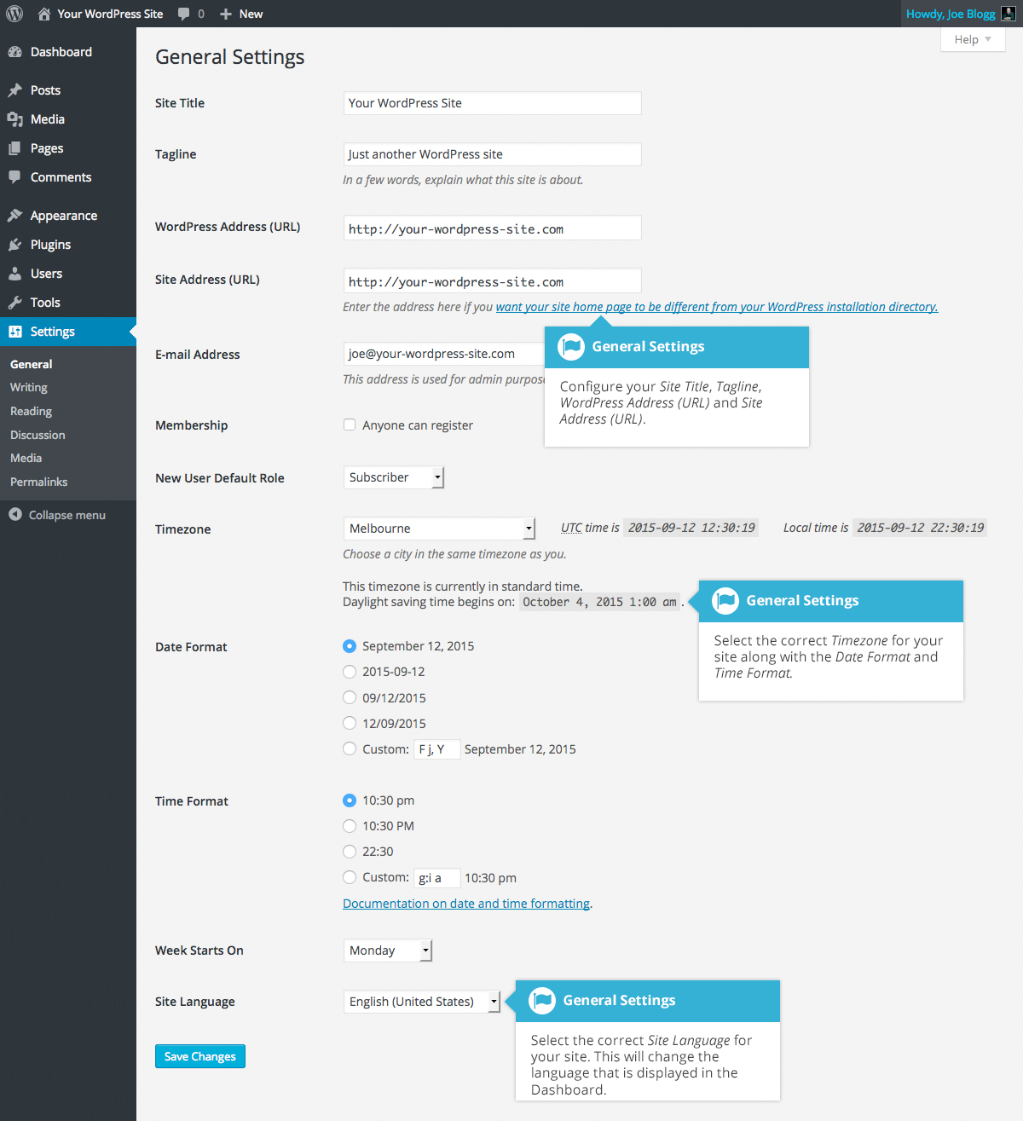

Writing
The Writing settings configure various options with regards to your site content. Settings include defining the Default Post Category, Default Post Format (if supported by your Theme) and if the Link Manager plugin is installed, the Default Link Category.
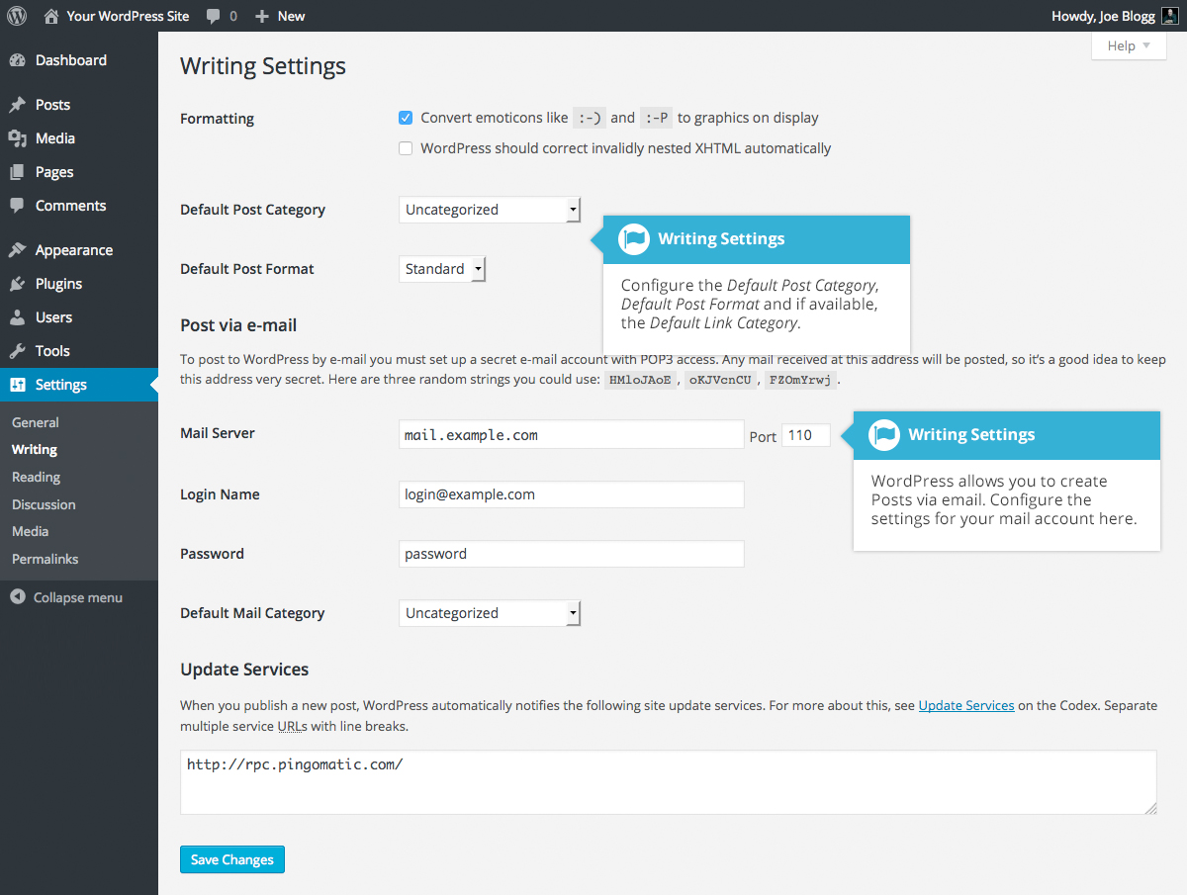

Reading
The Reading settings configure how your site is viewed. You can define whether your front page displays a static Page or your blog Posts, how many blog posts are displayed by default as well as Syndication/RSS options. If you configure your site to display a static front page, you can set which page to display and also which page will show your blog posts.
The Search Engine Visibility setting enables you to block your site from search engines or allow it to be visible.
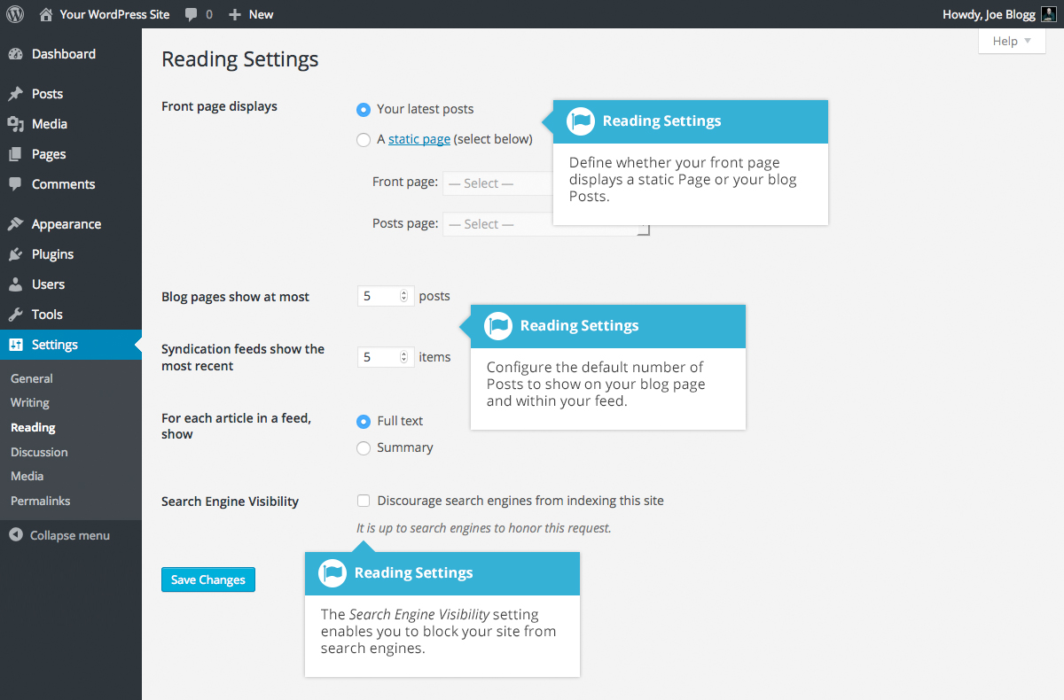

Discussion
The Discussion settings define how your readers interact with your site and how your site interacts with other blogs. You can configure Pingbacks and Trackbacks, whether readers can post Comments or not and if so, how those Comments are moderated and displayed on your site.
This screen also lets you configure whether the Post Author should be emailed whenever someone posts a comment on your site. If you are receiving emails whenever someone posts a comment, simply uncheck the box next to Anyone posts a comment within the E-mail me whenever section on this screen and then save your changes.
If you would like to be notified whenever a comment is held for moderation, it can be configured on this screen as well within the E-mail me whenever section. The email notification is sent to the email address listed on the Settings > General page.
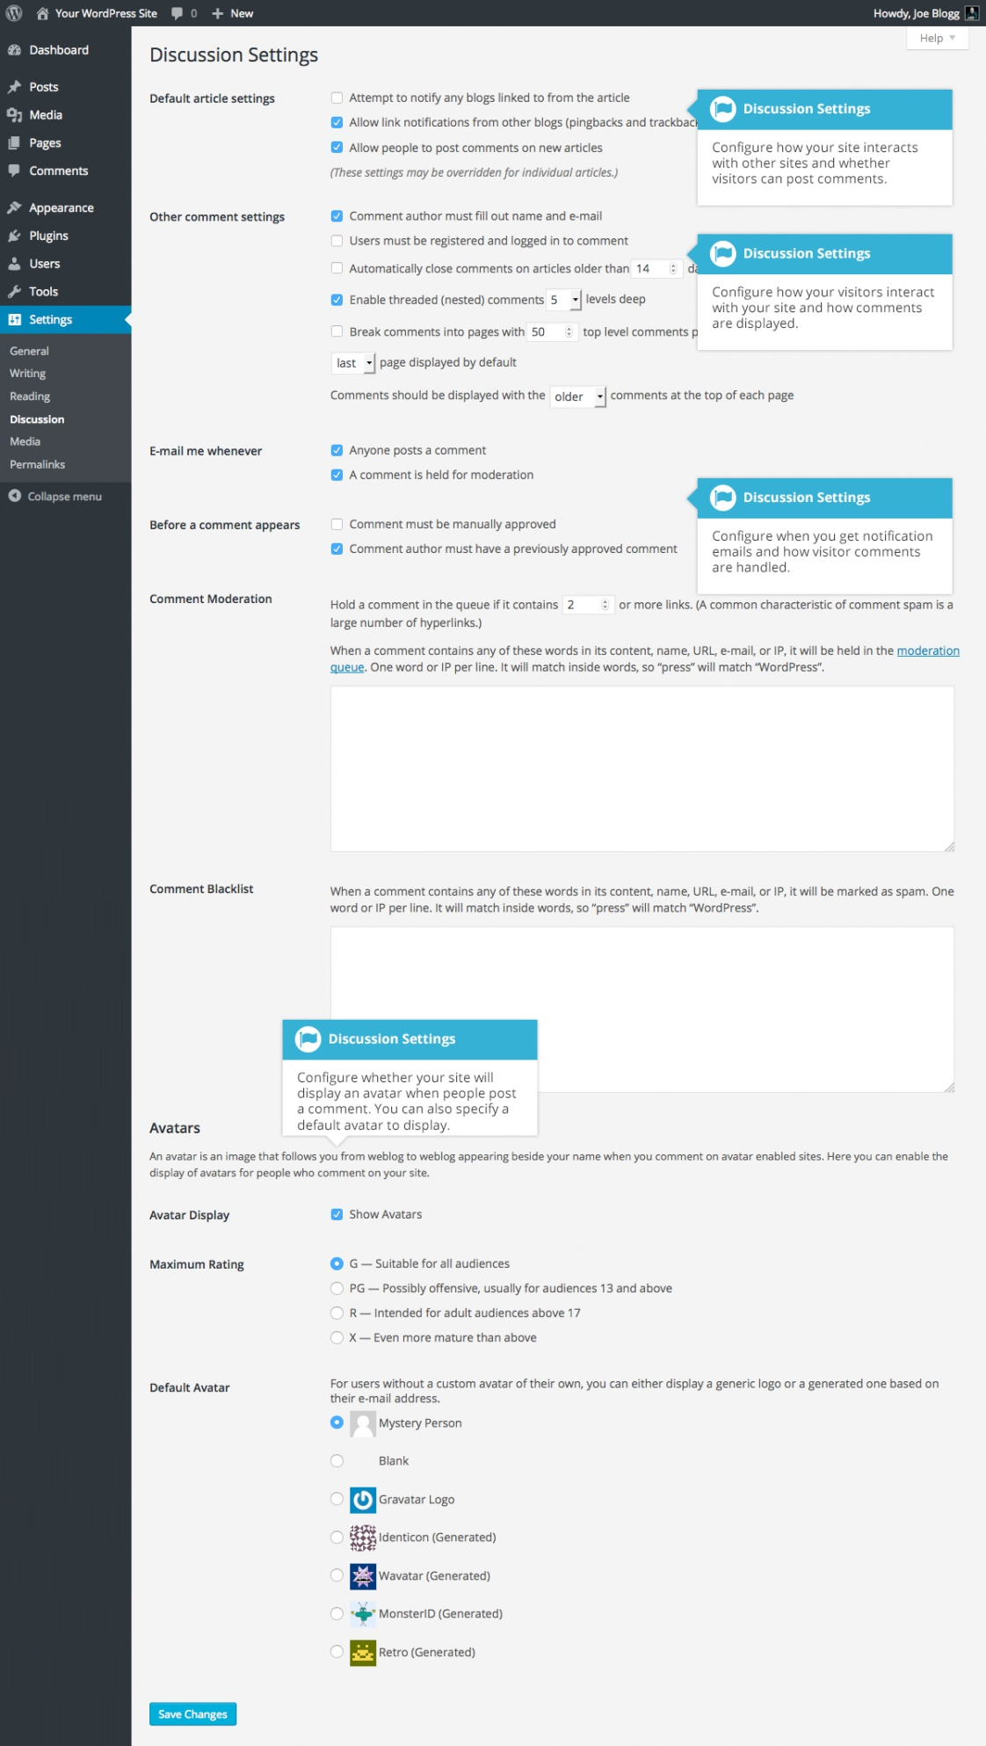

Media
The Media settings define the default image sizes that are created when an image is uploaded.
You can also configure whether your uploaded media files are stored in folders based on the year and the month of the upload.
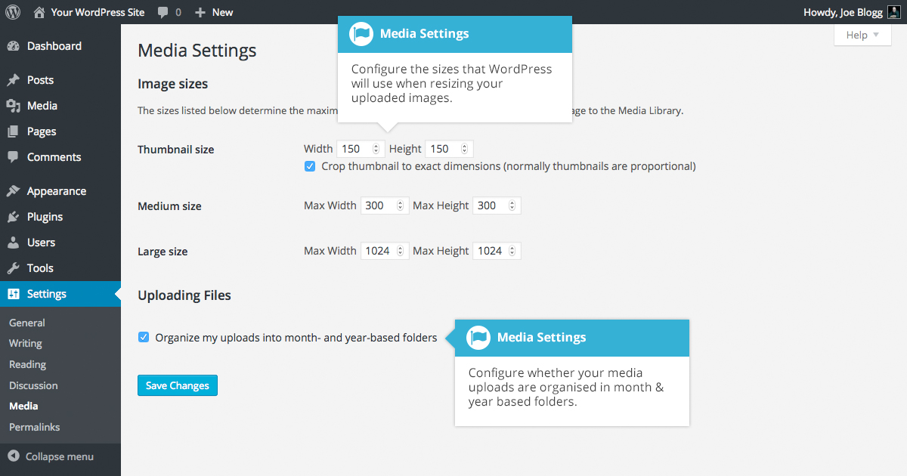

Permalinks
The Permalink settings enable you to configure the URL format that is displayed in the web browser when someone browses your site. WordPress will default your Permalinks to the Day and name format however you can change this so that the URL is more user friendly. This also helps considerably with Search Engine Optimisation (SEO). To change the way your site URL is displayed simply select one of the radio button options within the Common Settings section on this screen. Next to each option is an example of how the URL would be displayed.
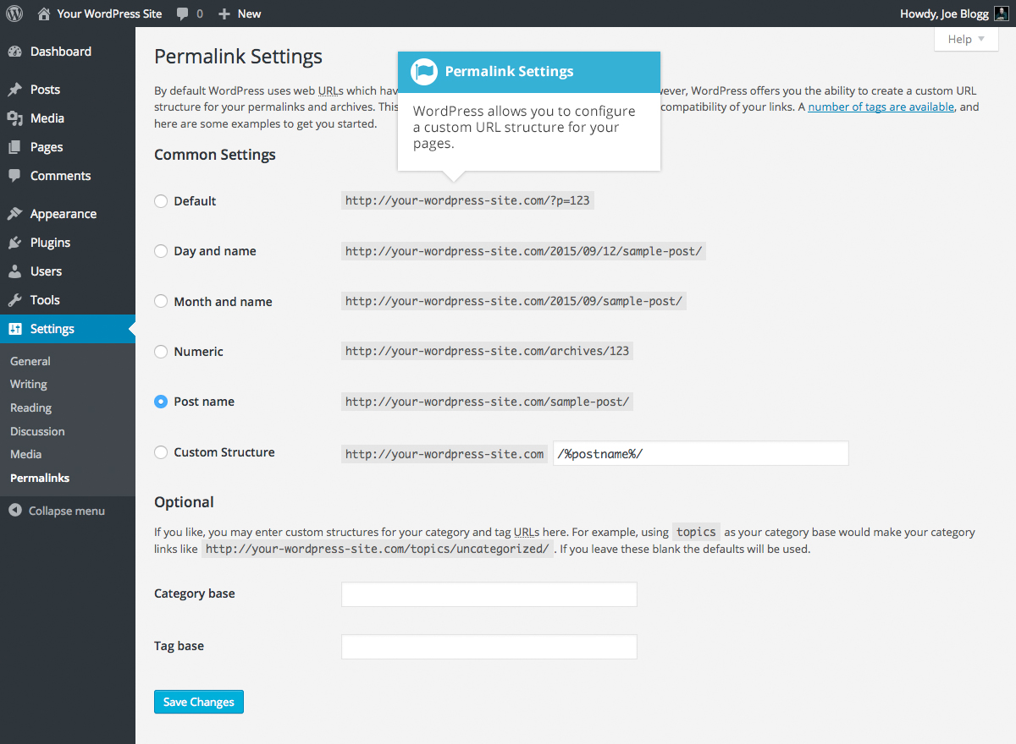

Keeping your Site Updated
From time to time, themes, plugins & WordPress will require updating. Updates typically happen when developers release security patches or add extra functionality.
It’s good practice to keep your themes, plugins & WordPress version updated to the latest versions. The top two reasons for sites being hacked are insecure passwords & outdated (vulnerable) software.
WordPress has introduced automatic background updates in an effort to promote better security and to streamline the update experience. By default, only minor WordPress releases are enabled (e.g. v4.4.1, v4.5.1). These minor releases are usually for maintenance and security purposes or translation file updates. Only core WordPress files will be auto-updated. Your themes or plugins won’t be automatically updated.
Once your site is auto-updated your site administrator will notified by email. If your WordPress installation can’t update itself automatically for one reason or another, your site administrator will be notified of this as well.
To update your WordPress version manually or to update your themes and plugins, hover your cursor over the Dashboard menu option in the left-hand navigation menu and in the fly-out menu, click the Updates link. Alternatively, click the Dashboard menu option and then click the Updates link underneath.
The Updates page is divided into three sections. If your version of WordPress requires updating, this will be displayed at the top of the page. Below that, you’ll be notified of any plugin updates and below that again, theme updates.
Updating your WordPress version is as simple as clicking the Update Now button. WordPress will download the necessary files, perform a validation of those files and then automatically update your site.
Before updating your site, it’s always wise to perform a backup first, just in case something unfortunate happens during or after the installation.
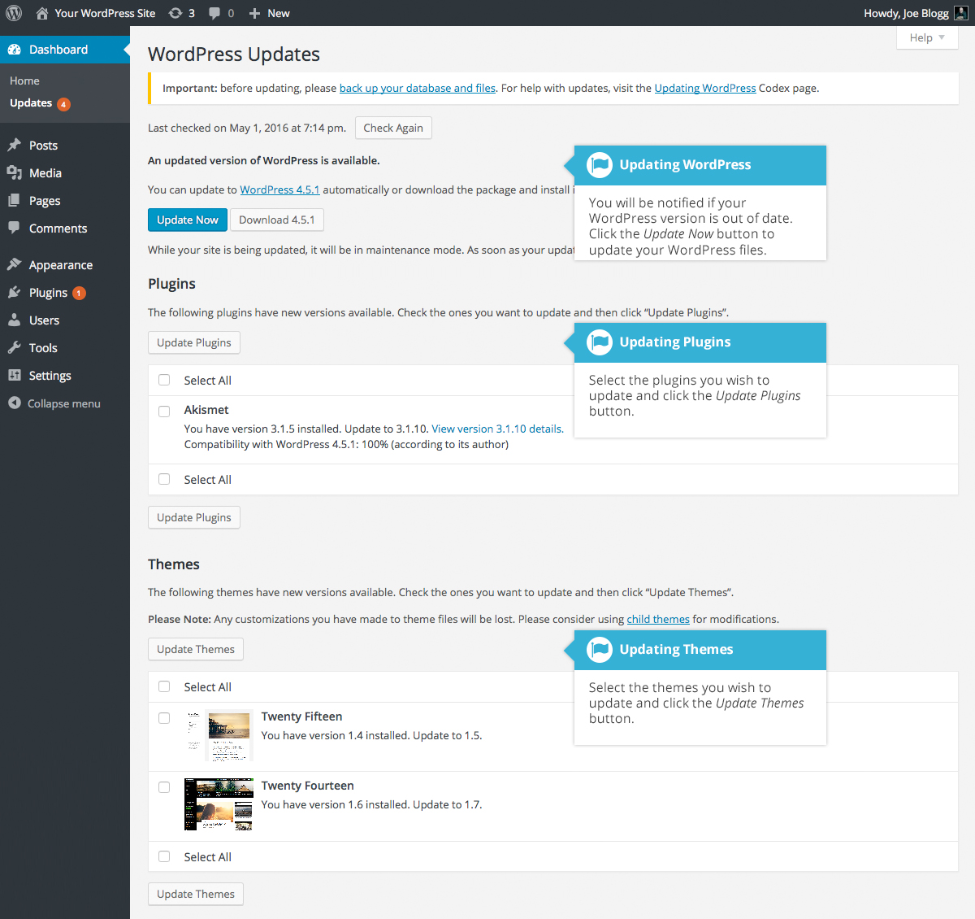
If there are any plugins that can be updated, these will be listed in the Plugins section on the page. To update your plugins, tick the boxes next to each of the plugins you wish to update and then click the Update Plugins button. The new plugin files will be downloaded and automatically installed.
If there are any themes that can be updated, these will be listed in the Themes section on the page. To update your themes, tick the boxes next to each of the themes you wish to update and then click the Update Themes button. The new theme files will be downloaded and automatically installed.
After your site has been updated, no matter whether it’s been done automatically, manually or just themes and plugins, it’s a good idea to give your site a quick test to make sure it’s functioning as expected. This will ensure that the new themes, plugins or even WordPress itself hasn’t introduced new functionality that adversely affects your site or changes how your site operates.

Where To From Here?
If you’re looking for more resources to further your WordPress knowledge the first place to check out is the WordPress.org website. There you’ll find technical support and new resources like plugins which are a fantastic way to add extra functionality to your site without having to modify your theme files. The Plugin Directory has over 44,000 different plugins that are available to download, for free. Furthermore, if you want to change how your site looks, have a look in the WordPress Themes Directory which is also there on the WordPress site.
If you find you need more information on a particular topic, have a search through the WordPress Codex which goes into greater detail about how WordPress works. Not only will you find information about updating your site content but there is all sorts of other useful information that will help you with installing WordPress, troubleshooting, using plugins & themes and also theme development, for the more technically minded.
Once your website is humming along nicely, you might want to think about getting involved in the awesome WordPress community. One of the easiest ways to get involved is simply by helping others within the WordPress Support Forums. There is always someone there who’s newer to the learning curve than you, and learning is so much improved while you’re teaching others! There are topics there for all ability levels, from installation issues, theme and template issues, and general troubleshooting all the way through to more advanced areas of theme and plugin development.

